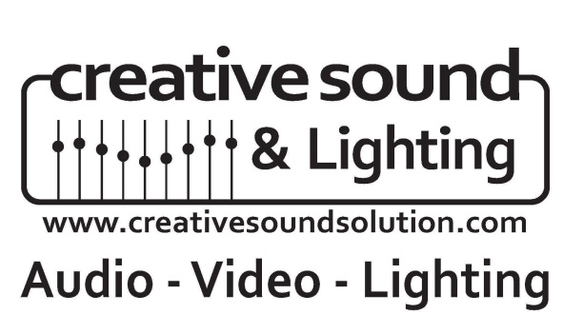
Sound – Lighting – Video – Projection – Theatrical Lighting – Custom Sound Panels
735 NE 19th Place, Unit11
Cape Coral, FL 33909
239.458.3408

Management

Russell Byas Rob Robinson

russell@creativesoundsolution.com rob@creativesoundsolution.com (239) 458-3408 ext.114 Office (239) 458-3408 ext. 113 Office
(239) 443-9648 Cell (239) 994-2865
(239) 673-9079 Fax

FEI & License Number

27-0374582 LIC#ES12001046

Mailing & Physical Address
735 NE 19th Place, Unit 11
Cape Coral, Fl 33909

Liability Insurance Company
Oswald Trippe and Company, Inc.
Paul Copeland
(239) 433-4535

Workers Comp Insurance
Hartford Underwriters Insurance Company
Hartford Plaza, Hartford, Connecticut 0615
Company Number: 10456

Experience
Creative Sound & Lighting Solutions has over 90 years of combined experience with Sound, Lighting, and Video installation, service and repair. We specialize in House of Worship Design/Build projects, Educational Facilities, Entertainment Facilities, etc...with turnkey integrated systems in audio, lighting and video. We have the skills and resources to get any size job done.

Recent Notable Projects

Northcrest Baptist: $300,00+
- Total Audio/Video/Lighting renovation
- First install worldwide to use FIR filtering
- Allen & Heath ILive Digital Console & Digital Snake
- 16:9 High Definition Projection System
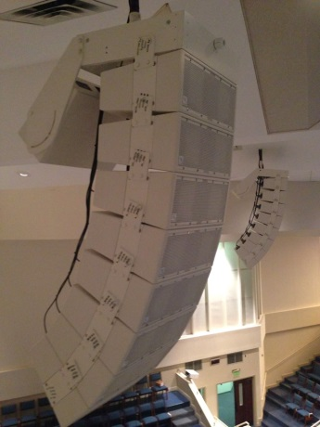
- Computer Automated Lighting System
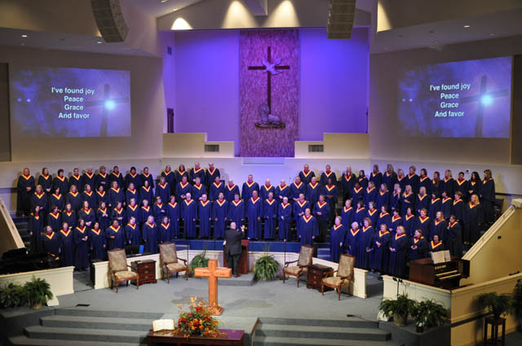
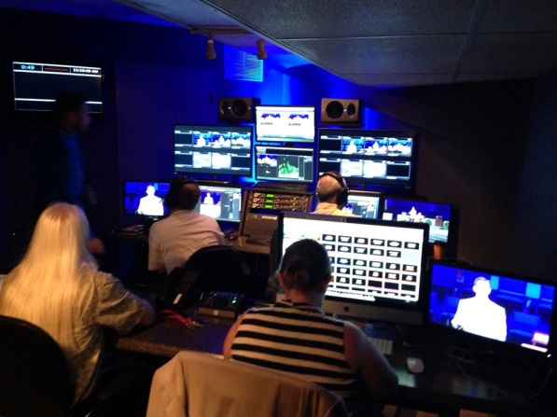

Belushi’s Live Club: $30,000.
- Digital Console that can be run from an iPad
- Integrated front of house and 70V system throughout venue
- 100% LED theatrical stage lighting system w/onstage control option
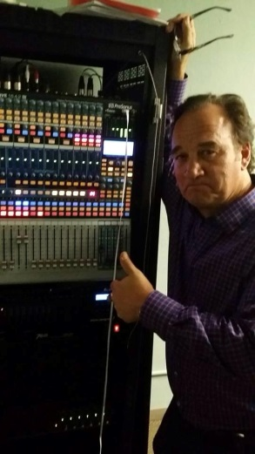
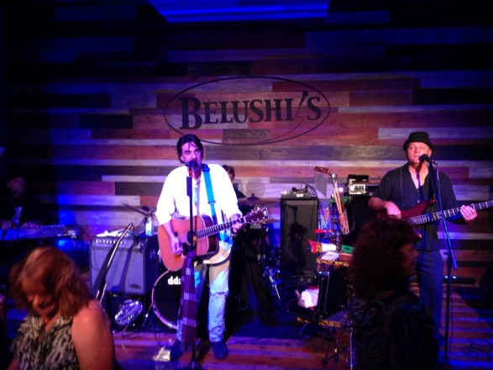
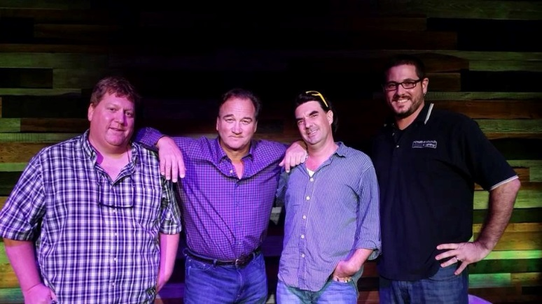

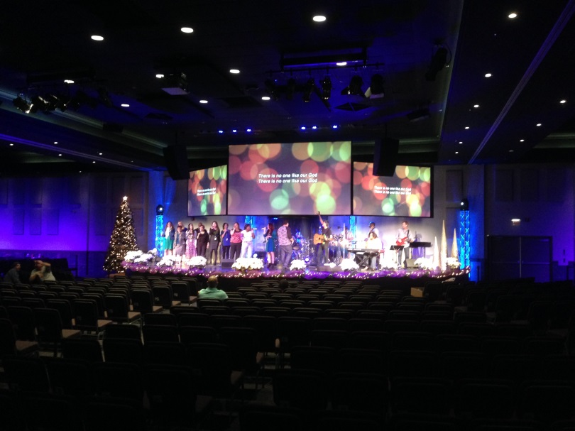
Miami Vineyard Church $300,000+

Bonita Presbyterian Church:

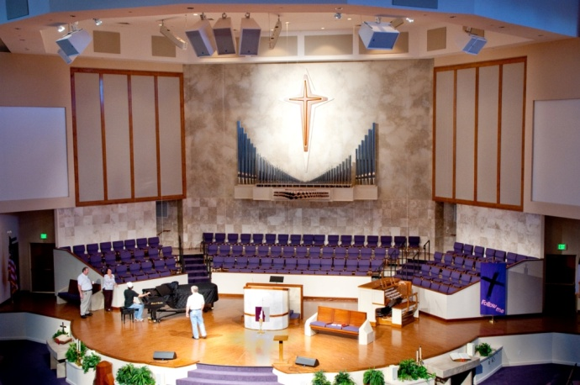
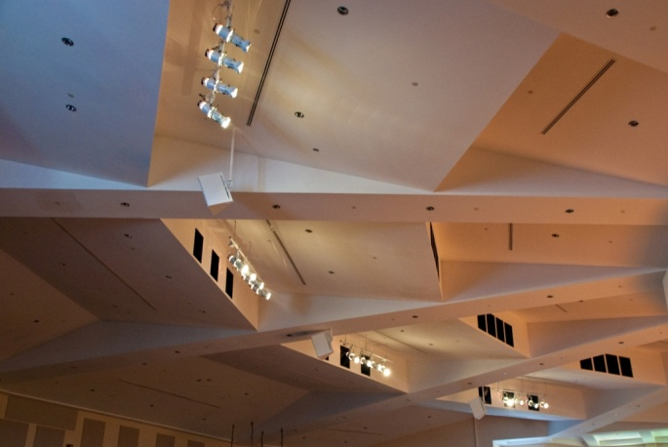
House of Worship
- Faith Church, Fort Myers Beach, Florida
- Family Life Church, New Jersey
- United Methodist of North Naples, Florida
- Boynton Beach Community Church, Boynton Beach, Florida
- Thomas Edison Church, Fort Myers, Florida
- Crossroads Baptist Youth Room, Alva, Florida
- Crossroads Baptist Main Sanctuary, Alva, Florida
- Cape Christian Fellowship, Cape Coral, Florida
- First Christian Church, Venice, Florida
- Crosspoint Church (Sound Panels) ( Lighting), Bonita, Florida
- Saint Michael & All Angles, Sanibel, Florida
- Shells Lutheran Church, Grantville, Pennsylvania
- Deep Creek Community Church, Punta Gorda, Florida
- Our Lady of Miraculous Medal, Bokeelia, Florida
- Victory Church, Sarasota, Florida
- Saint Williams Catholic Church, Naples, Florida
- Next Level, Fort Myers, Florida
- First Baptist, Lehigh, Florida
- Experience Life church, Waynesboro, Pennsylvania
- Elevation Church, Fort Myers, Florida
- The River, Bozeman, Montana
- The Summit, Houston, Texas
- Church at the Crossing, Dothan, Alabama
- Coastal Community, Fort Lauderdale, Florida
- Living Waters, Cape Coral, Florida
- Freedom Church, Lebanon, Indiana
- Healing Waters Remodel, Labelle, Florida
- First Assembly West, Cape Coral, Florida
- Grace United Methodist, Cape Coral, Florida (Sound Panels)(Audio System)(Lighting System)
- Grace United Methodist Community Center, Cape Coral, Florida
- First Presbyterian of Bonita, Bonita Springs, Florida
- Story Church, Durham, North Carolina
- Freedom Valley Church, Tulsa, Oklahoma
- Jesus The Worker, Fort Myers, Florida
- Faith Presbyterian, Fort Myers, Florida
- Discover Life Church, Melbourne, Florida
- The 7 Venue, Douglasville, Georgia
- Central United Methodist, Fort Myers, Florida
- Church of the Palms, Sarasota, Florida
- Christ the King, LaBelle, Florida
- New Life Assembly, Lehigh, Florida
- Life Church, Naples, Florida
- High Point Church, Lake Wales, Florida
- Calvary Assembly of God, Kissimmee, Florida
- Grace Baptist, Cape Coral, Florida
- King Jesus International Ministries, Cape Coral, Florida
- Messiah Lutheran, Fort Myers, Florida
- Seventh Day Adventist, Cape Coral, Florida
- Word of Life Ministries, Fort Myers, Florida
- The Source Church, Bradenton, Florida
- Northcrest Baptist, Meridian, Mississippi
- Hope Lutheran Church, Bonita, Florida
- Life Church, Naples, Florida
- Miami Baptist, Miami, Florida
- Second Baptist, Mt. Vernon, Illinois
- North Shore Alliance, Ft. Myers, Florida
- Roser Memorial community Church, Anna Maria, Florida
- Summit Church, Naples, Florida
- Gateway Church, Ft. Myers, Florida
- The Church At Bradenton, Bradenton, Florida
- Cypress Lake United Methodist, Ft. Myers, Florida
- Buckingham Presbetarian, Buckingham, Florida
- Centerpoint Church, Naples, Florida
- St John Newmann, Naples, Florida
- Our Lady Of Angels, Naples, Florida
- Good Life Church, Bradenton, Florida
- Church of Purpose, Sarasota, Florida
- Emmanuel Cathedral, Sefner, Florida

- First Assembly West, Cape Coral, Florida
- Freedom Valley Church, Tulsa, Oklahoma
- Hope Lutheran, Bonita, Florida
- First United Methodist Church of Coral Springs, Coral Springs, Florida
- Christ Central, Alachua, Florida
- Riverside Church, Ft. Myers, Florida
- St. Columbkille, Bokellia, Florida
- St. Francis Xavier, ft. Myers
- All Souls Episcopal Church, Ft. Myers, Florida
- Cape Coral United Methodist, Cape Coral, Florida
- Heights Baptist, Alvin,Texas
- Fellowship Baptist, Ft. Myers, Florida
- Miami Vineyard, Miami, Florida
- New Life Church, Gahanna, Ohio
- Gateway Trinity, Ft. Myers, Florida
- Unity Faith Missionary Baptist, Ft. Myers, Florida
- Church of the Cross, Ft. Myers, Florida
- Riverside Baptist, Ft. Myers, Florida
- First Baptist Church, Alva, Florida
- Sunnybrook Church, Tulsa, Oklahoma
- Cape Coral Christian Center, Cape Coral, Florida
- Fellowship Baptist, Meridian, Mississippi
- Southern Adventist Church, Collegedale, Tennessee
- Beth Messiah, Sarasota, Florida
- Carlson Memorial, Labelle, Florida
- Central Baptist Church, Melborne, Florida
- Christ Church, Venice, Florida
- Venice/Nokomis United Methodist, Venice, Florida
- Christ United Methodist Church, Lehigh, Florida
- Covenant Love Church, Crystal River, Florida
- FT. Myers Evangelical Free Church
- First United Methodist Church, Punta Gorda, Florida
- Good Shepherd United Methodist N. Ft. Myers, Florida
- Grace Central Church, Ft. Myers, Florida
- Holy Trinity Presbyterian, Ft. Myers, Florida
- Cypress Lake Presbyterian, Ft. Myers, Florida
- Legacy Baptist Church, Estero, Florida
- Thrive Church, Estero Florida
- Kingsley United Methodist, Van Wert, Ohio
- Mt. Hermon Church, Ft. Myers, Florida
- New Hope Presbyterian, Ft. Myers, Florida
- Northside Baptist, Corsicana, Texas
- Old Fort Baptist, Summerville, South Carolina
- River of Life Church, Ft. Myers, Florida
- Seventh Day Adventist, Ft. Myers, Florida
- Venture Church, Ft. Myers, Florida
- Story Church, Durham, North Carolina
- Thatcher Chapel Southern Adventist University Collegedale TN
- St. Michaels Episcopal Church, Sanibel, Florida
- Our Lady Of Mt Carmel, Osprey FL
- Our Lady of Lourdes, Venice FL
- Judson Baptist Church, Fayetteville NC
- North Shore Alliance Church, Ft Myers, FL
- Naples United Church of Christ, Naples, FL
- Judson Baptist Church, Walker, LA
- The Moorings Church, Naples, FL
- Golden Gate Assembly of God, Golden Gate, FL
- Community Life Center, Port Charlotte, FL

Commercial Projects
- Cultural Park Theater, Cape Coral, Florida
- Cypress Cove, Fort Myers, Florida
- Elks Club, Cape Coral, Florida
- Worldwide Vision Network, Fort Myers, Florida
- Waste Pro LED Parking Lot Lighting, Fort Myers, Florida
- Fleamasters Stage Lighting, Fort Myers, Florida
- Fleamasters Chevy Dealer, Fort Myers, Florida
- The Net Roller Rink, Fort Myers, Florida
- WRXY TV Set, Port Charlotte, Florida
- Hannoush Jewelers, Fort Myers, Florida
- Blu Sushi, Fort Myers, Florida
- Everglades National Park
- Blu Sushi, Miami, Florida
- Gulf Harbor Country Club, Fort Myers, Florida
- Belushi’s Comedy Club Ft. Myers, Florida
- Building Belushi outdoor stage, Medford, OR
- Alliance Financial, Fort Myers, Florida
- Budget Arenas, Lehigh, Florida (multiple laser tag arena sites)
- Audi, Coral Springs, Florida
- Yabo Restaurant, Fort Myers, Florida
- The Heights Foundation, Ft. Myers, Florida
- Admiralty Yacht Club, North Ft. Myers
- The Local, Naples, Florida
- Sarasota Veteran’s Center, Sarasota, Florida
- Lakewood Ranch Clubhouse, Sarasota, Florida
- The Comedy Club, Chicago, Illinois
- Cape Cabaret, Cape Coral, Florida
- Sky Zone, Ft Myers, FL
- Sky Zone, Tampa, FL
- Sky Zone, Sarasota, FL
- Cape Coral Brewing Company
- Extreme Paintball, Ft. Myers, Florida
- Greeks Pizza, Valparaiso, Indiana
- Sparez Bowling lanes, Davie, Florida
- Heron’s Glenn Country Club, Estero, Florida
- IPAL Theater, New Iberia, Louisiana
- Media Vista Group TV Station, Bonita, Florida
- Pelican Bay Clubhouse, Naples, Florida
- The Resort at Carefree Village, Ft Myers FL
- Rambler’s Rest, Venice FL
- Sky Zone Lee’s Summit, KA
- Sky Zone Pompano FL
- Sky Zone Macon GA
- Sky Zone Tallahassee FL
- Sky Zone Ocean NJ
- Sky Zone Aurora IL
- Sky Zone Charleston SC
- Sky Zone Albany NY
- Sky Zone Rochester NY
- Sky Zone Syracuse NY
- Sky Zone Boston Heights OH
- Sky Zone Belden Village OH
- Sky Zone Cutler Bay FL
- Sky Zone Doral FL
- Sky Zone Edmund OK
- Sky Zone Fargo ND
- Sky Zone Joliet IL
- Sky Zone Manchester NH
- Sky Zone Peoria AZ
- Sky Zone Raleigh NC
- Sky Zone Timonium MD
- Sky Zone Shawnee KS
- Sky Zone Springfield MO
- Sky Zone Ventura CA
- Sky Zone Elmhurst IL
- Sky Zone Appleton WI
- Sky Zone Dayton OH
- Sky Zone Tulsa OK
- Sky Zone Colorado Springs CO
- Sky Zone Vancouver WA
- Sky Zone Gardena CA
- Sky Zone Leetsdale PA (12/5/16)
- Sky Zone Monroeville PA (12/5/16)

Schools
- North Naples Middle School Stage Lighting, Naples, Florida
- Gulfview Middle School Stage Lighting, Naples, Florida
- Corkscrew Middle School Stage Lighting, Naples, Florida
- Golden Gate Middle School Stage Lighting, Naples, Florida
- Patriot Elementary, Cape Coral, Florida
- Saint John Neumann High School Auditorium, Naples, Florida
- Lee County Schools TV Set Lighting, Fort Myers, Florida
- Edgewater H.S. LED auditorium lighting, Orlando, Florida
- Oakridge H.S. LED auditorium lighting, Orlando, Florida
- Lake Nona H.S. LED Par Lamps, Orlando, Florida
- East River H.S. LED Par Lamps, Orlando, Florida
- Bonita Middle School Lighting System, Bonita, Florida
- Pine Ridge Middle School Lighting, Naples, Florida
- Evangelical Christian School, Fort Myers, Florida
- Barron Collier High School Auditorium, Naples, Florida
- Pinellas County Schools
- Charlotte County Schools
- West St. Lucie High School
- Westwood High School, New Port Ritchie, Florida
- West Centennial High School, St. Lucie, Florida
- Southern Adventist University, Collegedale, Tennessee
- Ave Maria University, Naples, Florida
- Pelican Elementary TV station
- Ft. Myers High School TV station
- East Lake High School, Tampa, Florida
- Tarpon Springs High School, Tarpon Springs, Florida
- Johns Hopkins High School, Tampa, Florida
- Lehigh High School , Lehigh, FL
- Riverdale High School, Ft. Myers FL
- Edison Park Elementary, Ft Myers, FL

