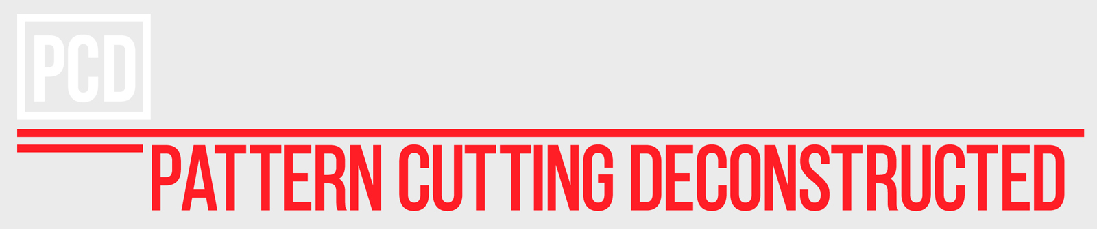

PRODUCTS PRICE QUANTITY TOTAL
Pattern Cutting 2: Basic Package £200.00 1 £200.00
Simple Skirt, Simple Trousers, Simple Sleeveless Top
Ten hour package

Subtotal £200.00
Additional Information Required
Preferred contact number

Billing Information | Order Summary
*First Name | Subtotal £200.00
*Last Name | VAT £40.00
Company Name | Total Due £240.00
*Address – Line 1
Please transfer amount due to:

Company: Armour & Kind LTD

Bank: Barclays. Peckham Rye Branch

Account Name: Armour & Kind LTD

Account Sort Code: 20-66-55

Account Number: 43502724
Address - Line 2
*City
*Post Code
*Country
*Phone Number
*Email Address

