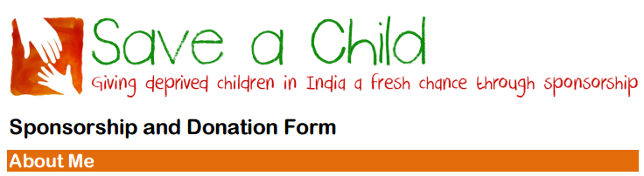
Name: ………………………………………………………………………………………………………………………………..
Address: …………………………………………………………………………………………………………………………….
Email: …………………………………………………………………………………………………………………………………
Telephone: …………………………………………………………………………………………………………………………
By giving my details I consent to being contacted by Save a Child
I would like to sponsor a child/children
Number of Children: Male Female No preference
I would like to sponsor a child
In annual sums of: £ (minimum sponsorship level £216 per child)
By quarterly standing order of: £ (minimum sponsorship level £54 per child)
OR
I would like to make in a general donation of: £
I wish to pay by Standing Order (Please complete and send the separate form to your bank)
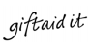
I will pay by direct transfer to Save a Child's account at Bank of Scotland (sort code 12-11-03, account no 00908629)
I enclose a cheque for: £ made payable to “Save a Child”
Help us gain extra funding – Please complete and send the separate Gift Aid form below.

Save a Child is a Registered Charity Number 328218
Registered address: 27 Canning Cross, London SE5 8BH
www.saveachildindia.com

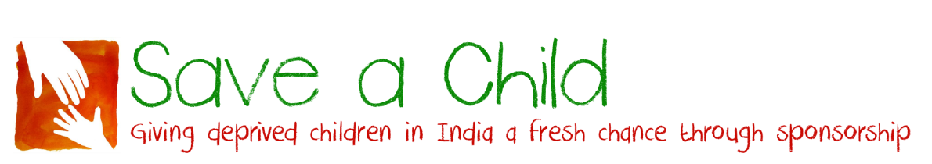
Standing Order Mandate

Standing Order Mandate To: The Manager
Bank Name:
Branch Address:
Postcode:
Please pay: Bank of Scotland, West End Office
Account No: 00908629 Sort Code: 12-11-03
Payee: Save a Child
Amount: £
Amount in words:
Reference: (your surname preferred)
Commencing: 1st (month) 20 (year)
and thereafter: Quarterly / Annually (delete as applicable)
on that date until further notice in writing and debit my account accordingly
Account Name:
Account No:
Sort Code:
Please cancel all previous standing order mandates made by me in favour of Save a Child.
Signature:
Name:
Address:
Postcode:
Please return this completed form to your bank or use it for the purpose of giving your on-line /telephone instructions to your bank.
Gift Aid Declaration

Name of charity: Save a Child (Registered charity no 328218)

Details of donor:

Title: ………….. Forename: ……………………………………………………….

Surname: ……………………………………………………………………………..

Home Address: ……………………………………………………………………...

………………………………………………………… Postcode: ………………

I want Save a Child to treat all donations I have made for this tax year and the four years prior to the year of this declaration and all donations I make from the date of this declaration until I notify you otherwise, as Gift Aid donations.

You must pay an amount of Income Tax and/or Capital Gains tax at least equal to
the tax that the charity claims on your donations in the appropriate tax year.

Signature: ……………………………………………………………………………..

Date: ……………………………………………………………………………………

Notes:
1. You can cancel this Declaration at any time by notifying Save a Child.
2. If in the future your circumstances change and you no longer pay tax on your income and capital gains equal to the tax that Save a Child reclaims, you can cancel your declaration.
3. If you pay tax at the higher rate you can claim further tax relief in your Self-Assessment tax return.
4. If you are unsure whether your donations qualify for Gift Aid tax relief, ask Save a Child.
5. Please notify Save a Child if you change your name or address.

Please return this completed form to:
Bill Baker, Save a Child, 27 Canning Cross, London SE5 8BH

Please supply any other helpful information, whether it be concerning children to be sponsored, whether the sponsorship is to be a gift or in someone’s name, or how you first heard of Save a Child.
…………………………………………………………………………………………………………………………………………………………..
Save a Child is a Registered Charity Number 328218
Registered address: 27 Canning Cross, London SE5 8BH
www.saveachildindia.com

