Goucher College’s Voter Registration and Mobilization Plan for Fall 2016

Background

Goucher College is a small private liberal arts college just north of Baltimore. Goucher College has a long history and tradition of innovation. A highlight of Goucher's unique liberal arts curriculum is the requirement that all undergraduates must study abroad at least once before graduation, making the college the first in the nation to make such a bold move in globalized education. Goucher's academic philosophy is focused on 3Rs: relationships, resilience, and reflection, and coursework reflects the core values of a liberal arts education: proficiency in English composition and in a foreign language, solid foundations in history, abstract reasoning, scientific discovery and experimentation, problem-solving, social structures, and environmental sustainability.

Voter Registration Plan

Goal: We aim to have more than 80% of our students registered to vote in the 2016 election.

Voter registration rate in 2012: 78.3%
Voter registration rate in 2016: 69.0%

Plan:

- During the 3rd and 4th weeks of the semester, we will be visiting all first year seminars (a requirement of all first year students) and register them to vote. We will bring with us, voter registration forms for most all of the states where students live. In the event we do not have a registration form for the student’s state, we will take their name and email and email it to them by the end of the day.

In addition to having voter registration forms, we will have absentee ballot application forms for most all of the states where students live.

Finally, for each student with whom we speak, we will ask them to sign the Goucher Votes! Pledge cards.

- During the 3rd and 4th weeks we will also have a voter registration stand on the main campus thoroughfare. Students will be able to register to vote (in their home state) and pick up absentee ballot applications. We will be asking each student with whom we speak to sign the Goucher Votes! Pledge cards. Note: we will enlist the help of professors and other notable individuals on campus to help work the voter registration stand – having the students’ role models make the ask

- We have started to make and hang large visible signs throughout the campus reminding students of the importance of voting and asking them to pledge to vote in November. By the time students return to campus in the fall, these signs will be everywhere on campus.

Mobilizing the Student Body to Vote

Goal: We aim to have a voting rate above 57%.

Voting Rate 2012: 54.0%
Voting Rate 2014: 19.6%

- We will use the Goucher Votes! pledge cards (see at the end of the document) to send back to students via campus mail in the middle of October to remind them to vote

- We will have a Goucher Votes! email announcement sent to all students in the middle of October and then again the week before the election

- We will have transportation available on November 8 to get students who registered to vote with their campus address to get to the polls. An announcement will go out via campus-wide email

- The Goucher Democrats and the College Republicans will host a couple of debates in the fall

- PSC 248: The 2016 Election class will host debate-watching parties throughout the campaign season

- Goucher has two delegates attending College Debate 2016. http://collegedebate16.org/ They will be using social media to mobilize voters around a set of student-centered issues

- Goucher College will join other Project Pericles Institutions in participating in the National Institute for Civil Discourse’s Text, Talk, Vote Program that in its pilot was shown to increase levels of voting

- Students enrolled in PSC 248: The 2016 Election will each be completing 20 hours of campaign work for the candidate, party or issue of their choice.

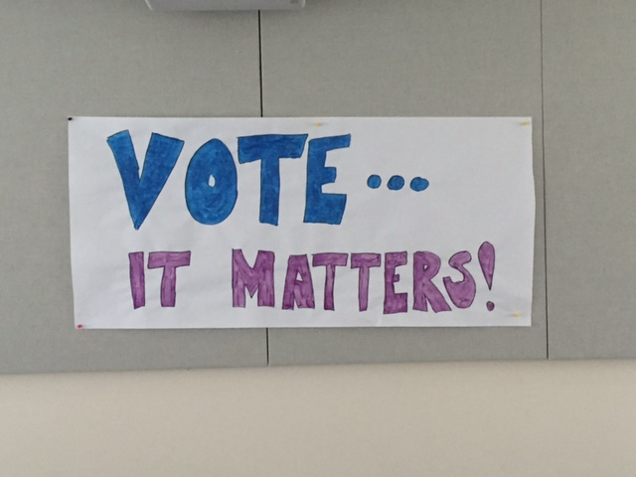

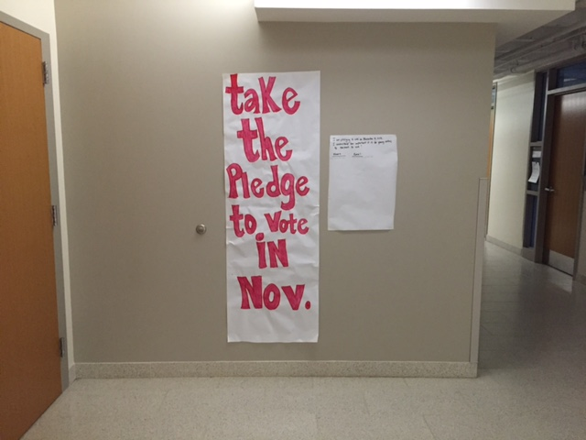

Back of the Goucher Votes! Pledge Card

The Other Side of the Goucher Votes! Pledge Card

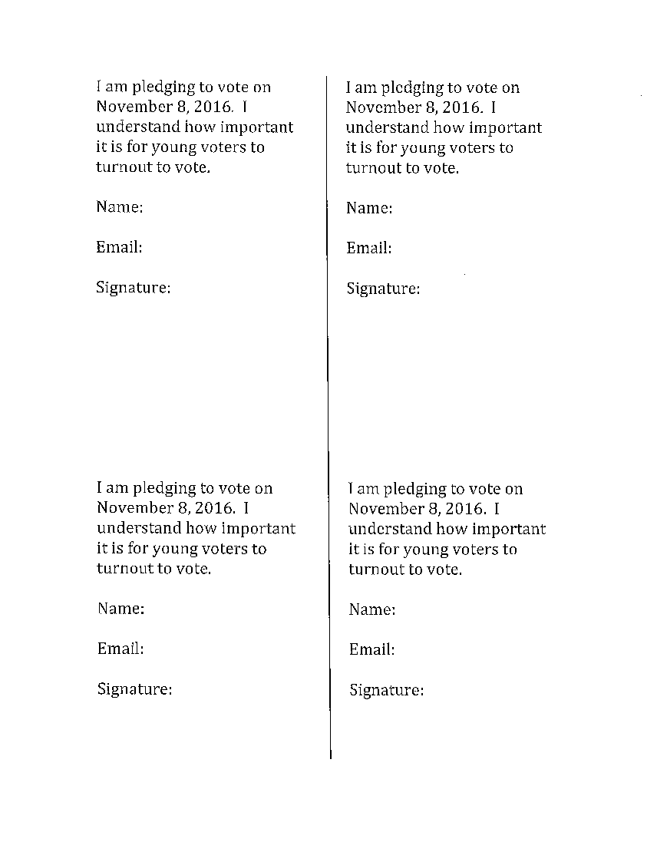

Acknowledgment

We would like to thank the Foundation for Civic Leadership and the National Study of Learning, Voting, and Engagement for supporting our voter registration and mobilization efforts.

Questions about this report may be directed to:
Nina Kasniunas, Ph.D.
Arsht Professor in Ethics and Leadership
Associate Professor in Political Science
nina.kasniunas@goucher.edu

