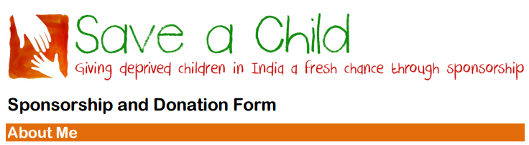
Name: ………………………………………………………………………………………………………………………………..
Address: …………………………………………………………………………………………………………………………….
……………………………………………………………………………………………………………………………………………
Email: …………………………………………………………………………………………………………………………………
Telephone: …………………………………………………………………………………………………………………………

I would like to sponsor a child/children:
Number of Children: Male Female No preference
I would like to sponsor a child:
In annual sums of £ (minimum sponsorship level £216 per child)
By quarterly standing order of £ (minimum sponsorship level £54 per child)
OR
I would like to make in a general donation of £

Please tell us how you heard about Save a Child.
…………………………………………………………………………………………………………………………………………………………..
…………………………………………………………………………………………………………………………………………………………..
…………………………………………………………………………………………………………………………………………………………..
…………………………………………………………………………………………………………………………………………………………..

I wish to pay by Standing Order (please arrange directly with your bank)
I will pay by direct transfer to Save a Child's account at Bank of Scotland (sort code 12-11-03 account number 00908629)
I enclose a cheque for £ made payable to “Save a Child”
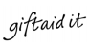

Help us gain 25% extra funding – please complete and send us the separate Gift Aid form.
Authorisation

I confirm that I have read and accept the details of the Save a Child UK privacy notice and therefore consent to Save a Child holding and processing my data including specifically communicating with me about my donation and sponsorship of children.
I also consent to Save a Child sending me newsletters and contacting me about its activities and events.

Signed …………………………………………………………………………………..

Date………………………………………………………………………………………

Please return this completed form to:

Bill Baker, Save a Child, 27 Canning Cross, London SE5 8BH

or by email to:

bill@h2glenfern.com

Save a Child is a Registered Charity Number 328218
Registered address: 27 Canning Cross, London SE5 8BH
www.saveachildindia.com
Standing Order Mandate
Standing Order Mandate To: The Manager
Bank Name:
Branch Address:
Postcode:
Please pay: Bank of Scotland, West End Office
Account No: 00908629 Sort Code: 12-11-03
Payee: Save a Child
Amount £
Amount in words:
Reference: (your surname preferred)
Commencing: 1st (month) 20 (year)
and thereafter: Quarterly / Annually (delete as applicable)
on that date until further notice in writing and debit my account accordingly
Account Name:
Account No:
Sort Code:
Please cancel all previous standing order mandates made by me in favour of Save a Child.
Signature:
Name:
Address:
Postcode:
Please return this completed form to your bank or use it for the purpose of giving your on-line /telephone instructions to your bank.

Please arrange your Standing Order payment directly with you bank either online, by phone or by sending it this form.

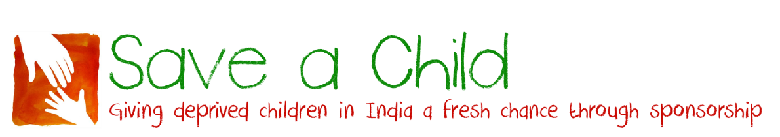
Gift Aid Declaration

Name of charity: Save a Child (Registered charity no 328218)

Details of donor:

Title: ………….. Forename: ……………………………………………………………………………………….…………………….

Surname: ………………………………………………………………………………………………………………………………………

Home Address: ……………………………………………………………………..........................................................

……………………………………………………………..…… Postcode: ………………

I want to Gift Aid all donations to Save a Child that I have made for this tax year and the four years prior to the year of this declaration and all donations I make from the date of this declaration until I notify you otherwise.

I am a UK taxpayer and understand that if I pay less Income Tax and/or Capital Gains Tax than the amount of Gift Aid claimed on all my donations in that tax year it is my responsibility to pay any difference.

Signature: ……………………………………………………………………………..

Date: ……………………………………………………………………………………

Notes:
1. You can cancel this Declaration at any time by notifying Save a Child.
2. If in the future your circumstances change and you no longer pay tax on your income and capital gains equal to the tax that Save a Child reclaims, you can cancel your declaration.
3. If you pay tax at the higher rate you can claim further tax relief in your Self-Assessment tax return.
4. If you are unsure whether your donations qualify for Gift Aid tax relief, ask Save a Child.
5. Please notify Save a Child if you change your name or address.

Please return this completed form to:
Bill Baker, Save a Child, 27 Canning Cross, London SE5 8BH

Save a Child is a Registered Charity Number 328218
Registered address: 27 Canning Cross, London SE5 8BH
www.saveachildindia.com

