Đề bài The diagram below shows how coffee is produced and prepared for sale in supermarkets and shops.

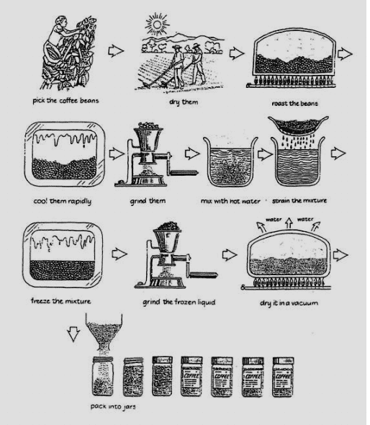

Từ vựng manufacturing process https://www.suabaiieltswriting.com/blog/ielts-writing-task-1-dang-process-tu-vung-manufacturing-process
Given is the process of manufacturing coffee before publishing it to the market for sales. Overall, it experiences ten stages, from collecting beans to packing the product into jars.

A closer look at the diagram shows that the production starts with the activity of collecting beans from the coffee tree on farm. Before the beans are roasted and cooled quickly, farmers expose them to the sunshine to dry them. Then, the beans are grinded by a machine, which converts them into mashed liquid.

After that, the liquid are mixed with hot water in a large container before being strained. To turn it into frozen liquid, people have to freeze the mixture. The water remanining in the liquid, then, vanish since they use a vacuum to dry the mixture, forming a sharp of flour. Finally, the process are completed with the stage of packing this coffee flour into jars, making them available for sales in supermarkets and shops.

