- Dàn bài mà em lập cho đề này
- Introduction
- Overview
- BP 1: Step 1 – 10
- BP 2: Step 11 – 15

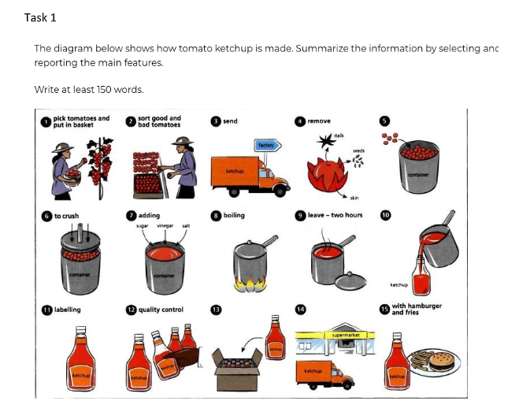
Bài viết Lần 1

Given is the diagram delineating the process of how to produce tomato ketchup.

Overall, it can be clearly seen that there are 15 steps in this process, starting with harvesting tomatoes and put them in baskets and culminating in using ketchup to eat with food.

First of all, farmers pick ripe tomatoes and put them in basket. The second step is to divide decent tomatoes and rotten ones into different groups. Next, they are delivered to the factories at which stalks, seeds and skin of tomatoes are removed. After being crushed in the container, tomatoes are seasoned with sugar, vinegar and salt. The next step is to boil the mixture and wait for 2 hours.

The mixture is now called ketchup, which is packed into bottles and labelled. Before being delivered to supermarket for consumption, the ketchup is checked carefully. Eventually, customers can purchase ketchup from stores and use it with dishes such as hamburger and fishes.

