Hướng dẫn làm map:https://www.ieltstutor.me/blog/map
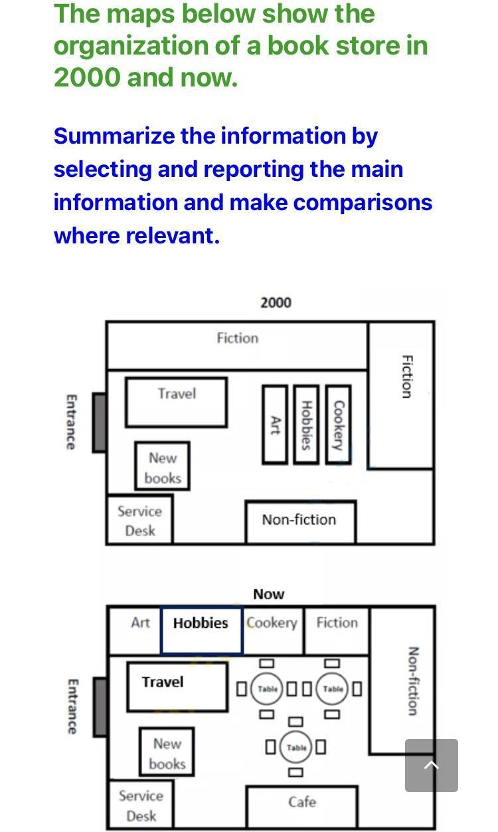
Given is the diagram illustrating the changes that took place in a book store’s organization in 2000 and now.

Overall, the book shop underwent a number of dramatic transformations, the most important of which is the appearance of tables after changing the position of several book shelves.

In 2000, to access the store from the entrance, there existed a travel division, located between the fiction and new books area, right after the door. After the travel area was a space for art which in front of hobbies, then cookery. Meanwhile, another fiction spot was located at the top right-hand corner. Additionally, to the bottom of the map, behind the new books zone, there appeared a service desk next to the space of non-fiction.

In the present day, the area of travel, new books and service desk still stay in its previous position while that of fiction has been narrowed to make space for art, hobbies and cookery shelves. As a result, beside the travel division, the previous position of arts, hobbies and cookery area is redecorated with a large number of tables. Simultaneously, an addition of a cafe which substituted the non-fiction area next to the service desk was recorded. Also, after being occupied by the cafe, the non-fiction area is currently relocated next to the fiction one, in the corner of the bookstore.
Học thêm cách từ này nhé
- floor plan (bản đồ sàn) = layout = bố trí mặt bằng (In the 2000 floorplan,…)
- display section / area = khu vực trưng bày
- remain intact: giữ nguyên

Lưu ý dạng map dễ nhất cứ mỗi năm sẽ viết một thân bài nhé, triển khai bố cục như sau:
- Overall:
- Body 1: Viết về năm 2000
- Body 2: Viết về Now
  - Overall: các phần lúc trước rời rạc thì trong layout mới đã tập hợp thành 1 nhóm (several scattering book sections have been consolidated to make space for the introduction of some new services)
  - Body 1 - Năm 2000:
    - Fiction là nơi tốn diện tích nhất (fiction was the most dominating genre which occupied the largest L-shaped shelves running along the top wall and half of the right-side one)
    - Hobbies, Cookery & Art chiếm diện tích khiêm tốn ở phía giữa
  - Body 2 - Now:
    - Entrance, Travel, New books & Service desk vẫn giữ nguyên (the area right after the entrance has been kept intact with space dedicated to the travel and new book sections)
    - Đoạn Fiction chữ L năm 2000 được chia gọn gàng lại (the L-shaped area has been divided into 4 nearly equal sections to accommodate art, cookery and fiction at the top, and non-fiction on the right, which has allowed the removal of the four separate display area)
    - Non-fiction section nhường chỗ cho cafe (the non-fiction section in 2000 has been removed to establish a cafe to improve customers’ experience)

