Notice of Board of Directors Meeting
Community Council of Greater Dallas
October 27, 2022

A regular meeting of the Board of Directors of Community Council of Greater Dallas will be held on October 27, 2022 at the offices of Community Council of Greater Dallas at 1341 W. Mockingbird Lane Suite 1000W, Dallas, TX 75247 in the Main Conference Room.

The subjects to be discussed or considered or upon which any formal action may be taken are listed below. Items do not have to be taken in the same order as shown on this meeting notice. Unless removed from the consent agenda, items identified within the consent agenda will be acted on at one time.

Mission:
Community Council of Greater Dallas provides leadership in moving families from surviving to thriving. We improve quality of life by alleviating poverty, fostering independence and wellness and connecting people to the resources they need.

Mission Minute-Housing Crisis
- Action Items:
  - Approve September Board Minutes
  - Election of Officers for FY 2023
  - Approval of FY 2023 Budget
  - Approval of FY 2023 Board Meeting Master Calendar
- Public Comment
- Discussion Items:
  - Programmatic Report
  - Report on United Texas Bank
  - Financial Reports
  - Development Update
    - Board Commitments for 2023
    - North Texas Giving Day totals
  - Current Lease
- Public Comment

If, during the course of the meeting, discussion of any item on the agenda should require a closed meeting, the board will conduct a closed meeting in accordance with the Texas Open Meetings Act, Texas Government Code chapter 551, subchapters D and E or Texas Government Code section 418.183(f). Before any closed meeting is convened, the presiding officer will publicly identify the section or sections of the Act authorizing the closed meeting. All final votes, actions, or decisions will be taken in open meeting.

This notice was posted in compliance with the Texas Open Meetings Act and CSBG public hearing requirements on Friday October 21, 2022.

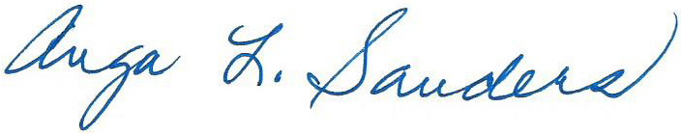
Anga Sanders, Board Chair

