Riding Groups

Please find below your assigned riding group. It is essential that everyone gets to know their group leader and sticks together throughout the day. Leaders will not start a trail if a rider is not present; therefore, if you are delayed or dropping out, you need to advise the group leaders.

If both leaders know about the change, riders can switch groups throughout the day. If you are texting one of the group leaders, please let them know who is contacting them, as your name may not be on their contact list, and you will show up as only a phone number.

Please be ready to ride at the designated start times at all trail systems. Groups will wait up to 10 minutes; after that, you will need to catch up

Pedro Faria(Leader) Cell: 647-884-7872 | Scott Melee (Leader) Cell: 905-815-3610
Matt Plaumann | Trevor Marks
Jason Locke | Mark Demmery
Marty Taylor | Steven Oliviera
Henry Lopez | Eddie Oliviera
Jeff Phillips | Liz Skelding
Tim Coulter | Judy Wilson
Lars Pastrik(Sweep) | Sue Demmery
 | Ian Christie (Sweep)
Mark Palmer(Leader) Cell: 905-808-7184
Mary Anne Knibbe
Anne Lee
Carla Schmitt
Walid Belal
Don Green (Sweep)
Sheri Bridge
Rob Abadie

1st Trail – Hydrocut
This trail system is a club favorite that can be enjoyed in about 1.5 hours. These trails are some of the most relaxing MTB riding trails that offer a good ride experience with super fun descents.
Fee: | None
Ride start: | 9:00am
Ride end: | 10:00am – 10:30am
Depart: | 10:45

Parking: Glasgow Parking Lot (Park at Walmart/Home Depot if the trailhead parking is busy)
Trailforks: https://www.trailforks.com/region/the-hydrocut/?activitytype=1&z=14.2&lat=43.42288&lon=-80.58322
Hydrocut Notes:
- You will need approx. 30 minutes to drive to Puslinch (regular traffic)
- Use Trailforks to familiarize yourself with the trail system before the ride. It is a great app on the phone as well, but you may need to subscribe to get full access
2nd Trail - Puslinch

Fee: | None
Ride start: | 11:30am
Ride end: | 12:30pm – 1:00pm
Depart | 1:30pm
Parking: OnRoute 401 Eastbound Hwy, Cambridge ON N3C 2V6, Canada. We will park in the picnic area as we have done for some previous rides. This parking location provides access to washrooms and food.

Trailforks: https://www.trailforks.com/region/puslinch-tract--twin-ponds/?activitytype=1&z=15.2&lat=43.42915&lon=-80.25230

Puslinch Notes:
- Lunch at riders discretion. We are allocating some extra time between Puslinch and Guelph Lake if riders wish to grab something to eat. Otherwise, pack a lunch and enjoy a wee tailgate dining experience.

3rd Trail – Guelph Lake
Fee: | No Fee for the trails
Ride start: | 2:30pm
Ride end: | 4:00pm
Dinner | 4:30pm

Parking: Victoria Road north (https://www.google.com/maps/place/43%C2%B035'14.7%22N+80%C2%B016'23.1%22W/@43.587405,-80.2756609,17z/data=!3m1!4b1!4m4!3m3!8m2!3d43.587405!4d-80.273086?entry=ttu&g_ep=EgoyMDI0MDkyNS4wIKXMDSoASAFQAw%3D%3D). This is not our traditional parking area for our rides – this is the on the side of the road by the actual Guelph Lake Trailhead
Trailforks: https://www.trailforks.com/region/guelph-lake-trails/

Grand Finale - Post-Ride BBQ
Guelph Lake Conservation Area
Address: 7743 Conservation Rd., RR 4 Guelph, ON N1H 6J1
You will need to pay the gate fee upon arrival of roughly $7
The BBQ is being held at the Island Pavillion again this year as indicated on the map below.
Guelph Conservation Map (The red circle is the entrance to the Conservation Area)
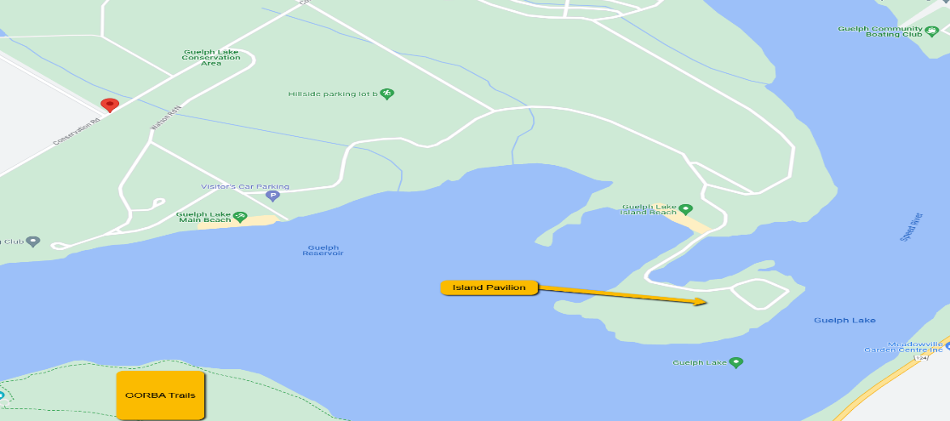

Darren Ross Food Services cater food for the third year.
The menu is as follows:
- Kale Quinoa Salad- Sweet peppers, dried cranberries, feta cheese, Honey Dijon Dressing
- Potato and bacon casserole.
- Pulled pork on Fresh baked (Italian) buns served with b.b.q sauce, chipotle sauce
- Beef Chili
- Bacon Wrapped Bacon
- Brownies with Caramel Sauce
Please Note: The caterer will be accommodating all the food sensitivities noted in your registration.
Refreshments: We encourage everyone to bring their own refreshment of choice. This is not a sanctioned or licensed event, so we must be cautious with any alcohol – be discreet
Inclement Weather
We hope weather will not impact our event this weekend based on current conditions. However, if things change, we will notify everyone by email and the BNBA club APP for members. If we have to cancel the event, we will provide a refund.
Safety and Contact Information
- We want everyone to enjoy the rides and leave in the same conditions we all started in.
- All riders must have a helmet and working bike. We will have tools available for minor adjustments.
- Please remember to dress for the weather. It is October, so the mornings can be chilly even if it warms up in the afternoon. Bring lots of layers.
- Don’t forget to bring your shoes, helmet and gloves. It may not be a bad idea to bring extras of everything in case there is a bit of rain or for fresh clothing at each ride.
- Routes will most likely be based on our normal routes at these trails, however you group leader and sweep may change things up a bit.
- All ride leaders will have their phones with them during the rides if someone needs to contact them.
  - Nature Lovers/Intermediate – Mark Palmer – 905 808 7184
  - Intermediate/Speed Racers –
  - Intermediate - Scott Melee - 905-815-3610

Information to Know
- For those who want to track their ride and see how everyone did on the day, there is a Strava group that you can join. The group leaders and some other riders are all group members and will be tracking their rides during the day, so feel free to join and see how you did. This is not a race but just a way to help track your day. https://www.strava.com/clubs/cmbac
- Please ensure you bring lots of hydration. We will have some water available to refill water bottles and some Nuun tablets for electrolytes.
- All riders must pay their fee and have a completed waiver on file before participating – no exceptions.
- If there are any problems or injuries on the trail, the leader must be notified immediately when the issue can be assessed and the next steps determined.
- Door prizes will be given via random draw during Grub time.
Car Pooling: We encourage everyone to arrange carpooling wherever they can to save on parking and to be environmentally friendly. Carpooling will work best if you are all in the same group

