Đề bài
The table below shows the cost of water in the five cities in Australia.
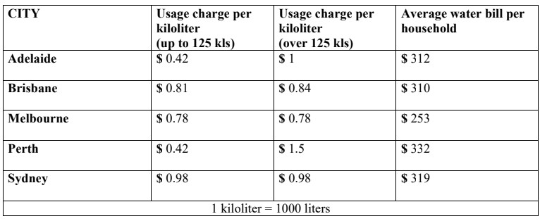
Bài viết (max 300 words cho Task 2, max 160 words cho Task 1)

Dàn bài
The table below shows the cost of water in the five cities in Australia.

- Present tense
- Số liệu: number
- Chủ ngữ: the cost of water in 5 cities in Australia
- Overall
+ brisbone: highest
+ perth: dramatic growth+dominate water bill

Body 1 usage charge
+ perth start=Adelaide, out number
+ Sydney, Melbourne: unchanged

Body2 household
+ perth dominate, 332
+ sydney second, 319
+ Brisbone, Melbourne

Bài viết Tham khảo cách làm dạng table https://www.ieltstutor.me/blog/table

Given is the table comparing the cost of water in five urban areas in Australia.

In general, it is evident that Brisbone has the highest numbers in almost all categories. In addition, Perth experiences a dramatic increase in the usage charge per kiloliter and dominates the average water bill per resident’ house.

Regarding the usage charge per kiloliter, the figure for Perth starts at $0.42 same as that for Adelaide, then outnumbering the number of water cost in Adelaide, at $1.5 and $1 respectively. Meanwhile, the cost of water in both Sydney and Melbourne remains unchanged, with $0.98 and $0.78 in the order given.

Moving onto the other category, the number of the average water bill per household in Perth dominates the chart, at exactly $332. Besides, the average amount of household’s spending on the water bill in Sydney ranks second, at $319. Moreover, the data of the average expenditure on the water bill of each home in Brisbone is $310, followed by that of Melbourne, with $253.

( chị ơi nếu câu 1 overall mình viết thành Brisbone is the city with the highest datas in almost all categories thì có được không ạ)
( chị ơi ngoài dominate ra thì mình còn cách gì paraphrase mà nó ngắn hơn cụm highest number hông ạ)

( chị uiiii, với cả những bài table có thời gian, thì mình có phân tích theo cách này được không vậy ạaaa; với lại có những bài nó không có sự giống nhau mà mỗi cái một kiểu, nhiều đối tượng không thể nhóm theo kiểu tương đồng thì mình phải làm sao vậy ạ ☹ )

  - Overall:
    - There is no difference between the cost of using under and over 125 kilolitres (KL) of water in Brisbane, Melbourne and Sydney whereas the difference in Perth and Adelaide is significant. >> IELTS TUTOR hướng dẫn Cách dùng danh từ "difference" tiếng anh
    - Households in Perth pay more in water used while those in Melbourne pay less than those in other cities.
  - Body 1: Viết về các thành phố có mức up to 125KL & over 125KL xấp xỉ hoặc bằng nhau (Brisbane, Melbourn, Sydney)
    - Residents in Melbourne and Sydney pay the same amount of money, $0.78 and $0.98 respectively, regardless of how much water they use. >> IELTS TUTOR hướng dẫn Cách dùng từ "resident" tiếng anh
    - Brisbane’s people only pay an extra $0.03 if they use more than 125KL.
    - Household water bills in Brisbane, Melbourn and Sydney are from $253 to $319.
  - Body 2: Viết về các thành phố có mức up to 125KL & over 125KL chênh lệch nhau (Adelaide, Perth)
    - The cost of water usage per kiloliter for use up to 125 KL in Adelaide and Perth was $0.42.
    - Those in Adelaide and Perth have to pay much more, at $1.00 and $1.50 respectively, if the water use exceeds 125 KL >> IELTS TUTOR hướng dẫn Cách dùng tính từ"residential"tiếng anh
    - Each household in Perth pay the highest bill, at $332
IELTS TUTOR gợi ý thêm cách phân bố 2 đoạn thân bài khác:
- Body 1: Viết về usage change per kilometer (up to 125KL & over 125KL)
- Body 2: Viết về average bill per household

