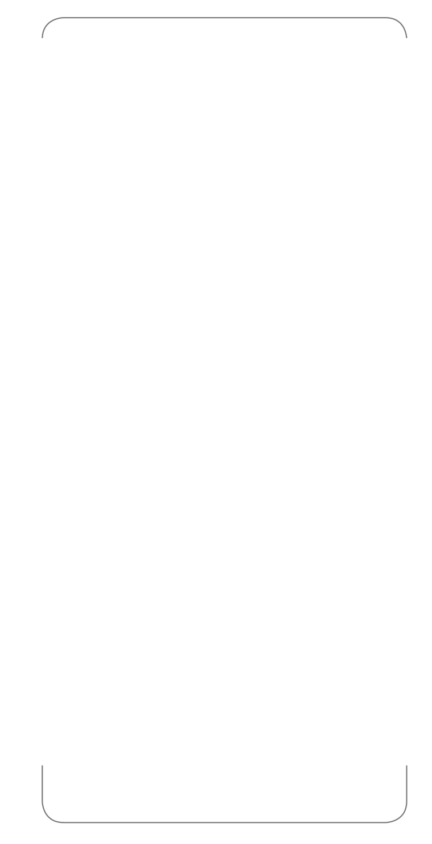

sermon title:

key verses:

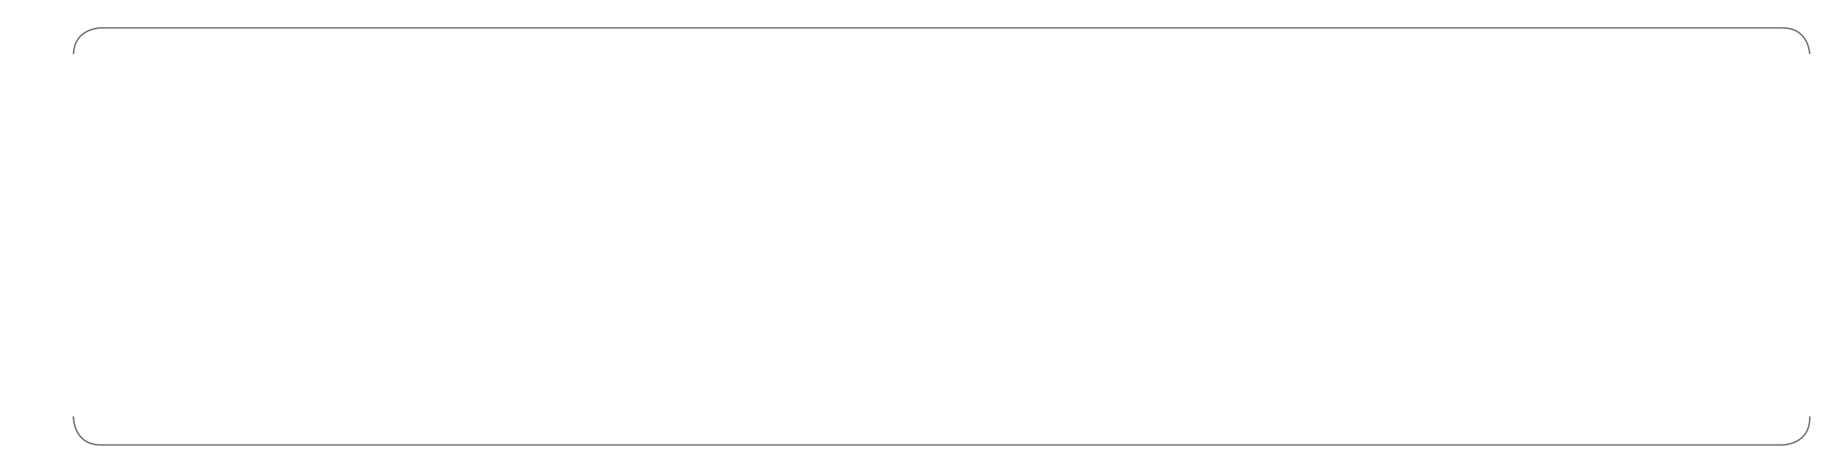

today is:

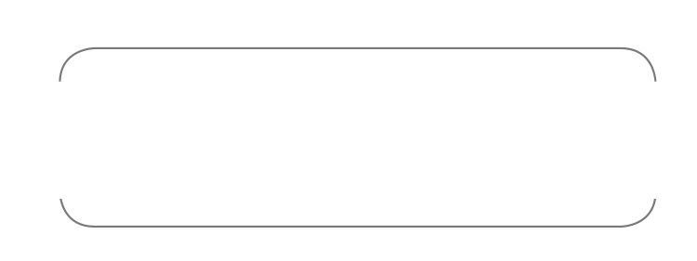

worship songs:

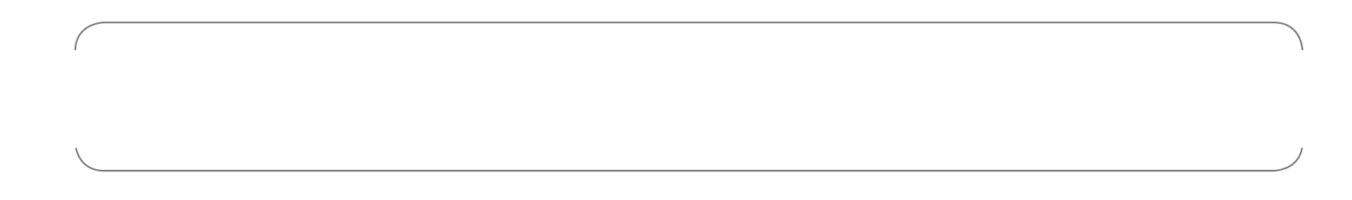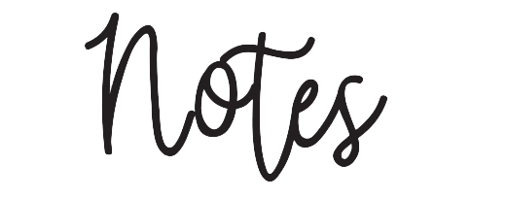

________________________________________________________________________________________________________________________________________________________________________________________________________________________________________________________________________________________________________________________________________________________________________________________________________________________________________________________________________________________________________________________________________________________________________________________________________________________________________________________________________________________________________________________________________________________________________________________________________________________________________________________________________________________________________________________________________________________________________________________________________________________________________________________________________________________________

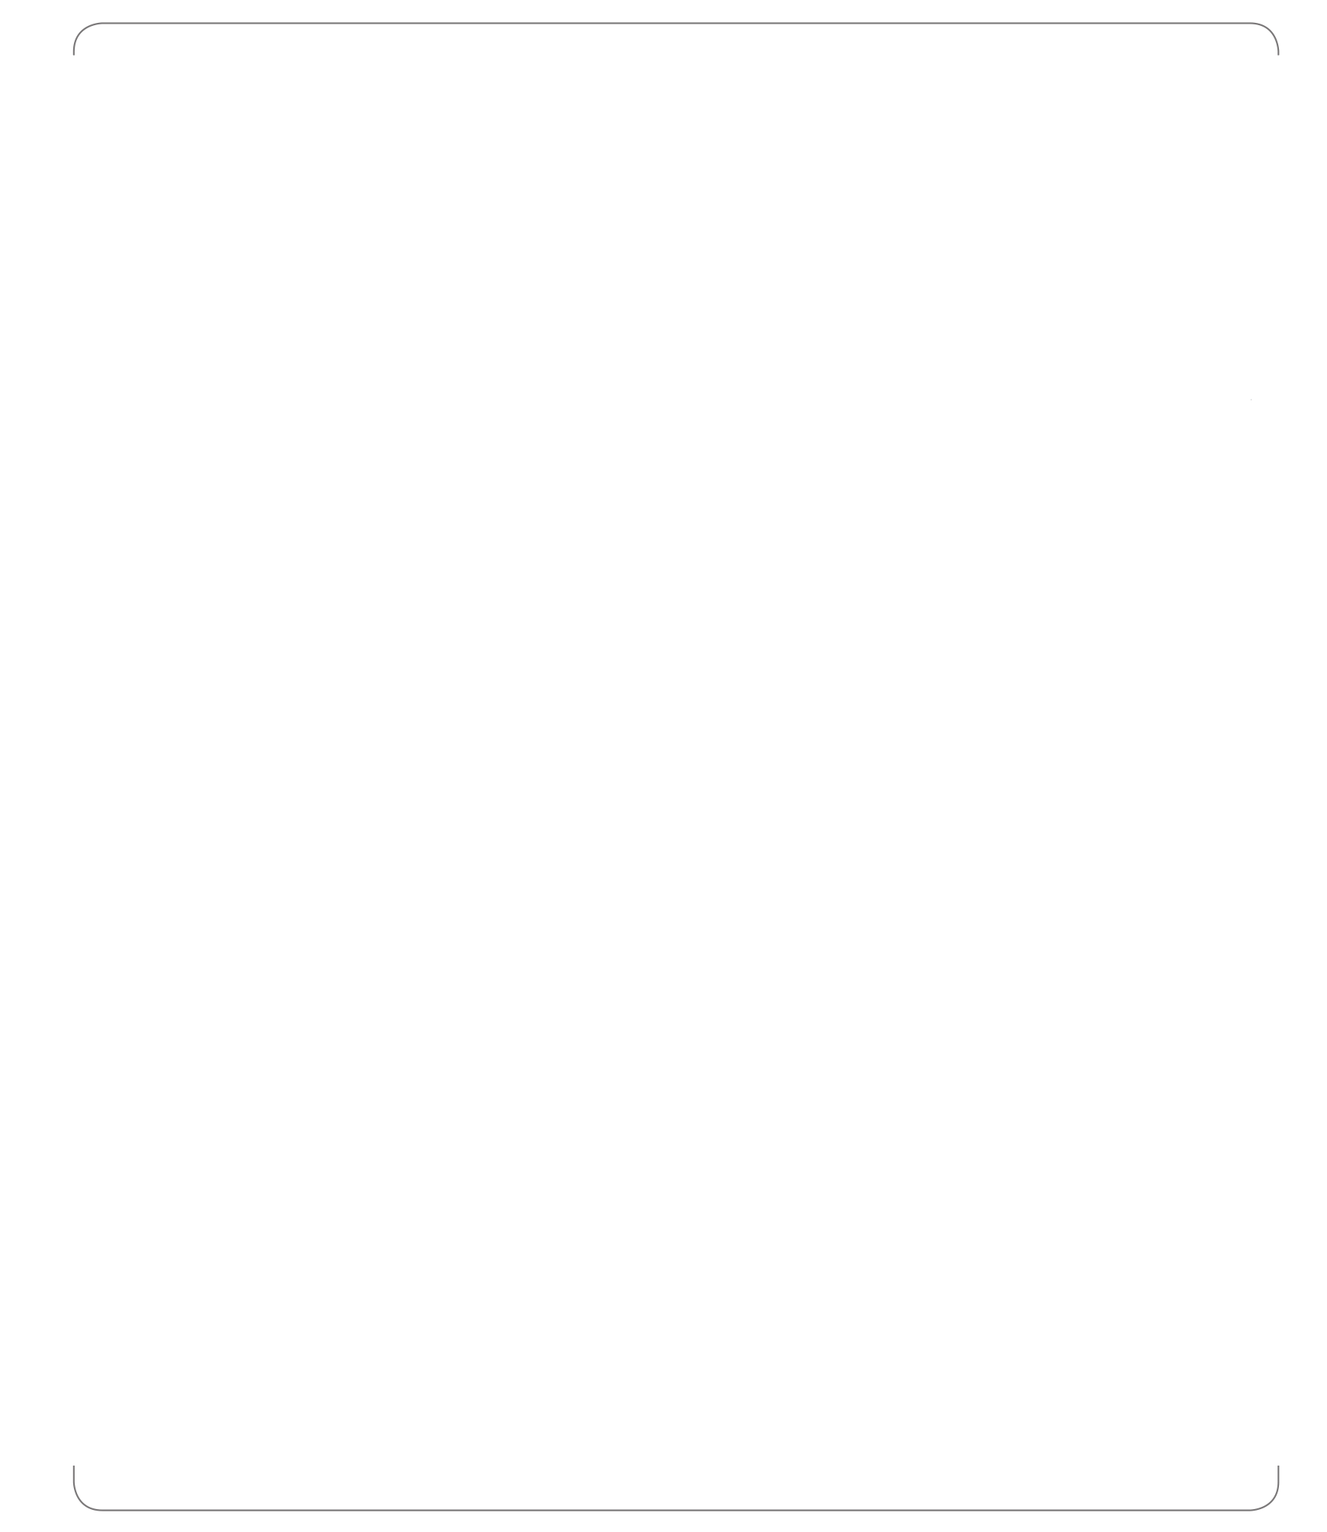

Church Name | Address | City | State | Zip | 000-000-0000 | www.churchname.com