The table below shows the percentage of patients saying the service was very good.

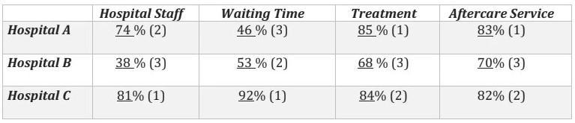
Dàn ý: Overview: Average % 4 services highest belongs to Hospital C
The Lowest at Hospital B, specifically is Staff, also lowest in any of other services.
Body 1: Hospital C
Body 2: Hospital A and B
Bài làm:
Tham khảo cách làm dạng table https://www.ieltstutor.me/blog/table

Given is the table comparing how the good evaluation of patients is attributed to 3 different hospitals in various services.
Overall, while the largest proportion of 4 factors with good assessment went on Hospital C, Hospital B witness a not too good judgement from the patients. Besides, the best service with highest percentage is also of the Hospital C.
It is clear that about 92% of good votes is of the Waiting time factor in the Hospital C. Following is the prevalent high proportion of patients positively evaluating about the other services; however, also belongs to the Hospital C, at 84% , 82% and 81% respectively. In the whole picture, The Hospital C accounts for the first rank in receiving nice words from patients compared to the other Hospital.
As can be seen in the rest 2 Hospital A and B, the percentage of patient’s great report to treatment sector of the Hospital A is significantly higher, at 85%. The opposite figure can be seen in the Hospital B’s staff service, which is dramatically lower at 38%. In the Hospital B, while there is a witness of bad assessment from patients in the Staff faculty, the Treatment and Aftercare service get a much more optimistic judgement in term of patient’s good feeling, at 68% and 70% respectively.
- Với nội dung bài này mình có thể chia theo hướng như trên cũng được nha, hoặc mình sẽ chia theo từng Category và so sánh các Hospital với nhau, đưa các số liệu ĐÁNG CHÚ Ý và miêu tả trước - Trên bài thì các số này được note với (1)
VD:
Body 1.
Hospital Staff & Waiting Time - Số % người đánh giá cao ở bệnh viện C Lớn nhất
Sau đó là các số liệu Nhỏ hơn.
Body 2.
Treatment - Số % người đánh giá cao ở bệnh viện A Lớn nhất - theo sau bởi số liệu của Hospital C
Aftercare Service - Số % người đánh giá cao ở bệnh viện A Lớn nhất - theo sau bởi số liệu của Hospital C
  - Overall:
    - Hospital C performed the most extraordinary as most patients thinked highly of its staff, waiting time, treatment quality and aftercare. >> IELTS TUTOR hướng dẫn Cách dùng động từ "think" tiếng anh
    - Hospital B received the least praise for almost all studied categories.
  - Body 1: Viết về Hospital C
    - The vast majority of patients (81%) were very satisfied with staff, slightly lower than its treatment quality and aftercare by 3% and 1% respectively while 92% of patients favored its time allocation. >> IELTS TUTOR hướng dẫn Cách Paraphrase "I THINK" trong IELTS
  - Body 2: Viết về Hospital A+B
    - Hospital A:
      - Nearly equal number of people were satisfied with treatment and aftercare service at 85% for the former and 83% for the latter.
      - While the staff preference was 74%, which was slightly less preferable. >> IELTS TUTOR hướng dẫn Cách dùng cấu trúc ĐẢO NGỮ tiếng anh
      - Noticeable is that the lowest number of people (46%) were content with its waiting time.
    - Hospital B:
      - The situation became barely satisfactory with the lowest percentages of respondents enjoying its three aspects of staff, treatment, aftercare service at 38%, 68%, 70%, respectively, except waiting time which gained satisfaction from 53% of patients, which was the second highest number in this category.

