The chart below shows the results of a survey about what people of different age groups say makes them most happy.
Summarise the information by selecting and reporting the main features, and make comparisons where relevant.
Write at least 150 words. (nguồn ielts-exam.net).
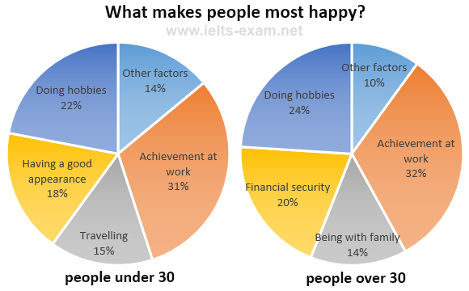

Overview
- Achievement at work sector :the largest proportion
- Under 30:travel and good looking while over 30: financial security and family
Body 1: achievement, hobbies
- Achievement at work: highest (31, 32%)
- Hobbies : nearly the same (22,24%)
Body 2: 3 nhóm còn lại
- Under 30 travelling 15% while 14% cho family of over 30
- 18% good appearance(under 30) whereas 20% financial security(over 30)
BÀI VIẾT
Given are the pie charts illustrating the outcome of an analysis of enjoyment factors for two separated age groups
Overall, it is obvious that the percentages of work accomplishment dominate in both charts. While the younger decribe going on journeys and physical appearance as reasons for true happiness, the older are pleased with financial security and family gathering.
Regarding the similar patterns in under 30 and over 30 age groups, the percentages of work achievement comprise more than a third of the total, followed by the figures for hobbies sectors, at 22% and 24% respectively. In addition, other factors in age groups have nearly the same proportions, with 14% and 10% for people aged under 30 and over 30 in that order.
Moving onto other happiness factors, 15% of residents in under 30 group considering travelling as pleasure while the same pattern can be seen for being with family in over 30 groups. Additionally, the figure for good appearance of younger citizens accounts for 18%; meanwhile, 20% remaining of enjoyment reasons in over 30 group is financial security.

  - Overall:
    - “Achievement at work“sector has the highest proportion of happiness in the both age groups (IELTS TUTOR gợi ý cách diễn đạt khác: there are two major factors that influence common people happiness, those are achievement at work and doing hobbies HOẶC: The most enjoyable factors that make people happy are the achievement at work)
    - People who just under 30 feels happy if they can travel and have a good looking while people who over 30 tend to satisfy with their life when they gather with their family and have financial security (IELTS TUTOR gợi ý cách diễn đạt khác: younger people and older ones show diverse proportion for other aspects including having a good appearance and financial security)>> IELTS TUTOR hướng dẫn PHÂN TÍCH ĐỀ THI 30/5/2020 IELTS WRITING TASK 2 (kèm bài sửa HS đạt 6.5)
  - Body 1: Viết về điểm tương đồng
    - For both younger and older people, the highest percentage says that achievement at work brings them most happiness (nêu số liệu) (IELTS TUTOR gợi ý cách diễn đạt khác: Both age group under and over 30 years old argue that work achievement accounts for 31 and 32% on making them happy)
    - Doing hobbies is also a noticiable factor triggering delighted feeling for both age groups mentioned with 22% and 24% respectively (IELTS TUTOR gợi ý cách diễn đạt khác: Following this is doing hobbies that have 22% impact of happiness factors on younger people and 24% on older people)
  - Body 2: Viết về điểm khác biệt
    - Different reason comes from having a good appearance which has 18 percent effects on the happiness of people aged 30 years old (IELTS TUTOR gợi ý cách diễn đạt khác: Many younger people regard having a good appearance as extremely important: (18%))
    - This is almost same proportion for financial security that affects 20 percent enjoyment of people over 30 years old.
    - The other interesting aspects are traveling and being with family that make 15 percent gladness for cohort below 30 years old and 14 percent for another cohort.>> IELTS TUTOR hướng dẫn Cách diễn đạt "xuất phát từ, dựa vào"
  - Hoặc có thể chia bố cục theo:
    - Body 1: Viết về people under 30
    - Body 2: Viết về people over 30
  - IELTS TUTOR lưu ý:
    - Khi cộng số liệu của mỗi pie sẽ ra tổng là 100% vậy nên nếu ghi This is followed by 15% who states that travel brings them happiness hoặc 20% of older people reports that having financial security is most important to their happiness, and 14% says they feel most happy when they are with their family là hoàn toàn sai vì không phải 20% người nói mà là doing hobbies chiếm 22% trong tổng số factor làm người ta happy >> IELTS TUTOR hướng dẫn Sửa bài IELTS SPEAKING PART 1-2-3 topic Work/Study(Sửa & Làm lại 4 lần - HS đạt 7.5)

