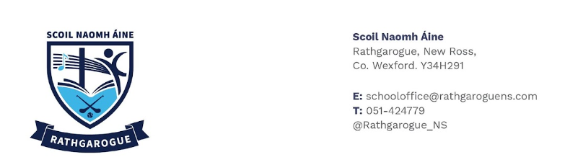

6th class
2025-2026

The Department of Education is funding the purchase of all school books under the Schools Book Grant. Your child’s school books will be purchased by the school.

Please provide your child with the following stationery for September:

- A4 Pad-Lined
- A4 protective plastic display folder (40 page)
- Ruler (30cm), rubber, colours, sharpener
- Student Solutions Compass with Lead
- Student Solutions Protractor,
- Music folder and D tin whistle
- Pritt stick x 3, red pens,pencils.
- Colours - Twistables, colouring pencils or markers
- A4 White board x1 and whiteboard marker x6
- Basic Calculator (Non scientific)
- Scissors
- Headphones (in ear that can be easily stored in schoolbag)
- Ziplock mesh folder x 3
- Scrapbook (360mm X 240mm)

Please label all items.

Other:
Art/Craft/Photocopying €30.00

To be paid in mid September

