Link Đề bài: https://www.ieltstutor.me/blog/ielts-speaking-describe-a-place

Transcript Bài Nói Part 1 (Từng câu hỏi bắt buộc phải có Takescript)

Hình Take note của Part 2:
Test 1

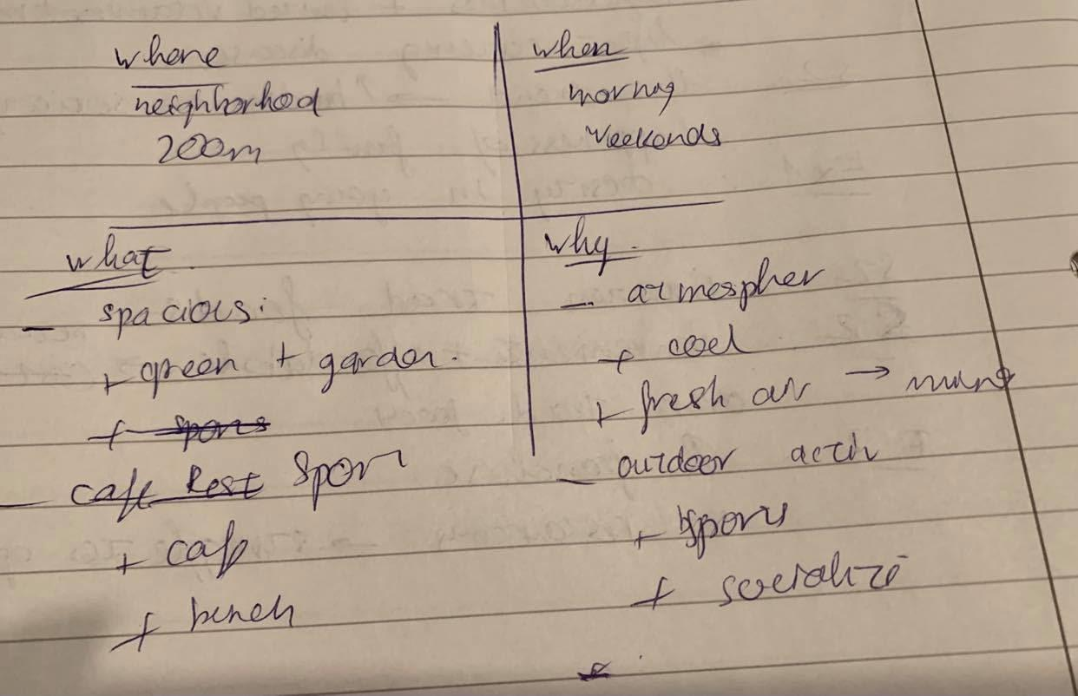
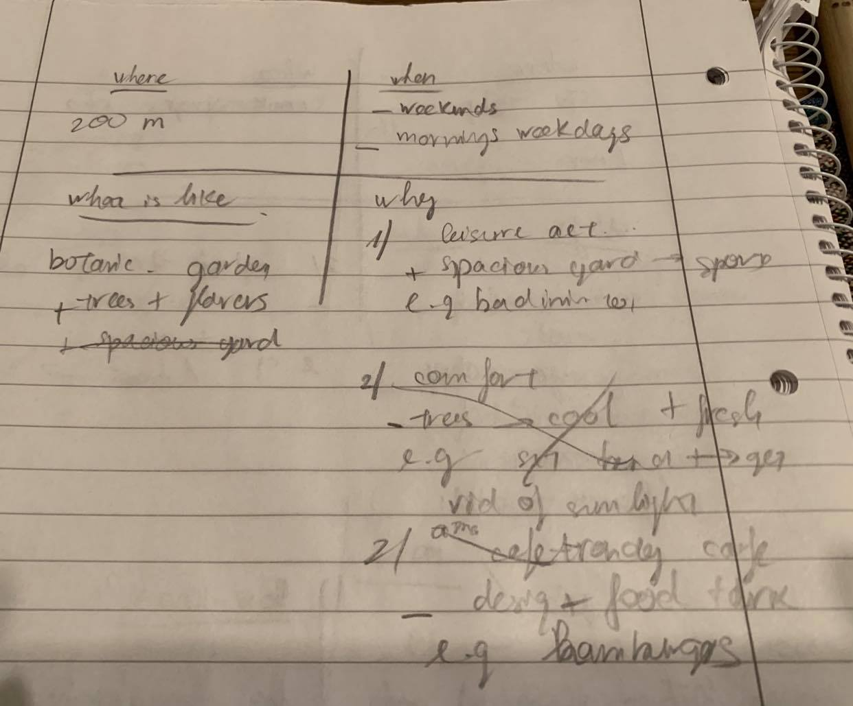

Test 2
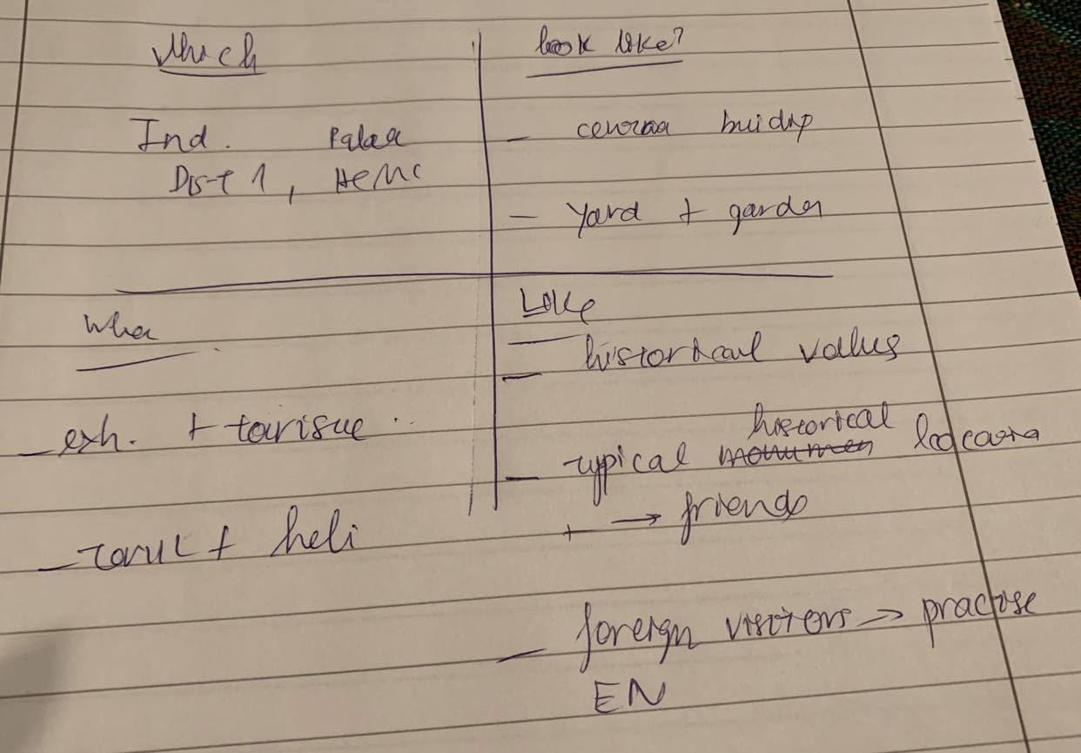

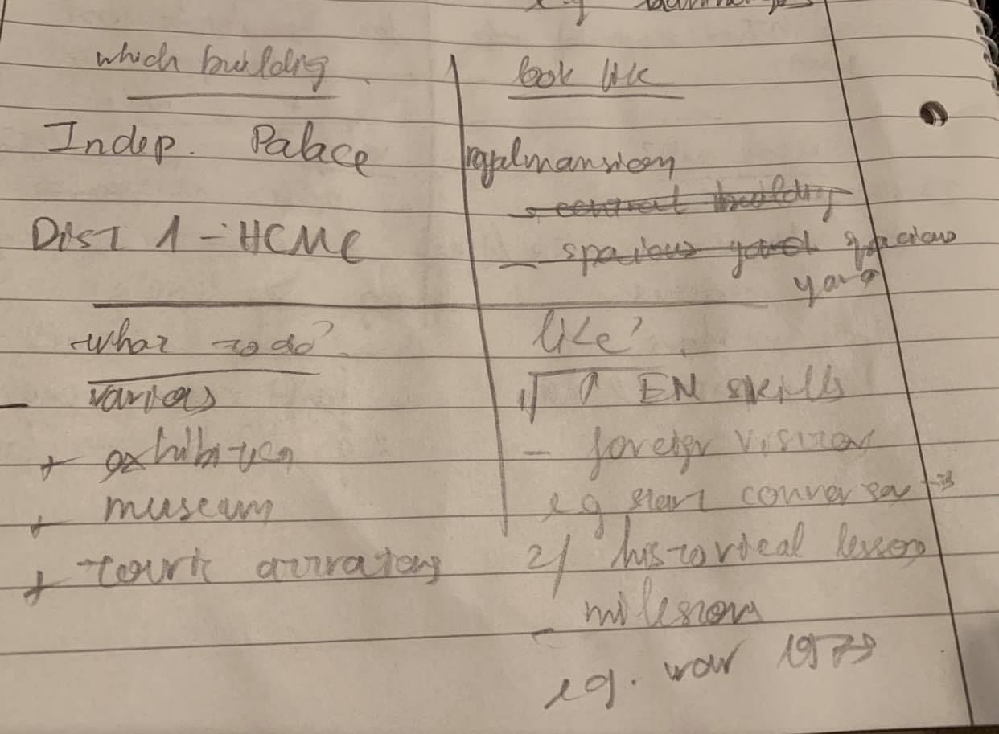

Test 3
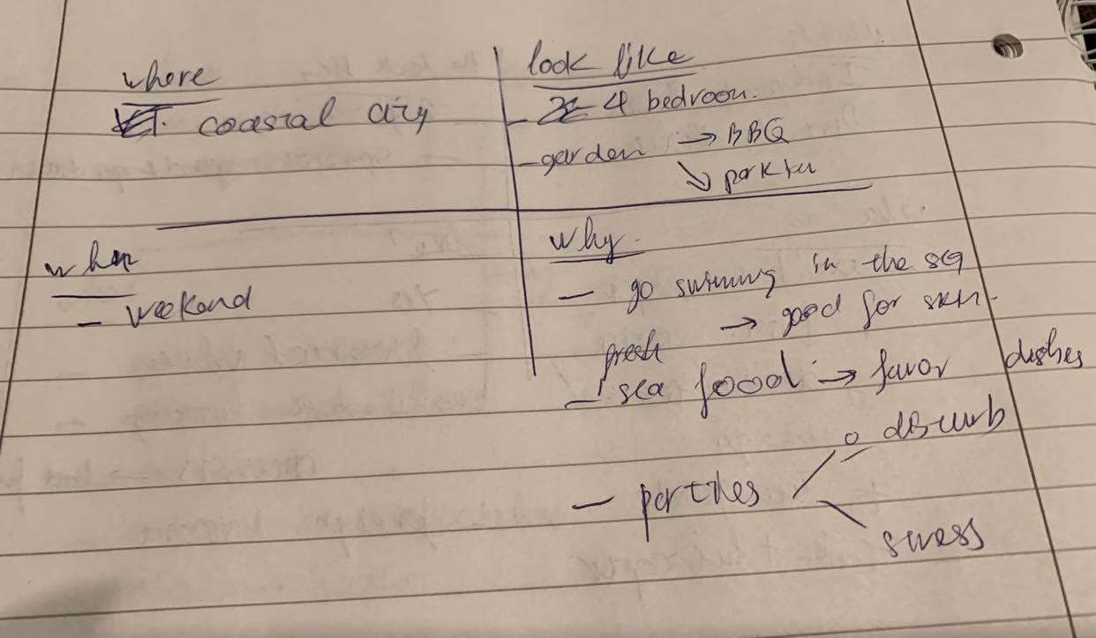

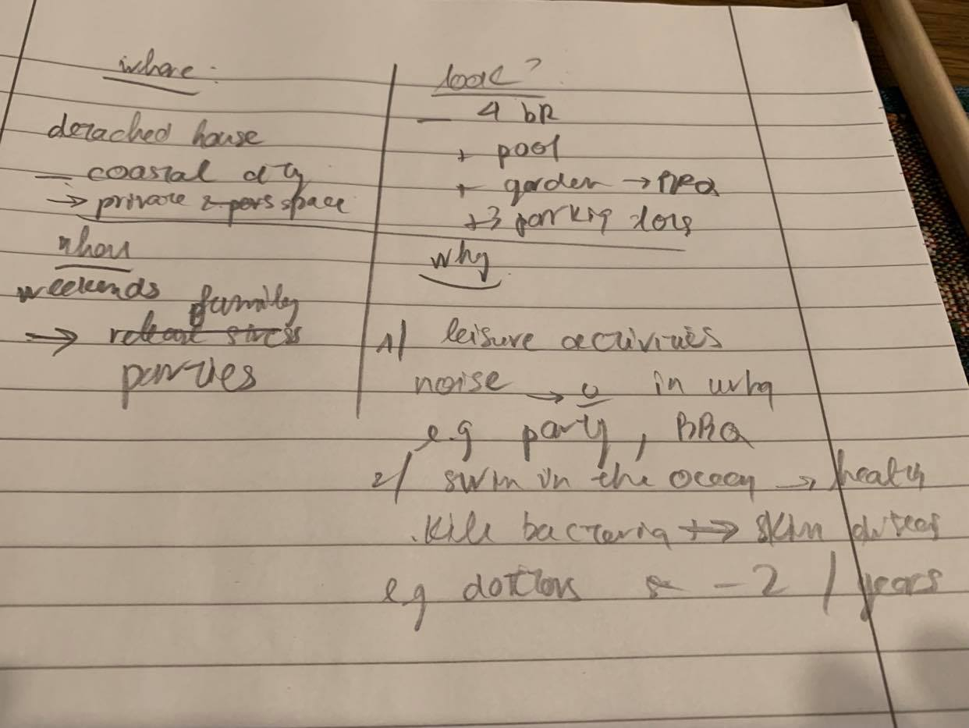

Transcript Bài Nói Part 2 (Sắp xếp theo từng câu hỏi của đề)
Ví dụ:
https://www.ieltstutor.me/blog/ielts-speaking-describe-a-place-building Đọc hướng dẫn làm đề này để có template va từ vựng nha
https://www.ieltstutor.me/blog/ielts-speaking-part-2 Đọc hướng dẫn chung cho part 2 nhé.
Test 1:
ĐỀ 1: Describe a park / garden you like visiting (Em cũng có thể dùng đề này để trả lời cho Describe a newly built facility (such as parks, cinemas... that influencers your city)

Describe a park/garden you like visiting

You should say
- Where the park is
- When you visited it
- What the park is like
- And explain why you like visiting it
Lan 1
- Where the park is
The park I’m going to talk about is approximately 200 meters away from my house and is located in my neighborhood.
- When you visited it
Speaking of frequency, I usually go there in the morning to do exercise or at weekends. -> mở rộng thêm supporting idea cho câu này nha.
- What the park is like
The park, in general, is very spacious and is divided into two areas.
In the first one, there are many trees and flowers which is mainly used for exhibition purposes.
In the remaining area, people and visitors are allowed to play sports, and there is a big café for them to take a rest and have meals after they do exercise.-> phần này chỉ cần 2 dòng đủ giải thích rồi, không nên kể dài quá
- And explain why you like visiting it
There are several reasons why I enjoy visiting this park.
Firstly, the atmosphere in the park is always comfortable because the temperature is very cool and the air is very fresh.
It is my favorite way to go to the park to refresh my mind after working days.-> nên bổ sung 1 ví dụ cho việc này
Secondly, I can do a lot of outdoor activities in the park. For example, I usually go to the park with my elder brother to play badminton every Saturday. Thiếu từ nối In my leisure time, I invite my friends to hang out with me in the café and it is very convenient because there are a lot of delicious foods and drink there.

lan 2:
Oke hơn về task response, nên tập dần cách sử dụng cấu trúc và từ vựng phức tạp hơn. Từ dùng và cấu trúc hiện đang rất đơn điệu. chủ yếu là câu đơn chủ động, từ vựng dễ -> Để tăng điểm, cần brainstorm từ vựng trước rồi tập đưa vào bài nói
- Where the park is
The park I’m going to talk about is located 200 meters away from my house.
- When you visited it
Regarding to the time that I visit the park, I usually go there in the morning of weekdays to do regular exercise or some times at weekends for some leisure activities.
- What the park is like
Regarding its layout, the park looks like a botanical garden because there are a variety of trees and flowers.-> Nên bổ sung 1 ý giải thích/ ví dụ… hoặc cảm xúc về botanical garden này
- And explain why you like visiting it
There are two main reasons why I'm interested in visiting the park whenever I have free time.
Firstly, the park is very spacious and suitable for a lot of leisure and outdoor activities.-> cần điều chỉnh ngắt nghỉ tốt hơn
the thing is, the park has a spacious yard in which visitors can play badminton or basketball.
For example, I usually go there at weekends with my elder brother to play badminton and have dinner together.
Secondly, there is an amazing cafe in the park where there are a variety of foods and drinks.
Honestly speaking, it has some typical specialties which you cannot find somewhere else. For example, its goat hamburger is my favorite one because it tastes very delicious.

Lan 3:
- Where the park is
The beautiful park I’m going to share with you is located in my neighborhood, which is approximately 200 meters away from my house.
- When you visited it
When it comes to the time that I visited the park, I usually go there in the morning on weekdays or from time to time on weekends mainly to do regular exercise or to hang out with my friends.
- What the park is like
Regarding to its appearance, the park looks like a botanical garden for the reason that there are variety of trees and flowers, which make minds feel peaceful and relaxing whenever I go there.
- And explain why you like visiting it
The park is my favorite destination for several reasons.
Firstly, it plays a vital role in the local residents’ lives because it offers a spacious place for a wide range of leisure activities. For example, many people go to the park to play sports, read books, walk their dogs, or have their meals in the local coffee shop.
Secondly, the park has an attractive location, which makes it like an oasis in the middle of the city. More specifically, the park is surrounded by many skyscrapers and residential houses. Therefore, the park becomes an ideal place for the local residents to spend their leisure time breathing fresh air and hanging out with their friends.

Có tiến bộ! Nghe mạch lạc và bớt ngắc ngứ hơn nhiều rồi nha

Lan 4:
Where the park is
The beautiful park I’m going to share with you is located in my neighborhood, which is approximately 200 meters away from my house.

When you visited it
When it comes to the time that I visited the park, I usually go there in the morning on weekdays or from time to time on weekends mainly to do regular exercise or to hang out with my friends.

What the park is like
Regarding its appearance, the park looks like a botanical garden for the reason that there are a variety of trees and flowers, which make my mind feel peaceful and relaxing whenever I go there.

And explain why you like visiting it
The park is my favorite destination for two reasons.
Firstly, it plays a vital role in the local residents’ lives because it offers a spacious place for a wide range of leisure activities. For example, many people go to the park to play sports, read books, walk their dogs, or have their meals in the local coffee shop.
Secondly, the park has an attractive location, which makes it like an oasis in the middle of the city. More specifically, the park is surrounded by many skyscrapers and residential houses. Therefore, the park becomes an ideal place for the local residents to spend their leisure time breathing fresh air and hanging out with their friends.

Test 2:
ĐỀ 2: Describe a historical building you have been to

Describe a historical building in your area

You should say:

Which the building is

How it looks like

What people do there

And also say whether you like this building or not

Lan 1
- Which the building is
The historical that I’m going to talk about is the Independent Palace which is located in District 1 in HCMC.
- How it looks like
Speaking of the layout, the palace is divided in two areas: the central building and the outside yard.
On the yard, there are some war models like a tank and a helicopter. Nếu đã liệt kê ra 2 cái rồi thì nên nói 1 chút về inside nữa
- What people do there
The palace has been used for exhibition and touristic purposes so far. Thiếu từ nối, tham khảo cách dùng từ nối nhé. Ở đây ý sau có ý bổ sung 1 ý nữa cho mục đích câu này có thể dùng in addition,...https://www.ieltstutor.me/blog/linking-words
The local authorities organize exhibitions, events and celebrations in the palace every year.
- And also say whether you like this building or not
I’m personally in favor of this historical location because of several reasons.
First of all, I treasure the historical information which we can find in this palace.
When I was in high school, I used to go there every weekends to read the stories about the war in 1975.
Secondly, the palace represents a historical icon in Vietnam, which I usually introduce to my friends and ask them to add to their bucking list if they have a chance to visit HCMC. => nên giải thích thêm vì sao nó là historical icon in Vietnam như thế nào ở đây. nên nhớ các câu sau có chức năng tập trung chứng minh câu trước nha

lan 2:

- Which the building is
The historical building that I'm going to talk about is the Independent Palace, which is located in district 1 in HCMC.
- How it looks like
Speaking of its appearance, it looks like a royal mansion because it has a central building with a spacious yard in which many tanks and helicopters are exhibited.
- What people do there
When it comes to the activities in the palace, it is used for the various purposes by the local government.
More specifically, the main function of the palace is for exhibitions and tourist attractions. However, in some special occasions, local authorities can use it as a place to organize some special events like trade fairs or some festivals.
- And also say whether you like this building or not
well, there are two main reasons why I’m interested in visiting it in my leisure time.
Firstly, it offers me a good way to improve my english skills. In fact, there are a lot of foreign visitors in the building, so I can easily start a conversation with them by asking about their experience and their thinking about the palace and HCMC.
Secondly, I have never bored by the by historical lessons and information in the palace. Honestly speaking, I’m passionate about the historical information about the Vietnamese wars, so i spent a lot of time visiting the palace and reading the materials there. For example, I’m particularly interested in the water in 1975 against the American empire.

Lan 3:
Which the building is
The historical building that I'm going to share with you is the Independent Place, which is located in District 1 in HCMC.
How it looks like
When it comes to its appearance, the building looks like a mansion with two main structures: the central building and a spacious yard in which several tanks and helicopters are exhibited.
What people do there
Regarding to the activities that people can do here, the palace is used mainly as a tourist attraction. Furthermore, in some cases, local authorities also used this palace to organize some festivals.
And also say whether you like this building or not
Finally, there are several reasons why this palace is my favorite destination in my leisure time.
Firstly, the palace offers plenty of historical values and images which I cannot find in other places.
The thing is, in the palace, there are a variety of samples, photos, documents, and videos about the previous history wars against the French colonist and the American Empire. For example, I used to go to the palace every weekend to read the materials there.
Secondly, it is a good place for me to improve my English skills. The thing is, there are a lot of visitors, mainly foreigners, in the palace, and most of them can speak English very fluently. As a result, I usually go there to make friends with foreigners, and in some cases, I volunteered to be their tour guide to introduce to them about the stories in the palace.

Lan 4:
Which the building is
The historical building that I'm going to share with you is the Independent Place, which is located in District 1 in HCMC.
How it looks like
When it comes to its appearance, the building looks like a mansion with two main structures: the central building and a spacious yard in which several tanks and helicopters are exhibited.
What people do there
Regarding the activities that people can do there, the palace is mainly used as a tourist attraction. Furthermore, in some cases, local authorities also use this palace to organize some festivals.
And also say whether you like this building or not
Personally, there are several reasons why this palace is my favorite destination in my leisure time.
Firstly, the palace offers plenty of historical values and images which can’t be found in other places.
Indeed, in the palace, there are a variety of samples, photos, documents, and videos about the historical wars against the French colonists and the American Empire. For example, I used to go to the palace every weekend to read the materials there.
Secondly, it is an incredible place for me to improve my English skills. In fact, there are plenty of foreign visitors, especially English-speaking ones, in the palace. As a result, I usually go there to make friends with foreigners, and \I volunteered to become their tour guide to introduce the stories in the palace to them.

ĐỀ 3: Describe an ideal house

Describe your ideal house

You should say:

where it is
what it looks like
when you would like to live in
And explain why you would like to live in it
Intro đâu
- where it is
If I can purchase a house in the future, I will buy a detached house in a coastal city.
- what it looks like
regarding to the size and the layout, I prefer a four-bed room house with a big garden where I can park my can and organize a BBQ party
- when you would like to live in
talking about when I live in that house, I want to go there every weekend with my family to enjoy the personal and private time.=>nên bổ sung ý mở rộng cho câu này. Ở đây mới trả lời là weekend, có thể nói vì sao? cảm giác như thế nào
- And explain why you would like to live in it
There are several reasons why I prefer that type of house.
Firstly, I can go to swim in the sea water whenever I want and I think it will be good for my skin and my health. => thêm 1 ý giải thích/ ví dụ cho ý này
Secondly, I can eat sea food everyday because sea food is one of my favorite dishes. -> seafood là hải sản. Không phải 1 món ăn cụ thể nào để gọi là dish được
Finally, I can organize a party with my family and my friends without worrying about disturbing other neighbors. This is one of my favorite ways to release the stress after busy working days.
=> Chỉ nên dừng lại ở 2 ý thôi nhé. Nên tập trung làm rõ các ý trên sẽ khiến bài sâu hơn

Yêu cầu là 2p Bài này nói có 1:40

- where it is
The ideal house that I want to share with you is a detached house in a coastal city because I want to have private space for myself and my family.

- what it looks like
when it comes to its appearance, the house should have 4 bedrooms, a big swimming pool, a spacious garden and at least 3 parking lots.

- when you would like to live in
Speaking of the time that I want to visit the house, I want to go there every weekend with my family because we can organize the bbq parties.

- And explain why you would like to live in it
There are two main reasons why I’m interested in that kind of house.
Firstly, my family and I can do a lot of leisure activities without worrying about the neighbors.
the thing is, we cannot do many things in the big city because we can cause a lot of noise or pollution which brings inconvenience to our neighbors. For example, I can organize a party with loud music or a barbecue party in this house.
Secondly, because the house is located in the coastal city, I can go to swim whenever I want. In fact, swimming in the seawater is very good for my health and my skin because it helps kill the bacteria and prevent many skin-related diseases. For example, I used to visit the doctors and they all advised me to go the beach twice a year to improve the health.

Lan 3:
where it is
The ideal house I’m going to share with you is a detached house in Vung Tau, which is a coastal city and is located approximately 100 km away from HCM.
what it looks like
When it comes to its appearance, the house should have 4 bedrooms, a spacious garden to organize a barbeque party, and at least 4 parking lots in case I want to invite some friends to enjoy with me.
when you would like to live in
Regarding to the time I want to visit the house, I want to go there on weekends when I have a lot of leisure time.
And explain why you would like to live in it
Finally, there are several reasons this is my ideal house.
Firstly, it offers a lot of private space for my hobbies which are inconvenient in city areas.
More specifically, I cannot do a lot of activities because it may disturb my neighbors.
For example, when I am in a private house, I can sing karaoke or listen to loud music without worrying about disturbing other people.
Secondly, I’m interested in a house in a coastal city because I can enjoy the fresh air there.
The thing is, the air in big cities is usually polluted by the heavy loads of traffic.
Therefore, I want to have a house in Vung Tau so that I can enjoy the air when I walk on the beaches, which is beneficial to maintain a good physical and mental health.

Lan 4:
Where it is
The ideal house I’m going to share with you is a detached house in Vung Tau, which is a coastal city and is located approximately 100 km away from HCM.
What it looks like
When it comes to its appearance, the house should have 4 bedrooms, a spacious garden to organize a barbeque party, and at least 4 parking lots in case I want to invite some friends to enjoy with me.
When you would like to live in
Regarding the time I want to visit the house, I want to go there on weekends when I have a lot of leisure time.
And explain why you would like to live in it
Personally, there are several reasons why this is my ideal house.
Firstly, it offers a lot of private space for my hobbies which are inconvenient in city areas.
For example, when I am in a private house, I can sing karaoke or listen to loud music without worrying about disturbing other people.
Secondly, I’m interested in a house in a coastal city because I can enjoy the fresh air there.
Indeed, the air in big cities is usually polluted by the heavy loads of traffic.
Therefore, I want to have a house in Vung Tau so that I can enjoy the air when I walk on the beaches, which is beneficial to maintain a good physical and mental health.

Transcript Bài Nói Part 3 (Từng câu hỏi bắt buộc phải có Takescript)

