FILOMENA CAMPUS QUARTET
THEATRALIA

Lyrics, translations, and notes on the songs

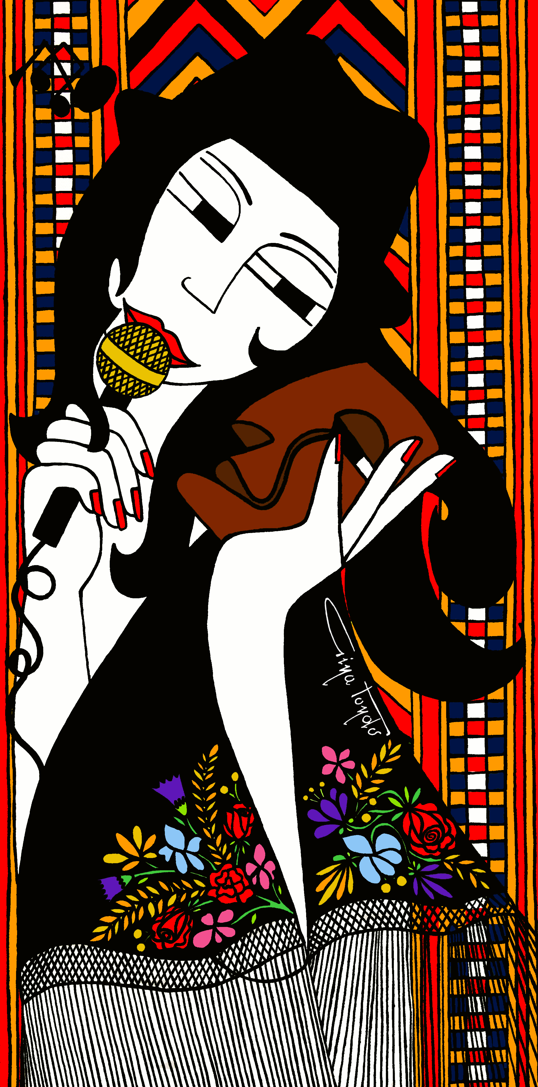

E Mi Drommia

Hush sweet flower
She sang gold notes
Ancient fables
Rocking in her arms
I fell asleep and dreamt of
Magic fairies in the moonlight
Dance in circle, race cane horses
Golden bridles, run free and wild
Free to fly strong as wind
In my blood centuries
Struggle! Power! Silent spell / Speak up now!
Find your voice and don’t look back
Now I got your strength
And all your past lives in me
Jaja mi contaiat ch’esistian
In Monte ‘Oe in su tempus da ‘ora
fadas bellas che sole in s’aurora
ch’in nott’ ‘e luna a dillu ballaian
“Drommidi però fiza ‘e su coro”,
mi narait cun dultzes ninnadas:
“si tue drommis falan cussas fadas
cun caddittos de canna in briglias d’oro!”
Bonu-‘onu drommìa, mi drommìa
sonniende s’incantu ‘e cussu monte
in sa notte de luna beneitta.
Tando in su sonnu, a boltas, bisaìa,
sos basittos issoro in custa fronte
e su caddittu ‘e canna in sa cabìtta
cun sas fadas ballendemi de fronte

English translation from Sardinian

My grandmother used to tell me that, long ago,
on Monte Oe, there lived
fairies as beautiful as the sun at dawn,
who danced the dillu (Sardinian dance) on moonlit nights.
“Sleep now, daughter of my heart,”
she would say, gently rocking me.
“If you sleep, those fairies will come,
riding little cane horses with golden bridles!”
Obediently, I would surrender to sleep,
dreaming of the enchantment of that mountain
on a magical moonlit night.
And sometimes, in my sleep, I imagined
their kisses upon my forehead,
a little cane horse beside my pillow,
and the fairies dancing before my eyes.

About the song
Written over Steve Lodder’s music, E Mi Drommia grew from ‘…E mi drommia!’, a poem by the late Sardinian poet Antonio Maria Pinna that I discovered in Il Ballo con le Janas, a beautiful book by my dear friend Tonino Oppes (T. Oppes, Il ballo con le janas. Cagliari: Domus de Janas, 2015). I began singing some of Pinna’s words over Steve’s music, and gradually a new melody emerged on Steve’s harmonies, woven through the sounds and rhythms of the Sardinian language.
In adapting the poem, I brought some of my own childhood memories into it. In Pinna’s original, it is his grandfather who tells him stories of the Janas; I changed this to my grandmother, who really did tell me ancient fables as she rocked me in her arms while I fell asleep when I was a child.
I also changed Pinna’s beautiful “lizu ’e su coro” — “flower of my heart” — to “fiza ’e su coro”, “daughter of my heart”, an expression my grandmother often used. These small changes made the poem intimately connected to my own memories and to the women who came before me.
The song has therefore become a kind of feminist manifesto for me: a reflection on female genealogy, connected to the Janas, the legendary fairies of Sardinian tradition. The strength of those women travels across generations, from grandmothers to mothers and granddaughters, from ancient stories to the present: find your voice and do not look back, their past lives live in you.

The original poem
…E mi drommia! By Antonio Maria Pinna

Jaju, mi contaiat ch’esistian
In Monte ‘Oe in su tempus da ‘ora
fadas bellas che sole in s’aurora
ch’in nott’ ‘e luna a dillu ballaian
“Drommidi però lizu ‘e su coro”,
mi narait cun dultzes ninnadas:
“si tue drommis falan cussas fadas
cun caddittos de canna in briglias d’oro!”
Bonu-‘onu drommìa, mi drommìa
sonniende s’incantu ‘e cussu monte
in sa notte de luna beneitta.
Tando in su sonnu, a boltas, bisaìa,
sos basittos issoro in custa fronte
e su caddittu ‘e canna in sa cabìtta
cun sas fadas ballendemi de fronte

(T. Oppes, Il Ballo con le Janas. Cagliari: Domus de Janas, 2015).

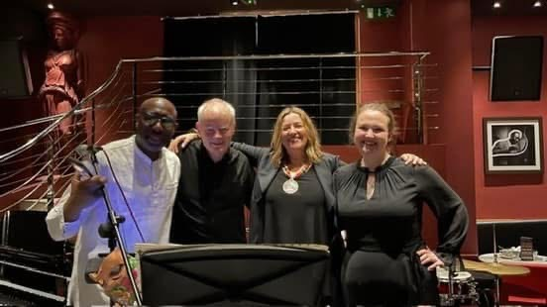

Evergreen

Evergreen the silence watches me
Playing alone its charming melodies
Noise inside hides peace far from my mind
Winter’s gone but spring is still away
I’m calling loud, life to be reborn

About the song
In September 2001, only a few days before moving to London, I recorded a project in Cagliari, Sardinia, with a jazz quintet I had been collaborating with. I wrote these words to music by the late Sardinian guitarist and composer Massimo Ferra, who later recorded the original composition as “Green”.
It was a difficult and transformative moment in my life. I knew that I needed a change, and that leaving Sardinia to begin a new life in London was part of it. “Evergreen” carries that mixture of uncertainty and hope: winter not quite over, spring not yet here, and the desire for life to begin again.

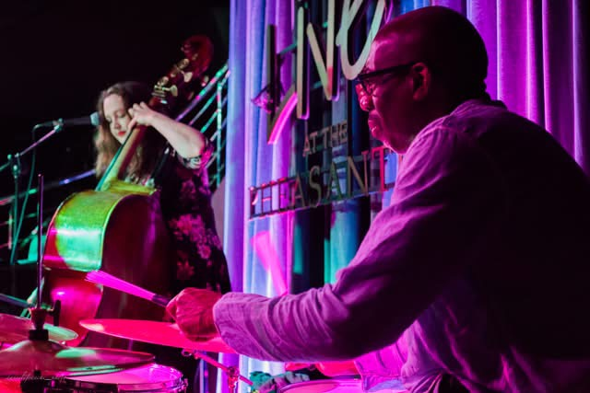

Shanghai to Nanjing

On the way to the temple
Holding hands as kids on their first trip
It’s so easy to feel at home, even thousands of miles away
Notes of incense burning, smell of prayers rising
All around like empty ghosts
Eyes glued to Blade Runner’s screens flow and fill the streets
Voices on loudspeakers on
Walking fast to Nanjing Lake, people smile as we try to avoid
all the anarchic bikers in town as we cross like clumsy clowns
Trying to find our way out to the Purple Mountain
But all around like empty ghosts
Eyes glued to Blade Runner’s screens
flow and fill the streets
Voices on loudspeakers on

About the song
I wrote these words literally on a train from Shanghai to Nanjing. I was fascinated by everything around me, but also struck, and a little disturbed, by how many people seemed unable to take their eyes from their mobile phones, even while walking through stations or getting off trains. The song became a playful but uneasy reflection on technology, consumerism and disconnection, searching for the increasingly hidden spirituality of this beautiful place.

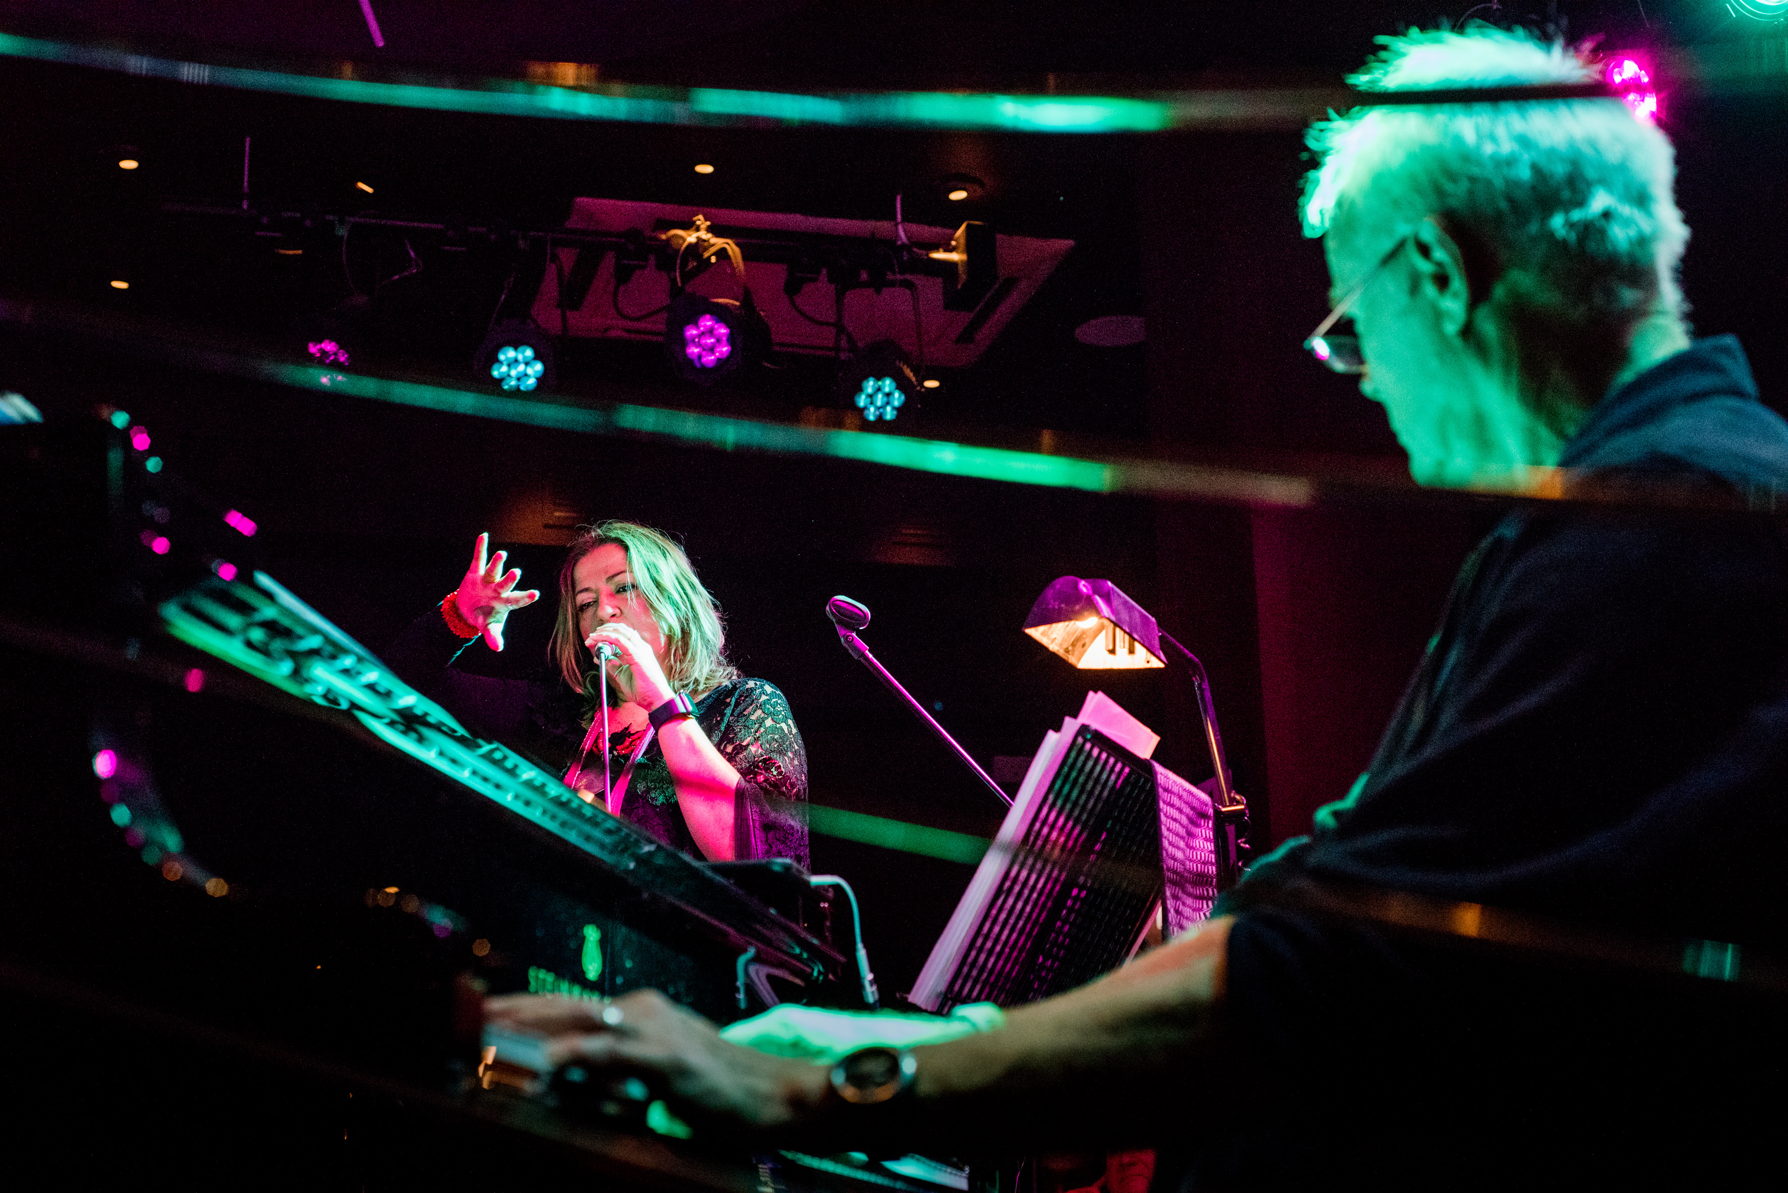

Song of a Siren

Su mari è altu e contene
muntagne e nimbi e barrancos ca la terra nun tiene
Su mari è mannu, doppu nu mari altro mari e altro mari appari
Su mari cagna culuri pote essere nieddu come sangue rapprisu,
o trasparente come il Cielo
Su mari cagna umori pote ridere o minacciare
Su mari cagna palabras e soni, pote parlari co murmuriu amicu
o sciacca de ninna nenna,
chiano chiano o con gridu barrosu irosu zrasos zalatta pelagos
che calma e inquieta, che culla e schianta
Su mari è matre, su mari è bestia manna, su mari è padroni.
Non vedrò mai la fine del mare ma lui vedrà la mia.
Portami a casa, dio specchiato in cielo e cielo specchiato in dio,
guidami poiché io sono sospesa sulla tua grande mano d’acqua.
Amigu meu Fratello germano mare
(From “Sagrademari”, a poem by Stefano Benni)
I will never see the sea’s end
But I know it will see mine
Take me home God mirrored in the sky
Or sky, guide me now
Suspended in your water hand I see past and future
The logos’ sacrifice
Irresistible vibration that will give you
Pleasure of hearing
Dangerous feeling
The song of a siren

About the song
In 2022 I invited Italian philosopher Adriana Cavarero to London for a talk about vocality. Her reflections on the voice of the Sirens, subsequently developed in her book Il canto delle sirene, profoundly resonated with my own research and practice.
Written on the music composed by Charlie Pyne, the song opens with an extract from Stefano Benni’s Sagrademari, the story of an Odysseus–Sinbad figure lost at sea, written in an invented language blending different sounds and voices of the Mediterranean. This connection to the sea and Odysseus leads naturally to the Sirens and to Cavarero’s re-reading of their myth. She challenges the way Western philosophical tradition privileges logos, reason and semantic meaning, while marginalising the human voice and, in particular, casting female vocality as seductive, irrational or dangerous. Her Sirens are not singing to seduce men: they sing for their own pleasure. For Cavarero, “the voice manifests the unique being of each human being.” Her concept of pluriphony brings unique voices together without erasing their individuality: like the Sirens, they sing with one another, each voice distinct within a shared plurality. I love this idea, and I hear something of it in the way Charlie Pyne and I sing together in this song and throughout the album: our voices meet, intertwine and improvise, while remaining distinctly our own.

SHE

She said I don’t have a home
And she ran to the shore
Her bags full of empty sounds
Too heavy to lift alone
She spoke words of flesh and stone
They can laugh, burn, and dance
Send your prayers to the sea
The wind will carry them on
Don’t look back
The waves will lull you to sleep
Ready to
But distance tears you apart
Swim in a sea of notes and sounds
Roots and wings
Music is your home
This is your home

Swim in a sea of bones and sounds
Roots and wings
Music is your home
This is your home
Find your way
Hold my hand
Time to go
To let go

About the song
This song is about women and migration. I am a migrant myself, but a privileged one: I was able to move to another country by plane, carrying a passport. I cannot compare that experience with those of women forced to risk their lives at sea, or to endure unimaginable violence and abuse in order to escape the circumstances into which they happened to be born.
Music has often helped me to feel at home, even in darker moments, a sea of notes, roots and wings. But alongside that image is another, unbearable one: the sea of bones and bodies of people abandoned and lost at sea. “SHE” holds those two seas together.

Franca

To Franca Rame.
Featuring Stefano Benni

Many years ago, in a circus I saw a little acrobat girl
On the top of a pyramid of men
And her serious face challenged the audience:
‘It takes courage’, she seemed to say, ‘and laughing is not enough!’
Years later I saw her again, with some sad shadows on her face
She had fallen, sometimes she was hurt
Now she is a great star
She lives in a golden brocade caravan
She has married the King of Clowns
But she hasn’t forgotten the old circus
The odour of the animals
The patient work of the clown Augusto
Of the trapeze artist that practices with her wings every day
And I saw her again on the top of a pyramid of men
And her serious face challenged the audience
‘It takes courage’, she seemed to say
‘To stay here and to laugh is not enough.
But I am only able to make miracles
I don’t have any nest but this one
Because I’d like to tell you about my dreams
I can only fly
I cannot pretend anything but the truth’.

About the song
Theatre artist Franca Rame was a dear friend and a mentor. A huge inspiration to my work both in theatre and jazz. Stefano Benni adored her too and wrote this poem for her seventieth birthday. Stefano and I performed it together with the quartet many times, both in Italy and the UK, and Steve Lodder later set my English translation to music.
While working on this album, we rediscovered a recording from one of our live performances of Italy vs England at the legendary PizzaExpress Jazz Club in Dean Street, Soho. We decided to include a fragment of Stefano’s voice in the track, a tribute to him, to Franca, and to the creative friendship that connected us.

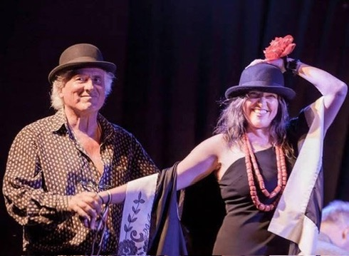

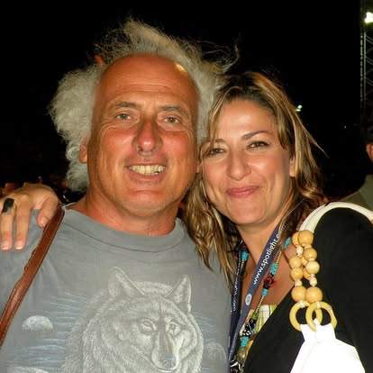

Daughters of Water

Daughters of water
Handmaidens of Persephone
Cursed for your failure
Reduced by the ages to this
Cautionary tale of how an ordinary male
Can be tempted to oblivion
By a woman mysterious and out of control

About the song
I talked to Charlie Pyne about my research into female vocality and the Sirens’ myth and she responded with this gem, writing both music and lyrics. At its heart is an extraordinary solo by Rod Youngs, a moment of breathtaking intensity that holds the audience completely still every time we perform it live.
The song looks beyond the familiar image of the Sirens as dangerous seductresses. In ancient traditions, they were maidens of Persephone, transformed after her abduction into bird-women as punishment for failing to protect her. Charlie’s words, “Cursed for your failure / Reduced by the ages to this / Cautionary tale,” evoke this forgotten history and its transformation into a story of dangerous women tempting men.

This connects once again with Cavarero’s rethinking of the Sirens and her questioning of a Western tradition that has so often treated the female voice as seductive, irrational or dangerous. Daughters of Water turns that cautionary tale around, reclaiming the Sirens as women with voices of their own.

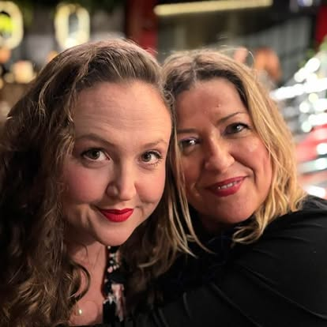

Unsettled (Status)
A love letter to London
I could never explain
How I felt on the night
When you broke up with me
I’m still wondering why
Always thought you were ‘home’
So progressive and bright
A place I could call mine
Now I might say goodbye!
But I do still love you
Your crazy vibe
Though now I have to prove I can
Stay here filling out forms to say
Who what why and where
To show that I care
I’m not going to give up on you.

About the song
This song is a love letter to London. My heart was broken on the night of the Brexit referendum, but I have never stopped loving this gorgeous city, its multicultural, open and creative spirit.
The bureaucratic language of “settled status” became part of an unexpectedly intimate question: when a place has become your home, what does it mean suddenly to be asked to prove that you belong there? Despite everything, this remains a love song.

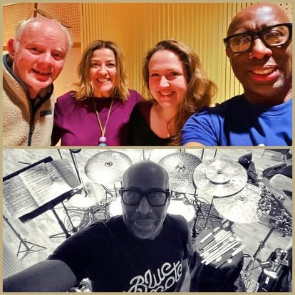

Queen Mab

Vai galoppando nel tuo cocchio di noce
Nei cervelli degli amanti
Nelle idee degli artisti
Sulle labbra di donne
Mai più mute, Mai più sole
Libere
Con un abbraccio le trasformi in regine
Il portamento da vere guerriere
Il tuo trapezio appeso al cielo
Una vita all'improvvisa
Vai come un'onda che avvolge le menti
Mille creature rosse con te cantano Bella Ciao
Con la voce un po' roca, come te
Voce violata, rinata con la rabbia
Un usignolo, un'aquila giullare
Il tuo trapezio appeso al cielo
Una vita all'improvvisa

English translation
Go riding in your walnut chariot
Through the minds of lovers
Through the ideas of artists
Upon the lips of women
Never again silent, never again alone
Free
With an embrace, you turn them into queens
Bearing themselves like true warriors
Your trapeze suspended from the sky
A life improvised
Go like a wave that engulfs the minds
A thousand creatures in red sing Bella Ciao with you
With a voice a little husky, like yours
A violated voice, reborn through rage
A nightingale, a jester eagle
Your trapeze suspended from the sky
A life improvised

About the song

The day Franca Rame died, I could not attend her funeral in person, but I followed it online. I watched something that felt like one of her wishes made real: thousands of women dressed in red singing “Bella Ciao”.
I imagined Rame as a kind of Queen Mab. When Stefano Benni translated Mercutio’s Queen Mab speech from Shakespeare’s Romeo and Juliet, for our project Italy vs England, I immediately thought of Franca: the fairies’ midwife who enters the minds of dreamers. In this song she becomes a force moving through artists and women, acrobat, warrior, improviser, eagle, nightingale, and jester, helping others to free themselves and give birth to their dreams. Like Philomela, transformed into Eliot’s nightingale, Rame turned the violence she endured into a powerful voice of art, truth and resistance.

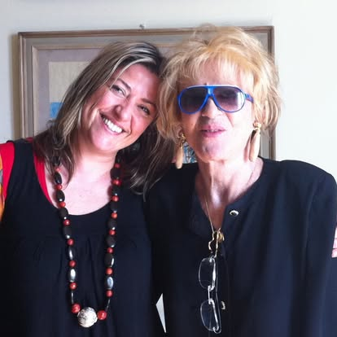

Nightingale

Filling the desert with her deepest voice
And still she cried into dirty ears
Sang water breathing like a shining mermaid
Catching the souls who dared to listen
Jug Jug she sang
Was changed in a bird
Cried till her notes
Flew higher to sing
Flew higher to see

About the song
When I discovered the origin of my name, Filomena, Philomela, through T. S. Eliot’s The Waste Land, the myth became another feminist manifesto for me.
Philomela is raped by Tereus, her sister’s husband, who then cuts out her tongue so that she cannot reveal his crime. The story remains painfully resonant in a world in which femicide and sexual violence are still embedded in patriarchal structures. Yet Philomela refuses silence: she finds another way to tell what happened. In the myth’s transformation, she becomes a nightingale. For me, that transformation is not simply an escape but an image of voice surviving violence, rising, singing and refusing erasure.
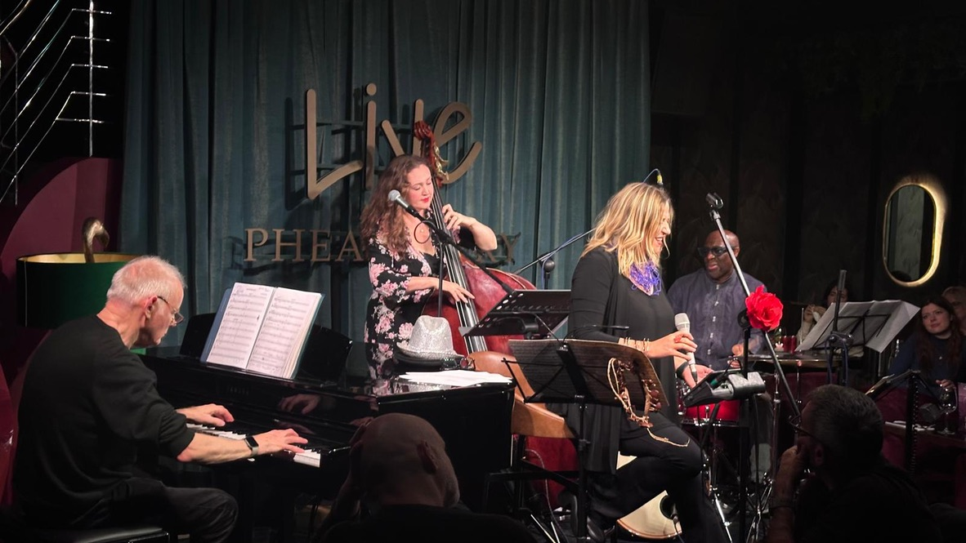

Niki’s Dream

Dedicated to Niki de Saint Phalle
Niki Tiresia Profeta in King Kong
Nel suo giardino di carte lo sa
Fulmine viola che spacca la torre in tre
Rompendo ogni muro di binari pensieri
Mille frammenti, specchi ribelli
Lotta è Donna Vita Libertà
Sola troverai
La Forza
Sole di maggio
Tira la carta
Senza fucile
Lei è qui
Primavera.
Luna.
Donna.
Insorgono le tue Nanas!

English translation
Niki, Tiresias, Prophet in King Kong
In her garden of cards, she knows
A violet lightning bolt splitting the tower in three
Breaking through every wall of binary thought
A thousand fragments, rebellious mirrors
The struggle is Woman, Life, Freedom
Alone you will find
The Strength
May sun
Draw the card
Without a rifle
She is here
Spring.
Moon.
Woman.
Your Nanas are rising up

About the song
Niki’s Dream is dedicated to French American artist Niki de Saint Phalle (1930–2002), whose work challenged conventional representations of women, the body and female creativity. She transformed personal trauma and anger into an exuberant visual language of colour, play and rebellion. Niki de Saint Phalle – video archive
I was particularly inspired by her Nanas, bold, colourful and unapologetically alive female figures celebrating women’s bodies, freedom and power, and by the idea of joy as resistance. Her monumental Tarot Garden (Il Giardino dei Tarocchi) near Capalbio, Tuscany, creates a magical world of sculptures inspired by the Tarot. There is also something strangely prophetic in her work. In King Kong (1962), created decades before 9/11, two aeroplanes appear flying towards New York skyscrapers. In the song, Niki becomes a kind of Tiresias, a prophet reading the signs of a world yet to come.
Her Nanas also made me think of women rising today under the words “Woman, Life, Freedom.”
The lyrics weave together images from her work: the Tower struck by lightning, rebellious fragments and mirrors, and the radical energy of Niki’s early Tirs (Shooting Paintings). But now she no longer needs the gun: “Tira la carta / Senza fucile”: “draw the card, without a rifle”. Her Nanas are rising.

