[Date]

Letter to the Editor
[Insert contact information here]

Dear Editors,

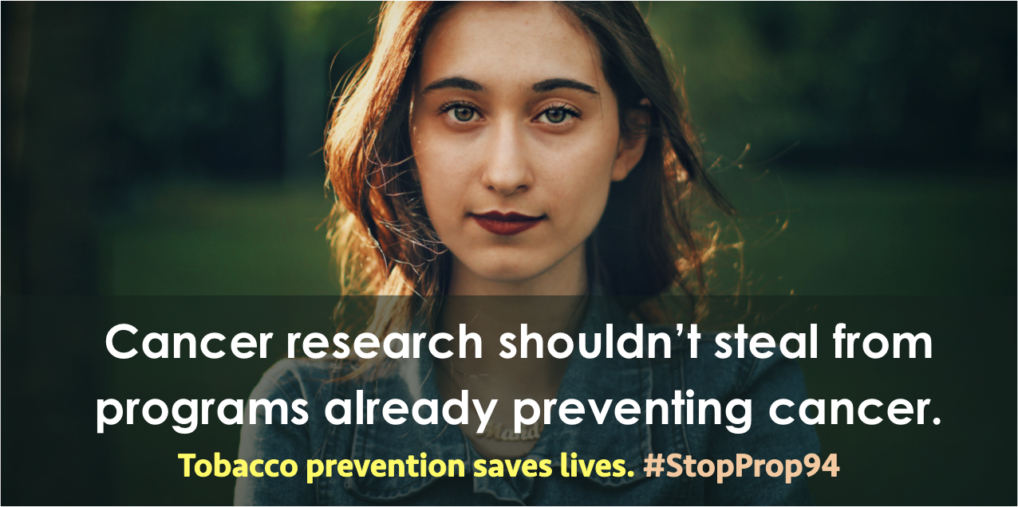
Florida’s tobacco prevention funding is at risk, and so are children. Proposal 94 of the Florida Constitution Revision Commission (CRC) seeks to dismantle our state’s highly successful Tobacco Free Florida Program, shifting money from tobacco control to cancer research. This proposal is shortsighted. Cancer research shouldn’t steal from a program that is already preventing cancer.
The Tobacco Free Florida Program benefits everyone, saving lives and money. According to the Florida Department of Health, from 2006–2016, Florida’s youth smoking rate declined by 71%. Adult smoking rates have also declined, saving our state more than $17 BILLION in smoking-related health care costs. Redirecting program funds would actually increase cancer rates and associated costs for taxpayers.
The Tobacco Free Florida Program follows CDC Best Practices. Cancer research is NOT a best practice for tobacco control programs and should NOT be incorporated into Tobacco Free Florida. The legislature can use tobacco tax dollars for cancer research without impacting the Tobacco Free Florida Prevention Program.
Proposal 94 jeopardizes our success combatting tobacco use, the leading cause of preventable death and disease. The American Cancer Society, American Lung Association, and American Heart Association do NOT support Proposal 94. The Florida CRC Commissioners should be proud of the Tobacco Free Florida program and commit to preserving its success by removing Proposal 94 from consideration immediately.

Sincerely,
[X]
[Title]
[Contact information (phone, email)]

