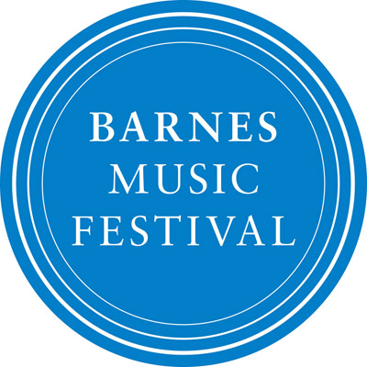

Youth Oliver!
Set in London, Lionel Bart’s Oliver! tells the story of a journey from workhouse to comfort. Oliver Twist escapes a life of slavery for a tumultuous adventure in which he joins the Artful Dodger, Fagin and their mischievous gang of pickpockets. This enjoyment is short-lived as the antagonist Bill Sikes takes his hold.
Ben Parry, Artistic Director of the National Youth Choirs of Great Britain and Assistant Director of Music at King’s College, Cambridge, will lead the assembled choir through full choral arrangements of much-loved songs such as Food glorious food, Who will buy? and Consider Yourself.
Year 4 to 8 and love singing? Dress as a pickpocket and spend the afternoon with Daniel Turner, former Artistic Director and co-founder of the Barnes music festival and acclaimed choral animateur, exploring the songs from Oliver! before joining with the adult chorus, band and soloists for the final rehearsal and performance.

Schedule

13:30 – 14:00 Registration in Kitson Hall
14:00 – 15:30 Children only rehearsal in Kitson Hall
15:30 – 16:00 Tea break (squash and biscuits will be provided)
16:00 – 17:00 General rehearsal (both choirs, soloists and band) in St Mary’s
17:00 – 18:00 Break (please pack a snack if necessary)
18:00 – 19:00 Performance

Registration form

Name of participating child
Name of parent/guardian
Emergency contact details
Email of parent/guardian
Medical notes / dietary requirements

…………………………………………………..
Signature of parent/guardian

Registration fee, which includes refreshments: £5/child, which you can pay under Come & Sing Oliver! on our ticketing site: https://www.ticketsource.co.uk/barnesmusicfestival

And please send the form back to info@barnesmusicfestival.com

