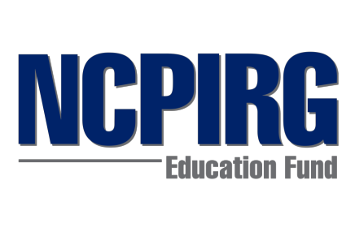 | 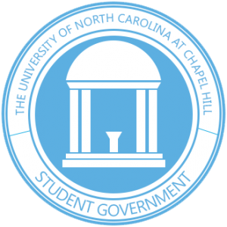

UNC Chapel Hill - 2016 Campus Get out the Vote Plan

This document was developed by:
- Amanda Nunn, NCPIRG Education Fund campaign coordinator for the New Voters Project, UNC Chapel Hill class of 2018
- Wilson Sink, UNC Student Government chair of the State and External Affairs Task Force, UNC Chapel Hill class of 2017
- Taylor Moss, NCPIRG Education Fund campus organizer

Table of Contents:
- Overview
- History
- Goals
- Coalition
- Methods
- Resources
- Anticipated Challenges
- Timeline

1. Overview

NCPIRG Education Fund, the UNC Student Government Association and the Campus Y are partnering together in the Fall 2016 as Tar Heel Votes to mobilize student voters and increase turnout on campus.

2. History

The UNC Student Government Association has been running the Tar Heel Votes project for the last several semesters. Starting in Fall 2015 NCPIRG Education Fund partnered with them to help get out the vote on campus. Together both are working in shared partnership to make sure every student at UNC Chapel Hill has all the information they need to vote, gets registered, and gets out to vote.

Students at UNC Chapel Hill have been faced with confusion when it comes to voting, everything from whether or not ID is required to the on campus early voting site moving on and off campus. Our program seeks to cut through all of this confusion and make sure that as many students as possible get registered to vote and then exercise their vote in fall 2016.

3. Goals

The 3 overarching goals are registration, education, and getting out the vote -- all with the goal of improving student voter turnout.
- 2,400 pledges to vote – We will collect pledges to vote through tabling and class announcements from the start of the fall semester until early voting begins.
- 2,000 registrations – While collecting pledges to vote we’ll also register everyone we talk to that needs to get registered.
- 10,000 GOTV contacts – Starting the week before early voting, we will distribute educational materials on how, when and where to vote; discuss with students their voting plans through face to face interactions all throughout campus; and we will contact students by mailing back pledge cards, via text messages, and by making phone calls.

4. Coalition

UNC Student Government Association, NCPIRG Education Fund, and Democracy North are partnering together to get out the vote on campus as Tar Heel Votes. Additionally, we are working with the Student Union and the Campus YMCA to provide voter resources and host events. We’ll work to expand this coalition to include other campus organizations as well.

5. Methods

- Recruitment
  - Class raps and announcements
  - Listserv email blasts
  - On-campus tabling
  - Dorm move-in tabling
  - Fall fest tabling
  - On-campus events
- Registration & Education
  - On-campus tabling
  - Dorm move-in registration tabling
  - Fall fest registration tabling
  - Campus organization/club outreach registration events
- Get Out the Vote (GOTV)
  - Tabling in the pit
  - Communications
    - Op-eds, LTEs
    - Social media
    - Other media outreach
  - On-campus events

6. Resources

- NCPIRG training resources
- Democracy North Carolina resources
- Student government resources

7. Anticipated Challenges

Some of the main challenges we anticipate for the coming semester are in recruitment, coalition, and organization. In order to make the biggest effect in our community, we want as many hands on deck as possible - so we are going to be challenged to involve as many students as possible in this effort.

NCPIRG Education Fund and the Student Government are still working out how to organize and manage a network of various student organizations and volunteers. We faced these same challenges last semester during the primary election and we made a lot of progress, so we optimistic that we will continue to do so in order to meet our goals for the November election.

Logistically, we are continuing to work to procure an on campus polling location for fall 2016 in the Student Union, but it has proven very difficult due to the amount of people we need to have on board (i.e. the Union Administration, Orange County Board of Elections Office, Department of Public Safety, etc).

8. Timeline

- Aug 20-22: registration of new students at dorm move-in
- Aug 21, 8pm: Fall fest tabling
- Aug 23: First Day of Classes
- Aug 19 begin class raps and organization outreach events
- Aug 27: Orientation training – train team members on recruitment, methods for GOTV, voter education
- Sept - Nov 8: Tabling on campus
- Sept 10: Professional trainings -- train team members on communications, social media, outreach, etc.
- ~Sept 20: NCPIRG Kickoff event -- big recruitment event
- Sept 27: National voter registration day event
- Oct 14: Voter registration Deadline
- Oct 20 - Nov 5: Early Voting
- Nov 8: Election day

