Application Form
Air Quality Challenge
Call for Projects - Indoor Air Quality

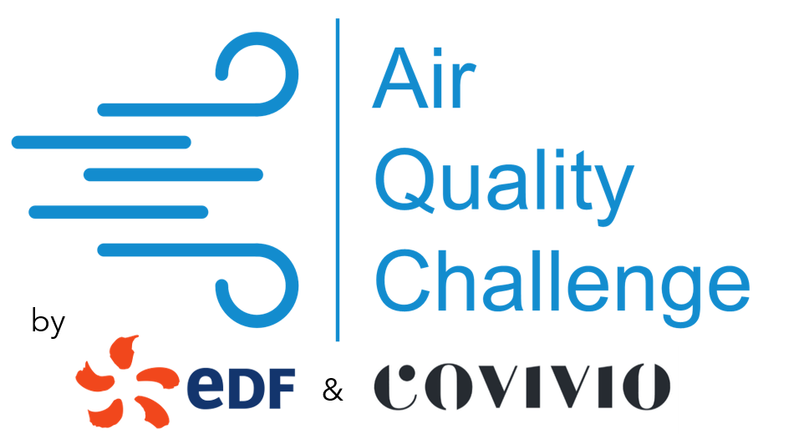

Documents
Once your file has been selected, you will be asked to provide us with the documents justifying your status.
Commitment
The founder certifies on his honour that the information provided in his registration file is true and genuine.
Privacy
The teams of COVIVIO, EDF and Impulse Partners are committed to keeping all information related to the projects confidential.
Impulse Labs Contacts: Astrid Bouchilloux and Benjamin Bodin
astrid.bouchilloux@impulse-partners.com
benjamin.bodin@impulse-partners.com

- Summary sheet
Company Name Creation date

DUNS Number Legal status

Website

Contacts
Phone |  |  |  | Adress
E-mail

Elevator pitch (5 lines)

Names of founders % of capital

Numbers and Forecast
 | 2017  Made | 2018  Made | 2019  Estimated | 2020  Forecast | 2021  Forecast
Turnover (k€)
Net profit (k€)

Amount of financing received or raised (k€)
Funds raised
Grants obtained
Loans obtained

- Your product / solution
Description of the key technology (patents, maturity level, MVP, awards received, etc.)

Description of the solution/product related to the focus and scope described in the call for projects (air quality improvement, IAQ energy efficiency improvement, biomimicry)

Remaining developments, planning and associated risks (roadmap)

What are the main functions of your product? What customer needs does it meet?

Who are your competitors and how is your product better than theirs (barriers to entry, IP)?

- Your market
Do you have any references (POCs) / achievements / customers and commercial references to highlight?

What type of building is your solution targeting? "Office", "Hotel", "Housing" or other?

Who is the target of your product / service (B2B, B2B2C)?

What are your existing / planned distribution channels?

What is the value (in €) of the market you are addressing?

What is your business model?

- Human Resources
Describe the background of each founder

Current team
Total number of employees |  | Of which R&D
 |  | Of which Marketing & Sales
Everyone's role

Expected change in the number of employees
2018 | 2019 | 2020 | 2021

- Value Proposition in the Air Quality Challenge

Why would you want to work with EDF or COVIVIO?

What would you like to experiment on one or more of the organizers' properties?

Estimated cost and time required to conduct the experiment

