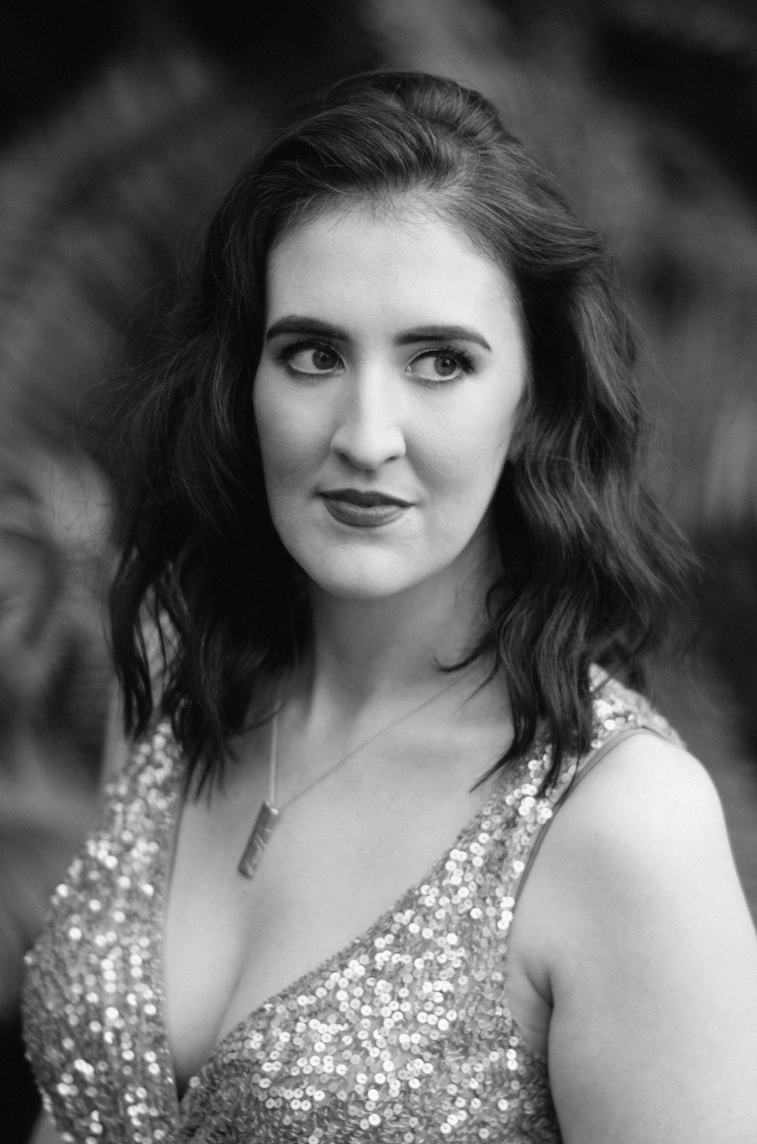
Gemma Ní Bhriain
Mezzo-Soprano

Agent: René Massis
Phone: +33 6 80 57 94 62
+49 160 938 350 13
Email: amo@amo-massis.com

gemmanibhriain@gmail.com
www.gemmanibhriain.com
+353 87 645 8727

Upcoming Engagements:

Recital Drogheda Classical Music Oct ’21
Recital Belfast Music Society Oct ’21
Mother Paper Boat Irish National Opera April ’22
Anna Maria Stuarda Irish National Opera June ’22

Operatic Roles Performed:

La Ciesca Gianni Schicchi BVOF 2021
Maid Marian The Maudlin of Paplewick BVOF 2021
Le Pâtre/La Chouette L’Enfant et les Sortilèges Opéra National de Paris 2020
Enrichetta di Francia I Puritani Opéra National de Paris 2019
Une Pretresse de Diane Hippolyte et Aricie Opernhaus Zürich 2019
Alisa Lucia di Lammermoor Opernhaus Zürich 2019
Niklausse Les Contes d’Hoffmann Irish National Opera 2018
Valletto L’Incoronazione di Poppea Opernhaus Zürich 2018
Ramiro La Finta Giardiniera IOS Zürich 2018
Le Pâtre/Chatte/ L'Écureuil L'Enfant et les sortilèges Opernhaus Zürich 2018
Zweite Dame Die Zauberflöte Opernhaus Zürich 2017
Cléone Médée Opernhaus Zürich 2017
Alisa Lucia Di Lammermoor Opéra National de Paris 2016
Proserpina Orfeo Atelier Lyrique 2016
Dorabella Così fan Tutte Atelier Lyrique 2015
Diane Iphigénie en Tauride Atelier Lyrique 2015
Mercedes Carmen RTÉ Concert Orchestra 2014

Concert/Oratorio Repertoire Performed:

Mezzo-Soprano Songfest (Bernstein) Radio France 2018
Chausson Poème de l’amour et de la mer, Op. 19 National Concert Hall 2015
Barber Dover Beach String Quartet ONP 2014
Elgar Sea Pictures, Op. 37 RIAM Symphony Orchestra 2014
Mozart Requiem RIAM Symphony Orchestra 2014

Teachers: Hedwig Fassbender, Edith Wiens
Coaches: Brenda Hurley, Dearbhla Collins
Born in Dublin, mezzo-soprano Gemma Ní Bhriain graduated in June 2014 with a BA in Music Performance at the Royal Irish Academy of Music where she studied with Dr. Veronica Dunne.
Over the past number of years Gemma has performed various roles in some of the world’s leading opera houses including; Enrichetta di Francia (I Puritani) at Opéra Bastille, Le Pâtre and La Chouette (L’Enfant et les Sortilèges) at Opéra Garnier, Alisa (Lucia di Lammermoor) and Une Pretresse de Diane/Une Matelote/Une Chasseresse (Hippolyte et Aricie) at Opernhaus Zürich.
She also made her concert debuts at Théâtre de Champs-Elysées, Radio France and solo recital debut at Amphitéâtre Bastille, Opéra National de Paris.
This September she returned to stage in Ireland, where she performed for the first time with Blackwater Valley Opera Festival. She performed the role of La Ciesca in Gianni Schicchi.
In 2018 Gemma made her company and role debut with Irish National Opera singing the role of Niklausse in Offenbach’s ‘The Tales of Hoffmann’.
In September 2016, Gemma joined the International Opera Studio of Opernhaus Zürich. During her two seasons as a member of the studio she performed many roles including Cléone (Médée - Charpentier), Le Pâtre, La Chatte and L’Écureuil (l’Enfant et les Sortilèges – Ravel), Zweite Dame (Die Zauberflöte - Mozart), Valletto (L’incornazione di Poppea - Monteverdi) and Ramiro (La Finta Giardiniera - Mozart) to name just a few.
From September 2014 until July 2016, Gemma was a member of the Atelier Lyrique Opera Studio at Opéra National de Paris. During her two seasons in Paris she debuted in five roles, including two world premieres; Dorabella (Così fan tutte – Mozart); Diane (Iphigénie en Tauride – Gluck); Proserpina (Orfeo – Monteverdi); Etienne (Maudits les Innocents - Urquiza, Lembke, Rotella, Alvarado) and Le Garçon (Vol Retour /The Way Back Home – Joanna Lee). She also made her main stage solo debut at Opéra Bastille singing the role of Alisa in Lucia Di Lammermoor (Donizetti).
Previous roles include: Mercedes in Bizet’s Carmen in the National Concert Hall with the RTÉ Concert Orchestra; Jenny's Girl (The Rise and Fall of the City of Mahagonny) with OTC and Rough Magic; Fox (The Cunning Little Vixen) and Florence Pike (Albert Herring) with Royal Irish Acdemy of Music.
Gemma has performed with various orchestras at home and abroad including; L'Orchestre de l'Opéra de Paris, Le Cercle d’Harmonie, Orchestra La Scintilla, RTÉ National Symphony Orchestra, RTÉ Concert Orchestra, Hungarian State Opera Orchestra, Orchestre de Pau Pays de Béarn and Orchestre Victor Hugo Franche-Comté.
In January 2013 Gemma was awarded 4th place and also the Dermot Troy Award for Best Irish Singer and the Dame Joan Sutherland Award for Most Promising Young Singer in the Veronica Dunne International Singing Competition. In the final she sang with the RTÉ National Symphony Orchestra under the baton of Patrik Ringborg. In the same year she also took part in the world renowned Hans Gabor Belvedere Singing Competition in Amsterdam, where she was awarded the Wil Keune Prize for a Young Singer of Real Potential.

