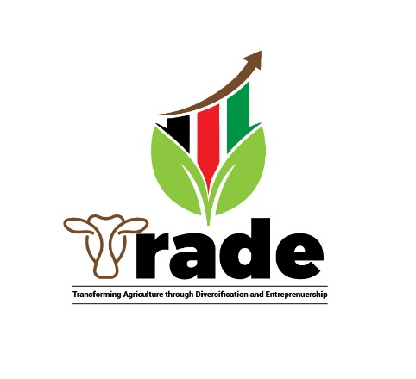

RESPONSES TO QUESTIONS BY SERVICE PROVIDER APPLICANTS

QUESTION | RESPONSE
Do applicants have to cover all 3 components of the TRADE approach, or can focus on Component 1 and 3 only? | All applicants will work within the specified scope of work for a particular value chain. The scope may cover all components but component one has the bigger scope.
Do you have a breakdown of the anticipated minimum targets for each value chain per district or by lot? For example, for Legumes the minimum target is 22,410 farmers, and there are three lots (Kasungu+ Ntchisi; Lilongwe+Dedza; Mchinji) - do you have minimum targets for each lot/district. | The numbers provided cover the entire area covered by a particular value chain. The information being requested will be made available at proposal stage.
Do applicants for Legumes and Oilseeds need to cover both Legumes and Sunflower value chains, or can apply for one only. | The legumes (Soybean and Groundnuts) are going together with sunflower in the areas where the programme is promoting sunflower.
Are applicants expected to cover all EPA and Districts noted in each lot, or can apply for a more focused geographic coverage | Applicants will be required to work in all EPAs under TRADE programme in the districts under a particular lot.
Which evaluation criteria are used - there are different criteria listed in the Terms of Reference compared to the EOI template. | Both are important at different stages. For the EOI stage, the one in EOI form will take lead whilst the one in TORs will take lead at proposal stage.
Do we submit electronically or hard copies, or both – the newspaper add indicated hard copy, while the PDF request for EOI indicates electronic. | Applicants are encouraged to submit through hard copies. However Soft copy submissions will still be accepted.
Lead organisations may only be awarded one lot - but can sub-grantees participate in more than one successful lot | If the applicant would like to go the consortium way, the lead and co-applicant can only be awarded one lot. a co-applicant can only participate in one consortium.
May Lead organisations apply for more than one lot, or should apply just one | Applicant can apply for up to a maximum of 3 lots but can only be awarded one lot upon being successful
Will TRADE make only one award per lot? | TRADE will award only one applicant per lot
Page 5, of the EOI application form states that “Key staff CVs are not required at shortlisting stage”. However, on page 7, CVs for 5 key staff are listed as one of the required attachments and , later in the document, 30 points are allocated to qualifications and experience of key experts. Please clarify if CVs of proposed team members are required at this stage | Submission of CVs for key staff is non optional requirement.

