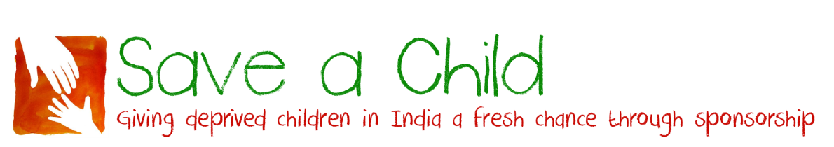
Gift Aid Declaration

Name of charity: Save a Child (Registered charity no 328218)

Details of donor:

Title: ………….. Forename: ……………………………………………………………………………………….…………………….

Surname: ………………………………………………………………………………………………………………………………………

Home Address: ……………………………………………………………………..........................................................

……………………………………………………………..…… Postcode: ………………

I want to Gift Aid all donations to Save a Child that I have made for this tax year and the four years prior to the year of this declaration and all donations I make from the date of this declaration until I notify you otherwise.

I am a UK taxpayer and understand that if I pay less Income Tax and/or Capital Gains Tax than the amount of Gift Aid claimed on all my donations in that tax year it is my responsibility to pay any difference.

Signature: ……………………………………………………………………………..

Date: ……………………………………………………………………………………

Notes:
1. You can cancel this Declaration at any time by notifying Save a Child.
2. If in the future your circumstances change and you no longer pay tax on your income and capital gains equal to the tax that Save a Child reclaims, you can cancel your declaration.
3. If you pay tax at the higher rate you can claim further tax relief in your Self-Assessment tax return.
4. If you are unsure whether your donations qualify for Gift Aid tax relief, ask Save a Child.
5. Please notify Save a Child if you change your name or address.

Please return this completed form to:
Bill Baker, Save a Child, 27 Canning Cross, London SE5 8BH

Save a Child is a Registered Charity Number 328218
Registered address: 27 Canning Cross, London SE5 8BH
www.saveachildindia.com

