Antennas  Rev. A |   YOUR WIRELESS DESIGN ACHIEVED

Through 23 years, Allis Communications has been specializing in producing GPS Antenna, GNSS Antenna, Iridium Antenna and GPS/CELLULAR/WiFi Combination Antenna. Our main products include Satellites Antennas, Cellular Antennas, WiFi Antennas, Combination Antennas, MIMO Antennas, Patch Antennas and GPS Receiver System.

For IoT applications, Allis Communications also design and produce HIGH PERFORMANCE antennas for Airport Security and Train/MRT Transportation System.

Key Features
- High quality production & workshop test
- Optimizing at 3D RF Chamber
- A selection of wider-band frequency
- Cost-effective design
- Compact & Light weight
- Screw Permanent or Magnetic mounting
- IP56 or IP67 water-proof
- Custom connectors and cable available
- RoHS、CE compliance

GPS Antennas
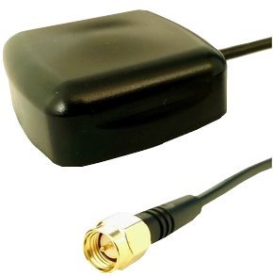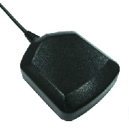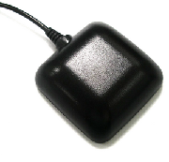
Model No. | X830B | M Series | L Series
Amplifier Gain | 27dB@2.7V/ 36dB@6VDC | 14~29dB | 14~29dB
Noise Figure | 1.5dB Typ. | 0.9 dB max. | 0.9 dB max.
DC Voltage | 2.7~6 V | DC 2.7~5.5V | DC 2.7~5.5V
DC Current | 9.5±2.5mA | 3~6mA | 3~6mA
Weight  (w/o Cable) | 32 grams | 42 grams | 46 grams
Dimension  (mm) | 36x36x13.9 | 48x40x13 | 50x50x17
Waterproof | IP67 | IP56 | IP56

GNSS Antennas
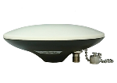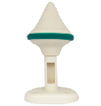
Model No. |  |  | MBA20 | W5GGR | M828G / M820G
GPS L1
GPS L2 |  |  |  | N/A | N/A
GLONASS L1
GLONASS L2 |  |  |  | N/A | N/A
BDS B1 |  |  |  |  | N/A
BDS B2 |  |  |  | N/A | N/A
BDS B3 |  |  |  | N/A | N/A
Galileo E1 |  |  |  |  | N/A
Waterproof |  |  | IP67 | IP67 | IP56

Cellular Antennas

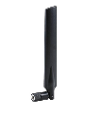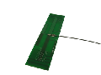
Model No. | GCRC2 | CE400 | CE300
LTE 700/800MHz
AMPS
GSM
DCS 1800
PCS 1900
WCDMA
LTE 2600MHz |  |  | N/A
Peak Gain | 3~5dBi | 1.94~5.85 dBi | 2.5dBi
Weight  (W/O Cable) | 280 grams | 22 grams | 5.8 grams
Dimension  (mm) | 100 Dia.× 67 | 13.5x(176.6±2 /150.4±2) | 118 *30*1.1

Band | Frequency Range
AMPS | 804~896MHz
GSM | 824~960MHz
DCS 1800 | 1710~1880MHz
PCS 1900 | 1850~1990MHz
WCDMA | 1920~2170MHz

Combination Antennas
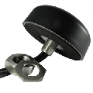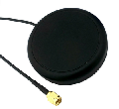
Model No. | AM460 | GCREB | CM20B
GPS
Iridium |  | N/A | N/A
LTE |  |  | N/A
AMPS |  | N/A | N/A
GSM
DCS 1800
PCS 1900
WCDMA |  |  | N/A
2.4G |  |  | N/A
5G |  |  | N/A

Iridium Antennas
Model No. | MPIDM | CMIDM | GCRGI
Iridium Certified
Iridium
GPS | N/A | N/A
Housing Material | ABS+PC | ASA | ASA
Weight  (w/o Cable) | 42 grams | 75 grams | 280 grams
Dimension  (mm) | 48x40x13 | 75mm Dia.* 15.8 | 100mm Dia.× 67
Mounting | Magnetic | Magnetic | Permanent
Waterproof | IP67 | IP67 | IP67

Antennas for Train/MRT/Airport
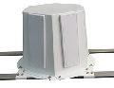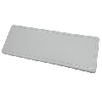
Model No. | FC512 | FA518 | FB512
Frequency | 5.1~5.8GHz | 5.4~5.9GHz | 5.1~5.8GHz
Average Peak Gain(Port1) | 13.5 dBi | 18dBi typ. | 13.9dBi
Average Peak Gain(Port2) | 12.0 dBi | 18dBi typ. | 12.1dBi
Average Efficiency(Port1) | 85% | 55% typ. | 84.60%
Average Efficiency(Port2) | 83% | 55% typ. | 82.10%
3dB Beam Width(Port1) | XZ: 15° /  YZ: 55° | XZ: 18°/  YZ: 18° | XZ: 15° /  YZ: 55°
3dB Beam Width(Port2) | XZ: 15°/  YZ: 60° | XZ: 18°/  YZ: 18° | XZ: 15°/  YZ: 60°

