Sweet Potato Breakfast Pudding
by Raquel DeHoyos, comfortandheal.com, January 2020
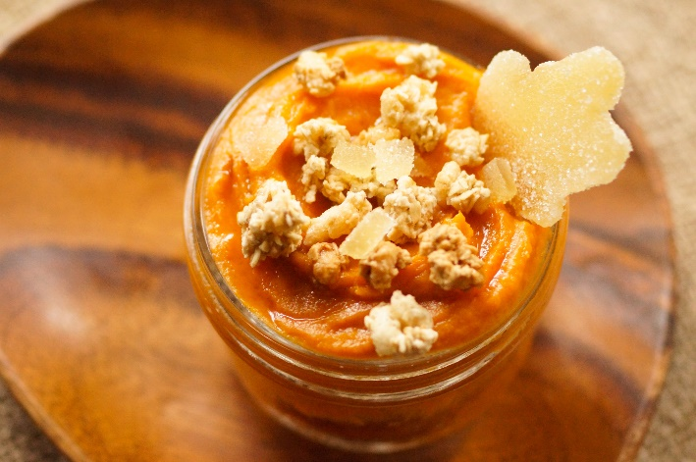
Ingredients
3 pounds red sweet potatoes, also known as red garnet yams
3 Tablespoons coconut oil
2 Tablespoons maple syrup
1/2 teaspoon ground cinnamon
optional toppings: granola, candied ginger, diced fruit or fresh berries, ground flax meal
Makes 9- 1/2 cup servings
Instructions
Peel and chop sweet potatoes into large chunks. Place sweet potatoes into a large pot, cover with cold water and a lid and bring to a boil over high heat. Once boiling, remove lid, reduce heat to medium and simmer for about 15 minutes or until you can easily pierce with a small paring knife. Drain and place into a food processor. No food processor? No problem. Mash with a potato masher and while still warm, whip with remaining ingredients.
Add coconut oil, maple syrup and cinnamon. Puree until smooth, about 1 minute.
Serve warm and top with optional toppings. Note* Additional toppings will alter the final nutritional content of this recipe. Adjust your daily calories accordingly.
Health Notes
Sweet potatoes aren't called sweet for nothing. Those with the orange colored flesh and orange-reddish colored peel are known to be naturally sweeter than their paler counterparts. If you're watching your sugar, omit the maple syrup and candied ginger in this recipe. If you accustom your taste buds and palate to favor the natural tastes of foods, your craving for extremely sugary foods will slowly subside.
Caregivers of children or infirmed who may have challenges properly chewing foods may enjoy a recipe like this that has a sneaky name like pudding but actually is naturally creamy and good for them. It also is dairy free to keep digestive upset at bay, but rich in fiber to keep things flowing.

