Link Đề bài: https://www.ieltstutor.me/blog/ielts-speaking-part-2-3-topic-media-culture

Hình Take note của Part 2:

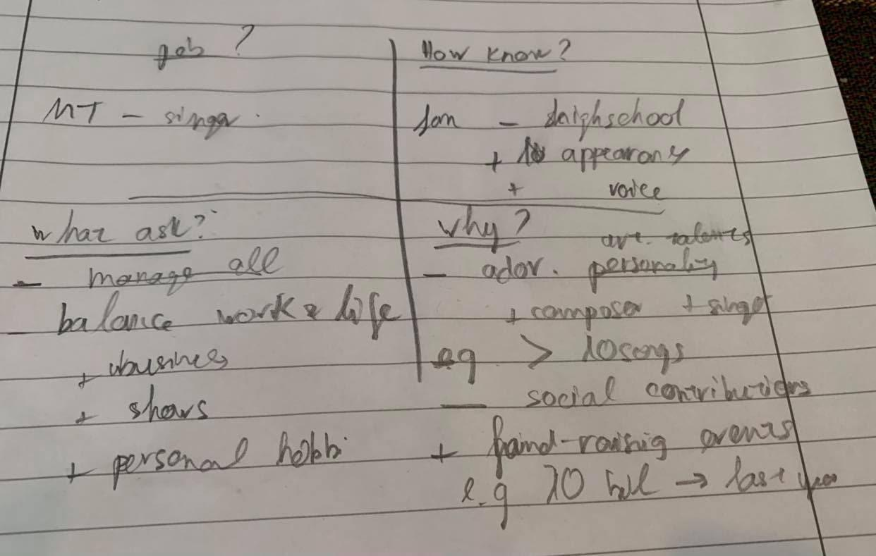

Phân tích các đề trong Part 2 về chủ đề Media and Culture
https://www.ieltstutor.me/blog/huong-dan-cach-tra-loi-ielts-speaking-part-2-3-topic-media-culture

Transcript Bài Nói Part 2 (Sắp xếp theo từng câu hỏi của đề)
Ví dụ:
Describe a person in the news that you want to meet
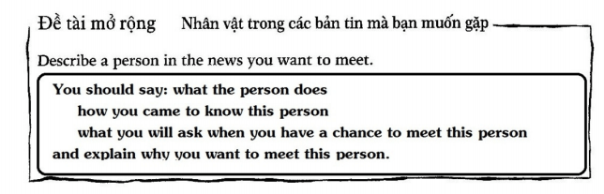
Lan 1:
What the person does
The person that I want to meet is My Tam, who is a leading singer in the Vietnamese entertainment market.

How you came to know this person
Speaking of the first time that I know her, it was 17 years ago when I was in high school. I was captivated by her lovely voice and her attractive appearance.

What you will ask when you have a chance to meet this person
Regarding the questions that I want to ask, I’m curious about how she can balance her work and her life.
In fact, she is not only a singer, a business owner, but also an active social player in the charity works. Therefore, I want to know how she can manage her time to fulfil all of the responsibilities of these positions effectively.

Explain why you want to meet this person
Well, I adore My Tam more than other idols for two reasons.
Firstly, she has admirable artistic talents which distinguish her from other singers.
More specifically, she’s not only a singer but also a composer who can write a lot of songs and lyrics. For example, she has written more than ten songs in her career.
Secondly, she has made a great contribution to the society.
In fact, every year, she organizes many fund-raising events to donate plenty of money for poor people.
In 2020, she and her charity organization have donated more than 10 billion VND to underprivileged children in Vietnam.

Chú ý phần trọng âm, bài hơi ngang cần có thêm ngữ điệu
Lan 2:
What the person does
The person that I want to meet is My Tam, who is a leading singer in the Vietnamese entertainment market.
=> còn hơi ầm à một chút nè, nghe chưa trôi chảy lắm

How you came to know this person
Regarding the first time when I came to know her, my friend invited me to her show 17 years ago when we were in high school. In this event, I was captivated by her lovely voice, eye-catching appearance and unique performance style.
What you will ask when you have a chance to meet this person
If I had a chance to meet My Tam, I would ask her how she can maintain a work-life balance. The thing is, she is not only a singer, a business owner but also an active donator in many charity events.
Explain why you want to meet this person
Generally speaking, I want to meet her in person for two reasons.
Firstly, she is my favorite idol for the reason that she has unique innate artistic talents which distinguish her from other singers.
More specifically, she is not only a singer but also a composer of many vietnamese songs. For example, the number of the songs she composed has exceeded 10 in 20 years of her career.
Secondly, she has made adorable contributions to society through many charity activities.
In fact, My Tam organizes and participates in many fund-raising events, bringing both physical and mental values to misfortune people in rural regions.
For instance, in 2020, she donated more than 10 billion VND and invited other celebrities to join with her in these activities.
BÀI MÌNH NÓI BỊ QUÁ THỜI GIAN RỒI NÈ, CHỈ NÓI TRONG VÒNG 2’ ĐỔ LẠI THÔI NHA. Tốc độ mình nói giờ còn hơi chậm và vẫn còn ngập ngừng chưa trôi chảy lắm đó, cũng là nguyên nhân khiến bài mình bị quá giờ nè. Nên luyện tập trước khi record để quen đó https://www.ieltstutor.me/blog/ielts-speaking-cach-hoc
Về Intonation thì mình nói còn đang hơi đều đều một chút, nên nhấn vào các thông tin quan trọng rõ hơn để tạo sự tự nhiên cho bài của mình chứ không nghe như là học thuộc văn nói đó https://www.ieltstutor.me/blog/intonation
Lan 3:
What the person does
The person that I want to meet is My Tam, who is a leading singer in the Vietnamese entertainment market.
How you came to know this person
Regarding the first time that I came to know her, my friend invited me to her show 17 years ago when we were in high school. In the event, I was captivated by her lovely voice, eye-catching appearance and unique performance style.
What you will ask when you have a chance to meet this person
If I had a chance to meet My Tam, I would ask her how she can maintain a work-life balance. The thing is, she is not only a singer, a business owner but also an active donator in many charity events.
Explain why you want to meet this person
Generally speaking, I want to meet her in person for two reasons.
Firstly, she is my favorite idol for the ground that she has unique innate artistic talents which distinguish her from other singers. ⇒ https://www.ieltsdanang.vn/blog/cach-dung-danh-tu-ground-tieng-anh → chỗ này dùng sai grounds, thường là on the grounds that on grounds of

More specifically, she is not only a singer but also a composer of many vietnamese songs that are loved by a large number of fans.. For example, the number of the songs she composed has exceeded 10 in the last 20 years of her career.
Secondly, she has made adorable contributions to society through many charity activities.
In fact, My Tam has organized and participated in many fund-raising events, bringing both physical and mental values to misfortune people in rural regions.
For instance, in 2020, she donated more than 10 billion VND and invited other celebrities to join with her on these occasions.
⇒ Xem lại cách dùng the number of https://www.ieltstutor.me/blog/phan-biet-a-number-of-the-number-of
Chỗ part 2 nói ngập ngừng quá k thì điểm Fluency & Coherence sẽ cao hơn

Transcript Bài Nói Part 3 (Từng câu hỏi bắt buộc phải có Takescript)

1. Câu hỏi yêu cầu sự lựa chọn
Do you prefer reading an electronic book or a real book?
Lan 1:
Personally, I’m a fan of electronic books because it is very convenient to store and read them in my leisure time. The thing is, thanks to the advancement of the technology nowadays, the storage capacity of the phone has increased dramatically, so I can save and store thousands of books electronically in my phone. For example, I save more than 100 novels and 300 comics on my mobile phone which I can read on my free time.
Lan 2:
Personally, I’m a fan of electronic books to paper ones for the reason that I feel more convenient and comfortable when I use electronic devices. The thing is, thanks to the advancement of new technology, e-book readers today have a variety of amazing features which cannot be offered by physical books. For example, e-book readers nowadays are very handy and they can store thousands of books electronically, so users can bring them together on their trips easily.
Lan 3:
Personally, I’m a fan of electronic books to paper ones for the reason that I feel more convenient and comfortable when I read virtually. Indeed, electronic devices nowadays, especially smartphones or e-book readers, offer a variety of advantages which are superior to traditional books. For example, e-book readers today are very handy and they can store thousands of books electronically, so users can bring them together on their trips easily.

2. Câu hỏi về sự phổ biến
What is the most popular reading material in your country?
Lan 1:
In Vietnam, it really depends on the generations that we are talking about.
For the elderly who are usually old-fashioned, they prefer reading paper books and paper magazines simply because it has been their habit for a long time. In fact, many old people are fond of reading paper newspapers or paper books so that they can highlight or write some notes on them. For example, my grandparents have a hobby to read books and take notes from what they can learn from the book.
Unlike the elderly, younger people who are savvy in technology prefer reading news and other information from electronic sources. In fact, people today are a fan of new technology, so they tend to find a convenient way to update their knowledge. For instance, my friends have a hobby to read electronic newspapers in their leisure time to know the latest news about politics and sports.
Lan 2:
Well, it really depends on which generations we are talking about.
For old people who are usually old-fashioned, conventional newspapers and magazines are still their favorite choices simply because it has been their habit to read them since they were young. In fact, many people are in favor of newspapers and magazines in the paper format as they can easily take notes or highlight interesting information. For example, it is my grandparents’ hobby to write down their personal remarks on the news and look back at them from time to time.
In contrast, unlike the elderly, younger people who are more savvy in technology prefer reading on electronic sources such as electronic newspapers or social networks. The thing is, the popularity of the Internet and the advancement of technology enable netizens today to broaden their horizons in different ways on the Internet. FOr instance, youngsters nowadays can read news on their mobile phones, Web browsers or other electronic devices.
Lan 3:
Well, electronic newspapers have become the most popular reading materials today in Vietnam. In fact, the popularity of the Internet and the advancement of modern devices, such smartphones or tablets, have brought far-reaching effects to human life nowadays. More specifically, people today, especially youngers, tend to read news on social networks or electronic newspapers platforms on their mobile phones. Độ dài đoạn 3 ngắn, chưa triển khai nhiều ví dụ

3. Câu hỏi về sự thay đổi
How has the way of reading changed?
Lan 1:
Well, the way of reading has changed dramatically in the last few decades, mainly from physical to virtual.
In the past, people have to read printing newspapers or printing books simply because it is the only way to broaden their horizons. In fact, there was no mobile phone or not internet 70 years ago, so they could not read information from electronic sources like electronic newspapers or websites. for example, my grandparents used to buy books from bookstores and read them in their leisure time, and it was their only option at that time.
However, people today prefer reading news on electronic platforms like electronic newspapers or social network because it is very convenient for them. The thing is, many young people nowadays who are savvy in technology are a fan of convenient ways instead of traditional ones. for example, my friends usually spend their leisure time surfing on the internet to read the newspaper and expand their knowledge.
Lan 2:
Well, the way of reading has changed dramatically in the last few decades, mainly from physical to virtual.
In the past, printed materials such as books, magazines, newspapers, are the most popular reading materials simply because there was no modern technology which could offer a better solution. The thing is, there was neither Internet nor smartphones 70 years ago, so those who wanted to broaden their horizons at that time had the only choice is to read printed books or newspapers. For instance, my grandfather told me that he used to purchase daily newspapers to read the news of politics and economy when he was young.
However, printed materials have been gradually replaced by electronic ones in the modern world. More specifically, netizens today can easily access various online sources to update their knowledge such as electronic newspapers, social networks, or other electronic platforms. For example, reading news on electronic platforms has become a hobby of many youngsters today as it is extremely fast and convenient thanks to the wideband Internet connection and modern smartphones.
Lan 3:
From my point of view, the way of reading has changed remarkably in the last few decades, mainly from physical to virtual.
In the past, printed materials such as books, magazines, newspapers, are the most popular reading materials simply because there was no better alternative. In fact, there was neither the Internet nor smartphones 70 years ago, so those who wanted to broaden their horizons at that time had the only choice, which is to read printed books or newspapers. For instance, my grandfather told me that he used to purchase daily newspapers to read the news of politics or economy when he was young.
However, printed materials have been gradually replaced by electronic ones in the modern world. More specifically, netizens today can easily access various online sources such as electronic newspapers, social networks, or other electronic platforms, to update their knowledge. For example, reading news on electronic platforms has become a hobby of many youngsters today as it is extremely fast and convenient thanks to the popularity of the wideband Internet connection and modern devices.
4. Câu hỏi về sự khác biệt
What are the differences between TV programmes and radio programmes?
Lan 1:
I think the basic difference between two types is the visual photos which are only available on TV programs. As a result, TV programs can offer more options and types of programs than the radio ones. for example, the audiences can watch movies or some TV shows which they cannot experience when they listen to radio programs.
Lan 2:
There are two major differences between TV and radio programs.
Firstly, the fundamental difference between these two types is the visual effects which are only available on TV. As a result, TV programs are usually developed with a higher level of sophistication and complexity compared to the ones on radios and they offer a variety of leisure options to audiences. For example, spectators can watch various programs on TV such as football matches, music performances, or documentary films about animals..
Secondly, the news offered by radios and TV channels have a different level of latency. The thing is, while radio only broadcasts live programs, the ones on TV are mainly the recordings in the past. Therefore, radio programs seem to be suitable for those who are interested in only the latest news. For example, radio programs are used to broadcast the live traffic situation in some big cities to decrease the severity of traffic congestion.
Lan 3:
In my opinion, there are two major differences between TV and radio programs.
Firstly, the fundamental difference between these two types is the visual effects which are only available on TV. As a result, TV programs are usually developed with a higher level of sophistication and complexity compared to the ones on radios and they offer a variety of leisure options to audiences. For instance, spectators can watch various programs on TV such as football matches, music performances, or documentary films about animals..
Secondly, the news offered by radios and TV channels has a different level of latency. More specifically, while radio only broadcasts live programs, the ones on TV are mainly the recordings in the past. Therefore, radio programs seem to be suitable for those who are interested in only the latest news. For example, radio programs are used to broadcast the live traffic situation in some big cities to decrease the severity of traffic congestion.

5. Câu hỏi trình bày quan điểm
How do TV programmes influence children?
NHƯ TRÊN THÌ PHẦN SPEAKING CỦA MÌNH CÒN CHẬM VÀ CÒN HƠI VẤP ĐÓ. NÊN LÀ MÌNH LUYỆN TẬP NHIỀU HƠN NHA ĐỂ CHO TRÔI CHẢY.
INTONATION THÌ GIỜ VẪN CÒN MONOTONE QUÁ, NÊN NGHE NHƯ LÀ MÌNH HỌC THUỘC LÒNG HOẶC LÀ CẦM TỜ GIẤY LÊN NÓI VẬY. XEM LẠI CÁCH NHẤN INTONATION ĐỂ BÀI NÓI TỰ NHIÊN HƠN NHA
Lan 1:
From my point of view, TV programs have influenced children in both positive and negative ways.
On the one hand, it is beneficial for children to watch TV programs because it is an effective way to release the stress. In fact, there are a variety of entertainment shows and programs that children can watch in their leisure time. For example, while some children prefer sports, the others can watch movies or TV shows in their free time.
On the other hand, watching TV too much leads to negative impacts on the development of young children. More specifically, children tend to spend less time on socializing with their friends mainly because they spend their whole day watching TV. For example, my friends usually spend their whole weekends to watch movies and sports, and they don’t want to go out to hang out with their friends.

Nói bị ngắt đoạn khá nhiều, chưa trôi chảy lắm, nên nói chậm rãi lại để khi mình cần thgian brainstorm thì khoảng nghỉ cũng không quá rõ
Lan 2:
From my point of view, TV programs bring both positive and negative impacts on children’s development.
On the one hand, TV programs offer a variety of shows and movies for children to entertain in their leisure time. More specifically, there is a wide range of programs on TV everyday, including sports, news, cartoons, movies, music, etc.; therefore, children can rely on them to release stress effectively. For instance, while some youngsters are fans of cartoons, others are fond of football matches.
On the other hand, the fact that children spend too much time watching TV creates many negative impacts on children’ physical development. More specifically, entertainment companies have invested tons of money on TV programs to attract their audiences; consequently, young children can be easily addicted to these entertainment shows and spend less time on outdoor activities, which are beneficial for their health. For example, TV addicts tend to ignore the importance of social or outdoor activities and spend their whole day in front of the screen.
Lan 3:
From my point of view, TV programs bring both positive and negative impacts on children’s development.
On the one hand, TV programs offer a variety of shows and movies for children to entertain in their leisure time. More specifically, there are a wide range of programs on TV everyday, including sports, news, cartoons, movies, music, etc.; therefore, children can rely on them to release stress effectively. For instance, while some youngsters are fans of cartoons, others are fond of football matches.
On the other hand, the fact that children spend too much time watching TV creates many adverse impacts on their own development. More specifically, entertainment companies have invested tons of money on TV programs to attract their audiences; consequently, young children can be easily addicted to these entertainment shows and spend less time on outdoor activities, which are beneficial for their health. For example, TV addicts tend to ignore the importance of social or outdoor activities and spend their whole day in front of the screen. => Cần nói chậm lại chút để phát âm mấy âm cuối nha

    - chú ý cụm từ grounds dùng sai https://www.ieltsdanang.vn/blog/cach-dung-danh-tu-ground-tieng-anh
    - Xem lại cách dùng the number of https://www.ieltstutor.me/blog/phan-biet-a-number-of-the-number-of
    - Độ dài đoạn 3 câu 1 ngắn, chưa triển khai nhiều ví dụ
    - Đôi chỗ còn nói thiếu số nhiều performances
    - Chưa đa dạng về linking word More specifically, dùng nhiều → Đổi thành in fact, To be more specific…. https://www.ieltstutor.me/blog/linking-words
    - Part 2 lần cuối tiến bộ hơn nhiều so với lần đầu, lần đầu ậm ừ fluency k ổn
    - Từ most phát âm lại
      - Grammar Range & Accuracy 6.5-7.0
      - Pronunciation 7-7.5 —> phát âm & intonation tốt
      - Lexical resource 7
      - Fluency & Coherence 7.5

