The chart below shows the numbers of registered road vehicles in use in a European country.

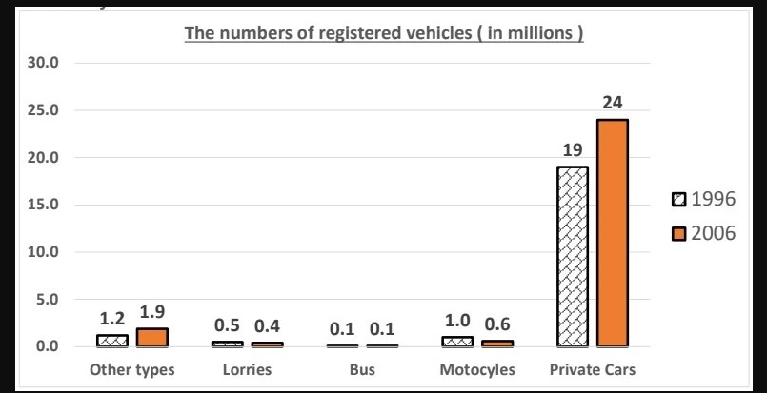
Overall:
Private cars dominate
Bus: lowest

B1: in 1996:
- Private cars highest: 19
- Bus lowest: 0.1
- Others: 0.5-1.2
B2: in 2006:
- Private cars increased: 24
- 1.9 other types
- Buses lingered on the lowest 0.1
- 0.4 lorries, 0.6 motocycles
- Hướng dẫn làm bar graph: https://www.ieltstutartor.me/blog/bar-ch

Given is the chart comparing several types of registered transports in terms of the quantities of them in use in a nation belonging to the Europe in 1996 and 2006. Overall, in both of the recorded years, the numbers of private cars which were utilized eclipsed all of the other vehicles’ data, and the figures for buses were at the lowest.
A closer look at the chart shows that in 1996, 19 million private cars were used, which was the highest number while there were only 0.1 million buses to be utilized. Additionally, the figures for the remaining kinds of transportations ranged moderately from 0.5 to 1.2 million.
Moving to the other year, the data of private cars rose by 5 million in 2006, which was still the largest number of vehicles in use, followed by 1.9 million other types of transports. Meanwhile, the figure for buses still lingered on the lowest quantity, at 0.1 million. In addition, there were 0.4 million lorries and 0.6 million motocycles in use.
Bố cục như này cũng được hoặc tham khảo bố cục khác
  - Overall:
  - Body 1: Viết về số liệu tăng (Private Cars + Other types)
    - Private Cars số liệu qua các năm đều lớn nhất
    - Số liệu Other types
  - Body 2: Viết về số liệu giảm & không đổi (Lorries + Motocycles + Bus)

Bài mẫu

Dàn bài lần 2

Bài viết lần 2

Dàn bài lần 3

Bài viết lần 3

Dàn bài lần 4

Bài viết lần 4

