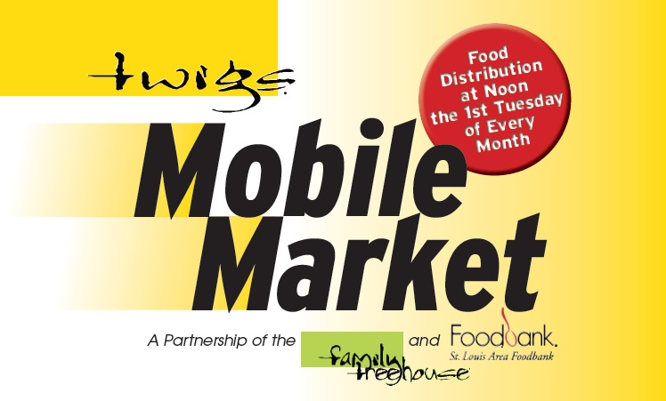

Since 2012, Twigs® and the St. Louis Area Foodbank have partnered together to host a mobile food market.
On the first Tuesday of every month, from noon until 1:30p.m. (or the food is gone) Twigs volunteers distribute food at:
Twigs Annex, 2450 Stratford Lane, Granite City, IL 62040
There are no forms, no questions to answer. Everyone who shows up receives food.
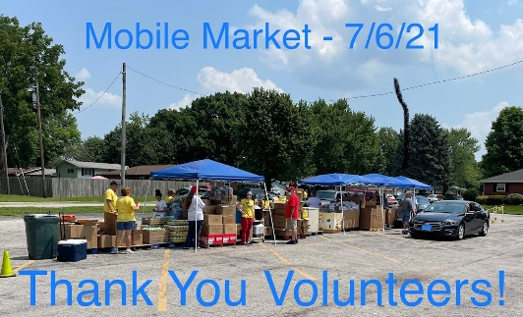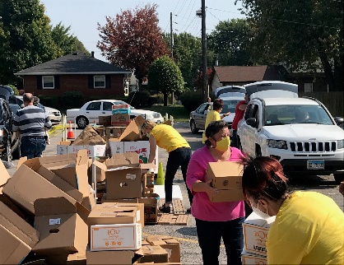
Twigs Annex | 2450 Stratford Lane, Granite City, IL 62040
Twigs Mailing Address | 2101 Cleveland Blvd., Granite City, IL 62040 Email: twigsforkids@gmail.com Website: twigsforkids.com
or find us on Facebook
618-973-1627

Since 2012, Twigs® and the St. Louis Area Foodbank have partnered together to host a mobile food market.
On the first Tuesday of every month, from noon until 1:30p.m. (or the food is gone) Twigs volunteers distribute food at:
Twigs Annex, 2450 Stratford Lane, Granite City, IL 62040
There are no forms, no questions to answer. Everyone who shows up receives food.
Twigs Annex | 2450 Stratford Lane, Granite City, IL 62040
Twigs Mailing Address | 2101 Cleveland Blvd., Granite City, IL 62040 Email: twigsforkids@gmail.com Website: twigsforkids.com
or find us on Facebook
618-973-1627

