Link Đề bài: https://www.ieltstutor.me/blog/ielts-speaking-describe-a-place

Transcript Bài Nói Part 1 (Từng câu hỏi bắt buộc phải có Takescript)

Hình Take note của Part 2:
Test 1

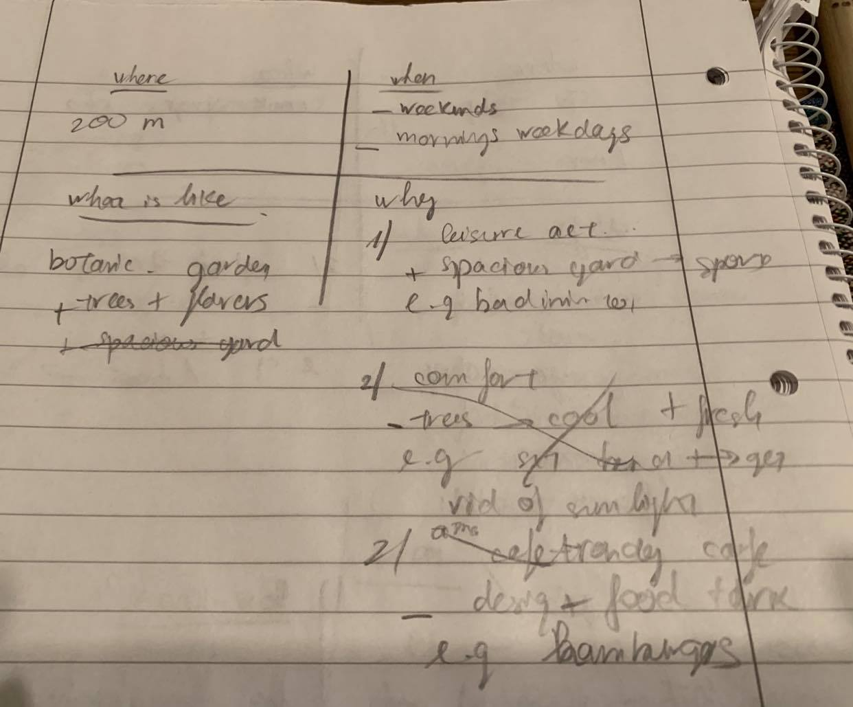

Test 2

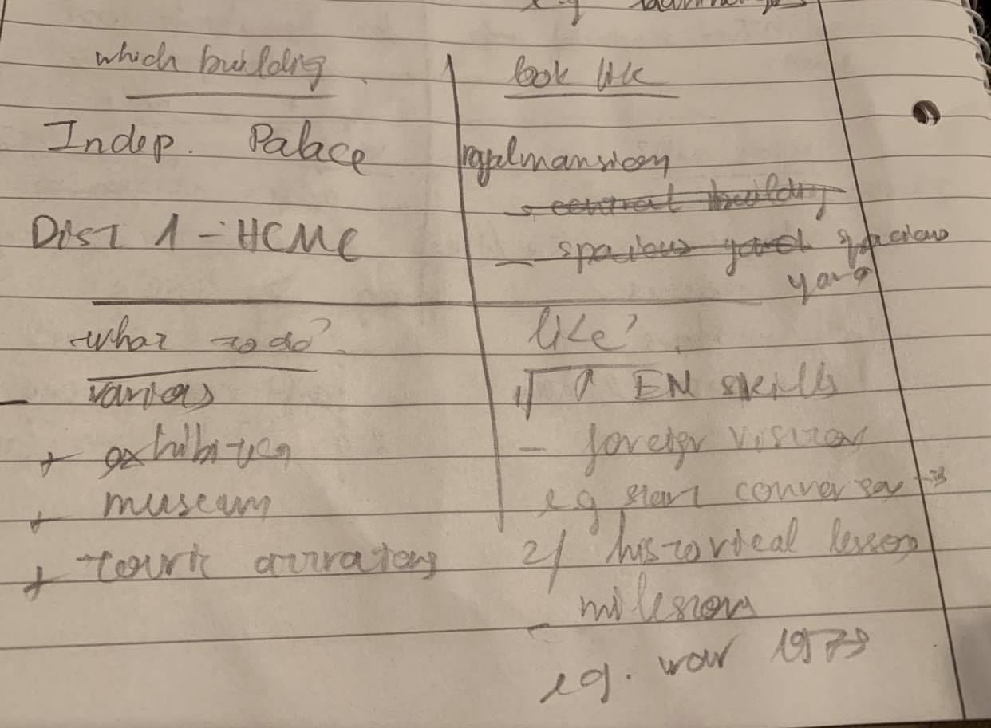

Test 3

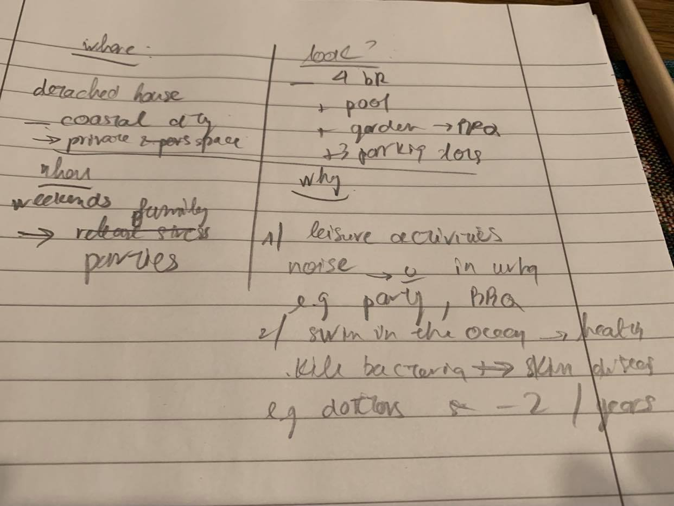

Transcript Bài Nói Part 2 (Sắp xếp theo từng câu hỏi của đề)
Ví dụ:
https://www.ieltstutor.me/blog/ielts-speaking-describe-a-place-building Đọc hướng dẫn làm đề này để có template va từ vựng nha
https://www.ieltstutor.me/blog/ielts-speaking-part-2 Đọc hướng dẫn chung cho part 2 nhé.
Test 1:
ĐỀ 1: Describe a park / garden you like visiting (Em cũng có thể dùng đề này để trả lời cho Describe a newly built facility (such as parks, cinemas... that influencers your city)

Describe a park/garden you like visiting

You should say
- Where the park is
- When you visited it
- What the park is like
- And explain why you like visiting it
Lan 4:
Where the park is
The beautiful park I’m going to share with you is located in my neighborhood, which is approximately 200 meters away from my house.

When you visited it
When it comes to the time that I visited the park, I usually go there in the morning on weekdays or from time to time on weekends mainly to do regular exercise or to hang out with my friends.

What the park is like
Regarding its appearance, the park looks like a botanical garden for the reason that there are a variety of trees and flowers, which make my mind feel peaceful and relaxing whenever I go there.

And explain why you like visiting it
The park is my favorite destination for two reasons.
Firstly, it plays a vital role in the local residents’ lives because it offers a spacious place for a wide range of leisure activities. For example, many people go to the park to play sports, read books, walk their dogs, or have their meals in the local coffee shop.
Secondly, the park has an attractive location, which makes it like an oasis in the middle of the city. More specifically, the park is surrounded by many skyscrapers and residential houses. Therefore, the park becomes an ideal place for the local residents to spend their leisure time breathing fresh air and hanging out with their friends.

Test 2:
ĐỀ 2: Describe a historical building you have been to

Describe a historical building in your area

You should say:

Which the building is

How it looks like

What people do there

And also say whether you like this building or not

Lan 4:
Which the building is
The historical building that I'm going to share with you is the Independent Place, which is located in District 1 in HCMC.
How it looks like
When it comes to its appearance, the building looks like a mansion with two main structures: the central building and a spacious yard in which several tanks and helicopters are exhibited.
What people do there
Regarding the activities that people can do there, the palace is mainly used as a tourist attraction. Furthermore, in some cases, local authorities also use this palace to organize some festivals.
And also say whether you like this building or not
Personally, there are several reasons why this palace is my favorite destination in my leisure time.
Firstly, the palace offers plenty of historical values and images which can’t be found in other places.
Indeed, in the palace, there are a variety of samples, photos, documents, and videos about the historical wars against the French colonists and the American Empire. For example, I used to go to the palace every weekend to read the materials there.
Secondly, it is an incredible place for me to improve my English skills. In fact, there are plenty of foreign visitors, especially English-speaking ones, in the palace. As a result, I usually go there to make friends with foreigners, and \I volunteered to become their tour guide to introduce the stories in the palace to them.

ĐỀ 3: Describe an ideal house

Describe your ideal house

You should say:

where it is
what it looks like
when you would like to live in
And explain why you would like to live in it

Lan 4:
Where it is
The ideal house I’m going to share with you is a detached house in Vung Tau, which is a coastal city and is located approximately 100 km away from HCM.
What it looks like
When it comes to its appearance, the house should have 4 bedrooms, a spacious garden to organize a barbeque party, and at least 4 parking lots in case I want to invite some friends to enjoy with me.
When you would like to live in
Regarding the time I want to visit the house, I want to go there on weekends when I have a lot of leisure time.
And explain why you would like to live in it
Personally, there are several reasons why this is my ideal house.
Firstly, it offers a lot of private space for my hobbies which are inconvenient in city areas.
For example, when I am in a private house, I can sing karaoke or listen to loud music without worrying about disturbing other people.
Secondly, I’m interested in a house in a coastal city because I can enjoy the fresh air there.
Indeed, the air in big cities is usually polluted by the heavy loads of traffic.
Therefore, I want to have a house in Vung Tau so that I can enjoy the air when I walk on the beaches, which is beneficial to maintain a good physical and mental health.

Transcript Bài Nói Part 3 (Từng câu hỏi bắt buộc phải có Takescript)

