Instructions
In American Born Chinese, an award-winning graphic novel, three stories play out and eventually merge together as they explore how a dominant culture impacts the characters who feel outside of that culture. It is a graphic novel about the struggle to fine one's identity. We want to explore what it means to be an outsider or minority to the dominant or majority culture as it is represented in the three storylines. As you are reading, you will undoubtedly be reminded of Chimamanda Adichie's TEDTalk on the "Danger of a Single Story" and how stereotypes are incomplete. The author of this graphic novel, Gene YangLinks to an external site., tries to bring more of the complete picture of the feelings one may feel when minoritized from a dominant group.
The story documents the struggles and stereotypes that an Asian-American protagonist, Jin Wang, is subjected to in school, portrays racist stereotypes as part of the storyline of a white Anglo-American student, Danny, and his Chinese cousin, Chin-kee, and tells the story of The Monkey King, a mythical god from Chinese legend, who struggles to find acceptance among his arrogant peers. Although these three tales seem unrelated, they are later woven together to form one incredible story of hope and resilience.
For this discussion forum, we will analyze some of the graphic novel and, in this way, begin preparing for our final exam which will be on ABC. These types of questions will prepare you for the exam. Choose 1 of the questions to respond to in 100 words. Then, kindly and politely respond to two classmates (50 words each).
- Look at the page below from ABC of Jin and Wei-Chen on the school playground. Make a claim about Jin's treatment of Wei-Chen and then state how this shows us something about Jin's inner conflict. In your response refer to one or more of the below as evidence (frames is linked to our reading about comics; please use comics terminology):

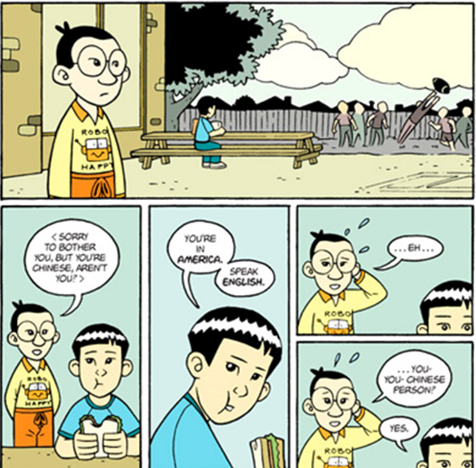
.

2. Look at the page below from ABC. Write a sentence making a claim about how the dominant culture views Jin. Explain how one or more of the frames below supports your claim.

