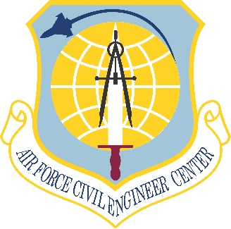
DRAFT
2020 Air Force
Eastern Regional Environmental Restoration Summit
EPA Regions 1, 2, 3, 4 & 5
22-23 July 2020

Wednesday

Time | Description | Speaker
7:30-8:00 | Meet and Greet  EPA and State Representatives | AFCEC/CL  AFCEC/CZP & DoD REC
8:00-8:15 | Welcome and Introductions | AFCEC/CZP
8:15-8:30 | Welcome Remarks | TBD
8:30-8:50 | Opening Remarks  AFCEC Mission | AFCEC/CL
8:50-9:10 | Overview of Air Force Environmental Program FY20 and Beyond | AFCEC/CZ
9:10-9:30 | Overview of EPA National and Regional Cleanup Policy and Goals | EPA Leadership
9:30-9:50 | Break
9:50-10:30 | EPA Regional Updates/Top Issues & Successes | Each EPA Regional Office
10:30-12:00 | State Updates/Top Issues & Successes | State Representatives
12:00-1:30 | Lunch
1:30-1:50 | Air Force Environmental Operations | AFCEC/CZO
1:50-2:10 | Air Force Restoration Program  Progress and Goals | AFCEC/CZR
2:10-2:30 | Optimized Remediation Contracts (ORC) Update | AFCEC/CZR
2:30-2:50 | AF Base Realignment and Closure (BRAC) Restoration Program Update | AFCEC/CIB
2:50-3:10 | Break
Time | Description | Speaker
3:10-3:40 | Air National Guard Program Update | Air National Guard
3:40-4:25 | Military Munitions Response Program (MMRP) Items of Interest | AFCEC/CZR
4:25-5:00 | Wrap-up, Action Items, and Closing Comments | AFCEC/CZP
5:00-7:00 | Networking Reception | All

Thursday

Time | Description | Speaker
8:30-8:40 | Welcome/Recap | AFCEC/CZP
8:40-9:10 | Association of State and Territorial Solid Waste Management Officials (ASTSWMO) Updates | ASTSWMO
9:10-9:30 | PFOS/PFOA Update | AFCEC/CZR
9:30-10:10 | PFOS/PFOA Path Forward Towards Remedial Investigation (RI) | AFCEC/CZTE
10:10-10:30 | Break
10:30-11:30 | PFOS/PFOA State Standards & Applicable or Relevant and Appropriate Requirements (ARARs) | AFLOA/JACE-FSC
11:30-12:00 | Air Force Installation Success Stories | Selected Air Force Installations
12:00-1:30 | Lunch
1:30-2:10 | Department of Defense and State Memorandum of Agreement (DSMOA) Overview and Best Practices | USACE
2:10-2:50 | Interstate Technology & Regulatory Council (ITRC) Updates | ITRC
2:50-3:10 | Break
3:10-4:10 | Regional Breakout Sessions | All
4:10-4:40 | Breakout Debrief | AFCEC/CZP
4:40-5:00 | Action Items, Meeting Survey, and Closing Comments | AFCEC/CZP

