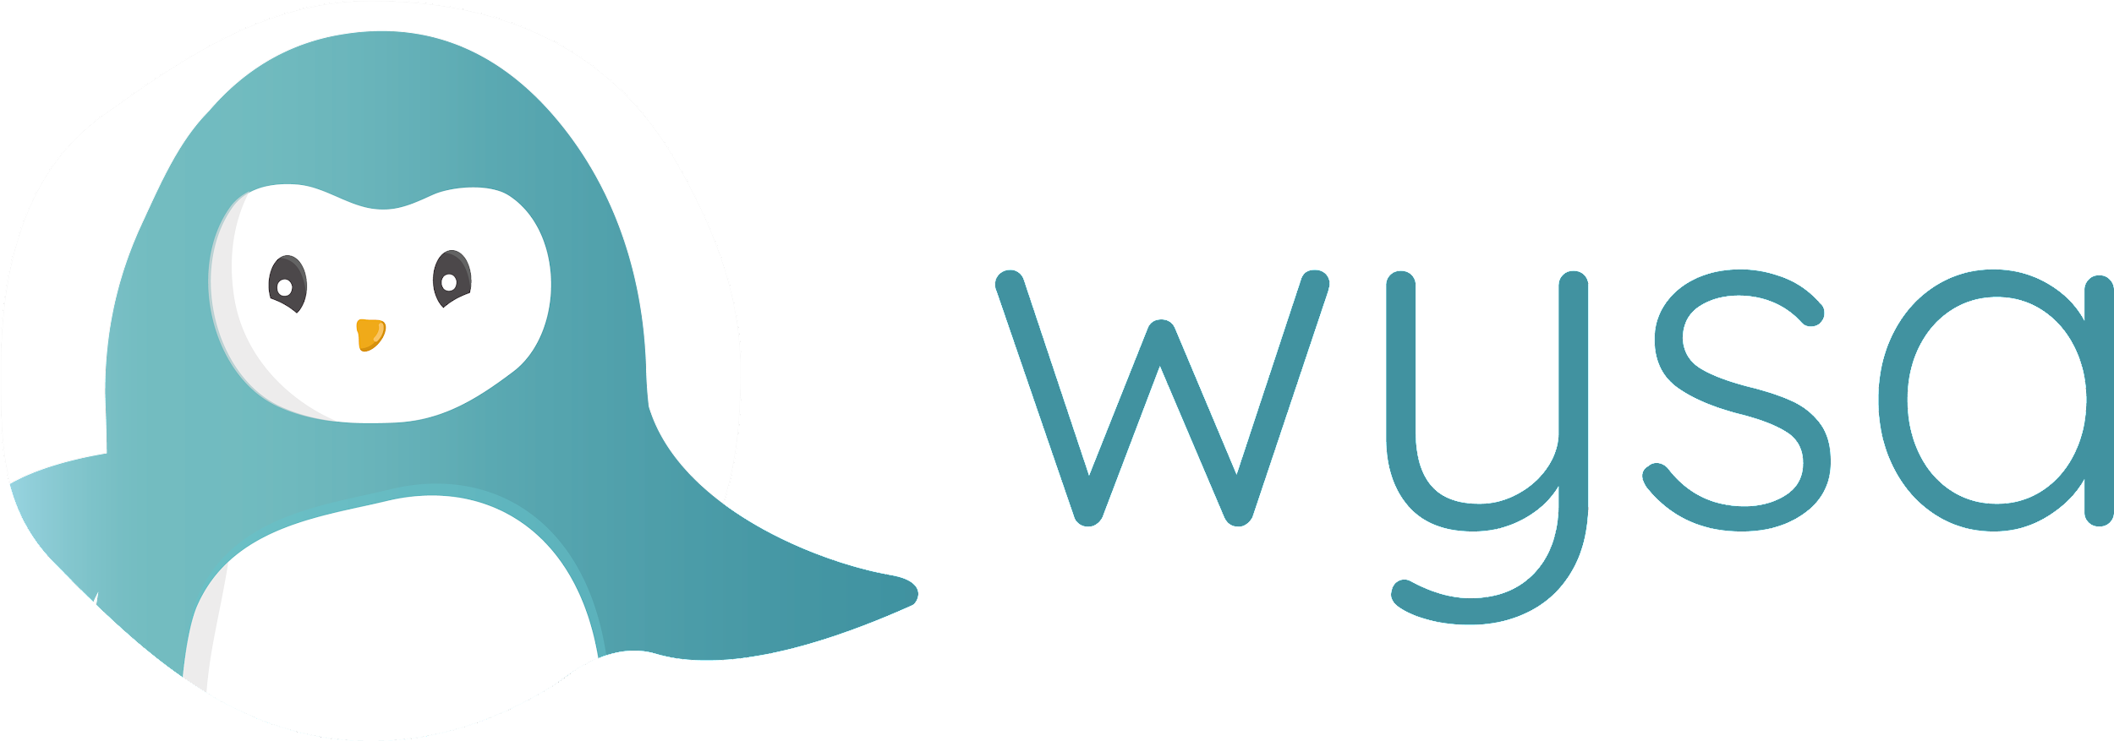
JD - Android Developer

Contents
- About Wysa
- Wysa’s Achievements, Investors & Partners
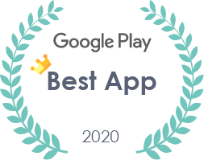
- Role & Responsibilities
- Qualifications & Skills
- Why work at Wysa?
- About Wysa’s Team
- In Their Own Words
- Buzzwords
- Contact Details

-----------------------------------------------------------------------------------------------------------------------------------

About Wysa
Wysa is a chatbot that helps people deal with depression, stress, anxiety, sleep and manage mental health

Wysa’s Achievements
Wysa is a cutting edge AI guided empathetic chatbot that is a global tech leader in mental health

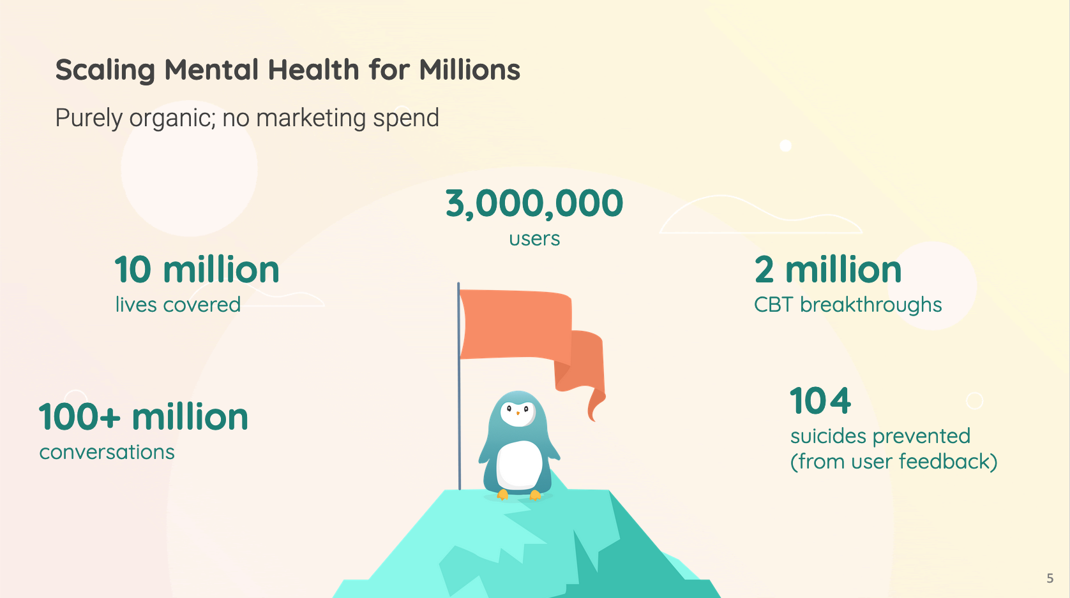

Investors

Partners

Role & Responsibilities
You will hold the beacon for Android app development and user experience at Wysa, while helping us scale from 3 million users to 50 million users

- Take ownership of Wysa’s Android platform
- Writing clean and efficient codes for Android applications
- Identifying and resolving bottlenecks, rectifying bugs and enhancing application performance
- Collaborating with cross-functional teams to define and design new features
- Staying up to date with new mobile technology trends, applications, and protocols
- Continuously improve stability and performance of Wysa’s Android platform
- Exhibits knowledge and behavior to adopt Information Security and Privacy practices at their work.

Qualifications & Skills

Technical
- Degree in Computer Science, Engineering or a related field
- You have prior experience (1-2 years) as an Android Developer using Java/Kotlin Android SDK.
- You have experience in publishing an application on the Google Play store
- Proven work experience in design patterns mobile architecture using frameworks such as MVVM/MVP
- Familiarity with RESTful APIs to effectively integrate Android applications
- Proficient understanding of code versioning tools such as Git
- You are a problem solver with good analytical skills

Team Building & Leadership
- Want to interact with all levels of cross-functional teams
- Love problem solving and thrive on handling multiple projects and tasks
- Foster strong professional relationships with the full organization

Why work at Wysa?
Take ownership and be an integral part of a fast growing startup. You will build valuable skills as a professional while also making friends for life

Get a chance to work closely on the latest tech offered by Apple, by attending events hosted by Apple. Wysa was one of only 10 startups chosen for the Apple entrepreneur camp in 2019!

We offer flexible work hours, a possibility for a fully remote job and a culture where you thrive and are rewarded for being a smart worker

Join our team for an exciting, challenging and fulfilling role!

About Wysa’s Team
Global Team - The team comprises people from all over the world and is distributed around the world. Expand your horizons by working with a multicultural team

Industry Leaders - The founders and senior team members are from IITs, IIMs, London School of Business and have held top positions across Goldman Sachs, Pearson, Microsoft leading cross functional global teams. Work with and learn from the very best

Passionate Colleagues - Work with passionate hard working colleagues who will push the boundaries and only deliver the best

In Their Own Words

“I have been working in Wysa for more than 5 years, and it has been an amazing journey! I had the chance to work with several tech like android/ios/flutter/node.js. I love working on product design and development. I have no words to describe the culture of Wysa. It feels like a family, People are Friendly, Collaborative and Passionate. Wysa saved many lives which makes me feel proud.”
- Jaswinder Wadali, Application Lead

Buzzwords
Google funded, VC funded, profitable, has achieved breakeven, global team, global customers, product company, Apple awarded product, Harvard research partner, Google Play Best App of 2020, Made in India, Made for the World

Contact Details!
If you are sold, please write a mail to hr@wysa.io with your resume attached and the subject line: “Application: Android Developer”

