Life & Stress Management Coaching

Class or One on One

Skype possibility

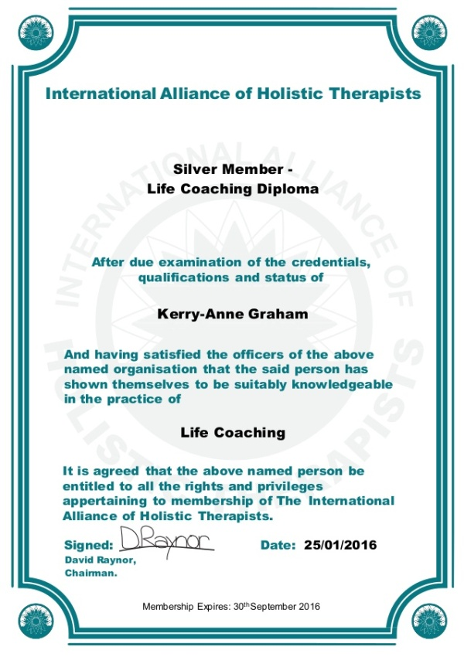

●CERTIFIED LIFE & STRESS COACH●

March 6 –april 5 (each Tuesday and thrusday 7 to 9:30 for 5 weeks)
7 spots remaining! – AT DEKWANEH

Private Tutoring (7 potential spots for March) -at AWKAR
~~~~~~~~~~~~~~~~~~~~~~~~~~

The Gap is getting wider or chaotic between Psychology and Stress coaching, HENCE STRESS COACHING IS A REVOLUTION in dealing with individuals who don’t require severe psychological intervention.

Each one of the mentioned has a specific role. Psychology and psychiatry for instance requires a normal-rigorous M.A or PHD degree, while we all know coaching is a non academic program

You Care for helping others?

You have Deep intuition and random knowledge about stress and would like to share it professionally?
Stress is on the rise like never before; people need the help of professionals.
Some cannot wait months, and years of endless sessions to feel they are back on track.
Do you Have empathy and love towards others?
Are you a professional (in another domain, and feel this course can be an added value?)
Learning the ancient and modern techniques of the body and the mind appeals to you?

If you answered yes, then this program is for you!

‘What is stress coaching?’

the stress coach can be a great bridge between all the clients (yes we call them clients, coaches are not allowed to see “sever mentally ill” patients!) who are lost and cannot get out of their STRESSFULL comfort zone
The majority of people are in that area.
Stress coaches provide solutions (body-mind-spirit), and help in these areas
-anger management
-Anxiety-irritation-depression (not due to a mental illness)
-goal achievements
-obstacles (body-mind-emotions)
Many others…

Many people prefer to follow the natural-way, through healthy food, healthy mental habits, and healthy life management.
Most importantly this program is unique in providing you tools for the physical and mental aspect.

After 500 clients, and years of coaching one on one or by groups, I think I know a thing or 2, about the secrets, insights, and wisdom in that arena

This program requires minimum 7 to 9 session, dedicated privately for your study or via a class environment,
Learning the standards international norms of coaching according to ICF ethics code ,Along with my personal experience and innovated techniques to achieve higher results .

-Course Fee (Class fits for 14 students) 1100$

-March 2 last delay – down payment 500$ to book your place.
8 places left (total 14)

~~~~~~~~~~~~~~~~~~~~~~~~~~~~

-One on One Private Tutoring (7 students for march only!!)
Course Fee: 1500$ (1000 first payment /500 2nd month)

-Skype Tutoring
900$ (7 sessions) transfer or payment via credit card
Email jadmhanna@gmail.com or call/whatsapp +961 76606410

-The materials are the same, while the class allows for interaction, but the pace is slower, and some material cannot be given in extreme depth. But the credentials are the same!

-The private allows for more in depth, and are condensed, and allow dedicated time, and the interaction is of course on all levels

-Skype allows the same as private but less condensed, the screen won’t allow extra exercises meant for direct application, but it’s still powerful.
More videos will be sent besides the direct video interaction)

Jad Mehanna –Life & Stress Coaching –Certificate. Accredited by Uk (Cma) and lebanon.

Life coaching
Subjects included in this Course

• History of Life Coaching
• What Life Coaching is and what it isn’t
• Basic Coaching Principles
• The GROW Model of Coaching – Goal, Reality, Options, Will
• Coaching Applications
• The Role of Other Therapies in Connection with Coaching
• Relationships as Systems
• Obstacles and Anchoring
• The Milton Model
• Time Management
• Stress Management
• The Life Coach’s Clinic
• Contra-indications
• The Role of the Life Coach
• The I-CAN-DO Model of Coaching – Investigate – Current, Aims, Number – Date, Outcome
• SWOT Analysis – Strengths, Weaknesses, Opportunities, Threats
• Mission Statements
• Framing and Reframing
• Representational Systems
• Building Rapport
• Coaching Meta Programs
• Spiral Coaching
• Ethics and Professionalism
• The Consultation
• The Secrets of Life Coaching Success
• How to Build a Life Coaching Practice

Stress Coaching
Course Outline

Module 1: Stress and the Mind-Body Connection. - Definitions of stress; identifying stress – signs and symptoms; positive and negative effects of stress; acute and chronic stress; stress as a positive force; achieving peak performance; emotional intelligence and stress management; strengthening relationships; raising self-awareness; understanding and managing resistance; emotional intelligence and leadership; relating styles; developing assertiveness skills.

Module 2: Coaching and Stress Management. - Defining coaching; planning client sessions – beginning, middle, and ending; active listening skills; questioning and focusing skills; goal-setting; building client rapport; learning styles; ethical guidelines – boundaries and referrals; coaching models including GROW; principles of NLP; relaxation techniques; mindfulness; visualization, imagery and affirmations.

Module 3: Stress Management in the Workplace - Time management. Developing client skills. Impact of workplace stress. Employer's responsibilities. Stress in the workplace. Supporting mental health in the workplace. Stress risk management. Management standards.

Module 4: Stress Management and CBT. - Principles of CBT; ABC model; examining unhelpful thinking patterns; overcoming blocks to change; CBT approaches to managing anxiety; CBT and individual coping styles; identifying and addressing unhelpful core beliefs; behavioral approaches; worksheets and activities.

Module 5 : Proper nutrition for the brain, body mind connection
Basic exercises for stress, breathing.

What you will learn with Coach Jad Mehanna

The Life coaching by itself is losing value as there is now over 10 000 schools and accreditations, and it’s becoming an industry of commercialism. The value nowadays is not in the accreditation but by getting the experience of a coach who has been around the block for over a decade.
It’s true that coaching is an art, but the essence is a must.
Most online certification, end up giving you videos, complicated talk with no practice! Promises in vain! (they focus on how to run a business but not on what they are delivering)

Coaching and specifically stress coaching, requires years and personal growth which can be transmitted only by a professional who has been practicing (working with clients, not working solely in teaching!!!)

Watch out from these “become a coach in few days!!)

Who the heck will hire someone that has been coached in few days?
And coaching you in what?
Hence my course is for people who are interested in deepening their knowledge in STRESS and HEALTH. And TRANSFORMING PEOPLE.

2-My course will last for 5 weeks to, in a friendly office environment.(for the private tutoring) AWKAR

Or At Dekwaneh , main street, In AUCE Building (st takla toward dekwaneh round point) for the class

-This will help you establish immediately the know-how to handle clients one on one.

-Assessing personalities
-Recognizing personalities
-Personality disorders
-The power of the mind (conscious and subconscious)
Applying NLP, EFT, TIME LINE THERAPY, and other skills which nowhere are provided in details, because they come from a personal, and long years of experience.

-Nutrition and Anti-Stress targeted nutrition for the brain.
-Secrets of breathing, Body movements, body therapies that can immediately benefit the client
-active meditation, Mindfulness
-dealing with difficult clients
-Transforming negative beliefs into positive
-Is the law of attraction true-and how to use the essence of it scientifically?

Dozens of sheets, ready-made, for your clients,
Knowing how to run a session starting from the consultation

-This course is registered with the CMA (Complementary Medical Association), which is internationally recognized as the elite force in professional, ethical complementary medicine by professional practitioners, doctors and, increasingly, by the general public.

Upon completion of the course you can gain membership to the CMA, which in addition to supplying a professional accreditation, offers a number of benefits, all of which can be found here.

This course is certified by the IAHT (International Alliance of Holistic Therapists), the IAHT is an internationally recognized organization. The IAHT certify personal development, health, fitness and nutrition courses.

Upon completion of your course assessments, you will receive 3 certificates.
An accredited certificate from the awarding body relating to your course,
a CPD certificate displaying the number of CPD points earned from the course and a certified Diploma certificate from the Centre of Excellence.

-accredited by E.M.A(Ecole Méditerranéenne des Affaires ) a Lebanese accredited body.

About Me

Jad Mehanna, Life Health and STRESS Reduction Coach/
Mentor.
Studied Coaching since 2008, particularly Stress Management, Stress Reduction, combined with Proper Nutrition
made to tackle this issue.
Accomplished musician, since year 2000, also studied Music therapy.
My Mission in Life is to help and be a support for any person who is about to explode from stress or cannot handle it
anymore and it works in parallel with medicine
My Practice and protocol are not about the standard Stress management
It's a multi combination techniques that ranges from
-Interactive-intuitive talk, to learn about the client (the client will feel free to speak about his pas or not)
-learning proper breathing techniques!
-mental exercises done in the office and at home, these exercises depends on the case i receive -method uses are
NLP/ EFT and others/ dynamic speech/body exercises
-gentle medium or heavy body exercises depending on the cases, to unleash repressed energies
-Alexander Lowen, M.D speaks about how the body holds the major part of the stress stored in our system
when we address the body, it will help the mind heal itself, WE DON'T WAIT FOR THE MIND to heal itself
Without proper breathing, meditation, body techniques, postures, mental exercises
Do not dream of removing Stress, with pills only
WHEN YOU GAIN CONTROL OVER YOUR MIND, then you can Move towards your goals.
Take care of YOURSELF first.

Certified Life and Stress Coach
Nutrition Consultant
Stress management Consultant
Sacro- Cranial Therapist
Structural Massage
Meditation and breathing for Stress
Yoga and Tai Chi for Stress
Music Therapist (healing with Music)
www.jadmehannacoaching.com
(sign in to receive my Free-stress e-book)
www.facebook.com/stress.coach1

