Đề bài:
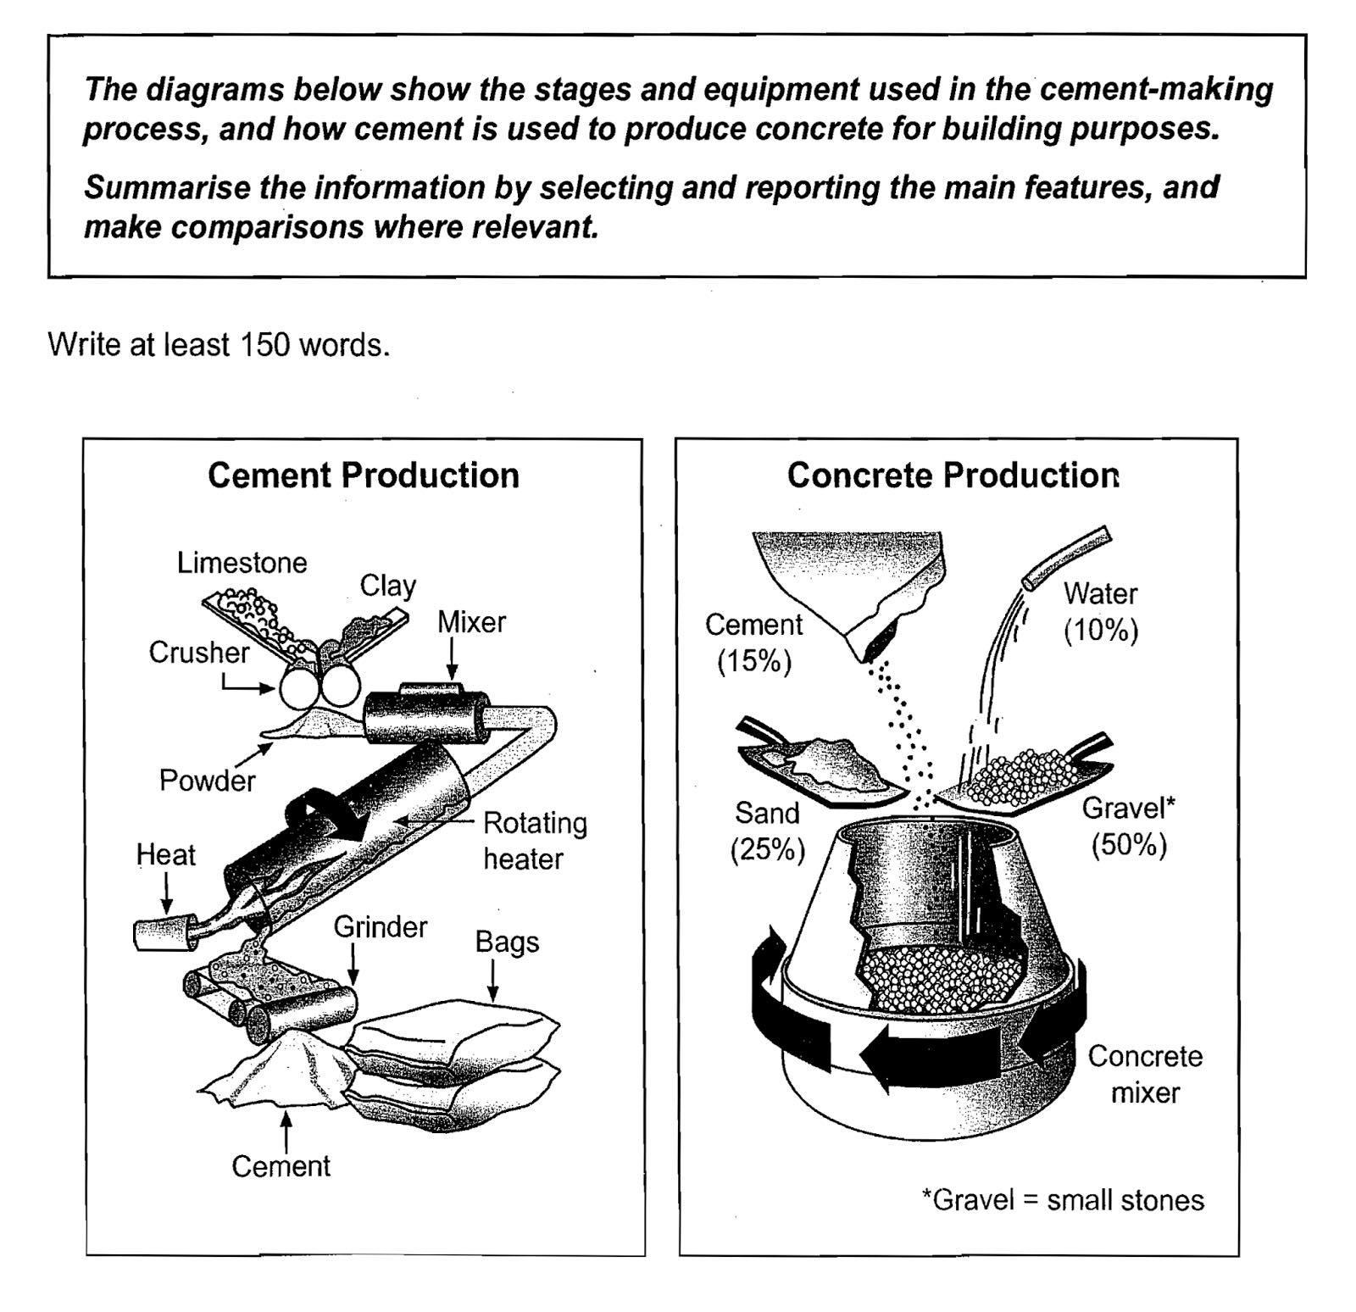

- Dàn bài mà em lập cho đề này

Overall: Cement: 5 steps (mix raw materials -> package new cement)
Concrete: only 2 stages

Body 1: cement:
- Limestone and clay are crushed -> powder -> mixed -> brought into a rotating heater
- Next, grinding the material, and cement is produced -> package in large bags

Body 2: concrete:
- 50% small stones, 25% sand, 15% cement and 10% water combined together in a concrete mixer

Bài viết của em ( luôn nhớ max 300 words cho Task 2, max 160 words cho Task 1)

Tham khảo cách triển khai bài nhé: https://www.ieltstutor.me/blog/process

Given are the diagrams illustrating the production of cement, and how to use cement to make concrete.

Looking at the processes, it is immediately obvious that there are 5 stages in the production of cement, beginning with the mixing of raw materials and finishing in the packaging of new cement; meanwhile, only two steps are required to make concrete.

At the first stage in the production of cement, limestone and clay are crushed to the form of powder. This powder is then mixed and brought into a rotating heater where it is heated in high temperature. The process continues with grinding the material, and cement is produced. In addition, the cement is packaged in large bags.

The process of making concrete by using cement is simpler. To be more specific, concrete consists of 50% small stones, 25% sand, 15% cement and 10% water. Finally, all four materials are combined together in a machine called concrete mixer.

IELTS TUTOR lưu ý:
- Với 2 hình thì cứ chia theo bố cục mỗi hình một đoạn thân bài, chia bố cục như sau:
  - Overall: mô tả sơ qua mỗi hình có bao nhiêu bước (There are five stages in the production of cement, beginning with the input of raw materials and ending with bags of the finished product. To produce concrete, four different materials are mixed together)
  - Body 1: viết hình số 1 (cement production)
    - limestone and clay are crushed to form a powder.
    - This powder is then mixed before it passes into a rotating heater.
    - After heating, the resulting mixture is ground, and cement is produced.
    - The cement is packaged in large bags.
  - Body 2: viết hình số 2 (concrete production)
    - Cement is one of the four raw materials that are used in the production of concrete, along with gravel, sand and water (concrete consists of 50% gravel, 25% sand, 15% cement and 10% water)
    - All four materials are blended together in a rotating machine called a concrete mixer

