Productive, Cost-effective Dairy Farm Model for Sri Lanka

DAIRY FARMER IN SRI LANKA SHOWS THE WAY TO QUADRUPLE MILK PRODUCTION COST EFFECTIVELY by LEVERAGING EXISTING RESOURCES
Mr. Sugath Kumara Bandaranayake is a smallholder dairy farmer in the Northwestern Province of Sri Lanka. Although based in the second highest milk producing region of the country, Mr. Sugath’s dairy management style was rudimentary, and his milk yields were low. Every day he would allow his animals to roam free to feed on roadside grasses and bring in only the milking cows at night to sleep under a basic temporary shelter, where the animals would rarely receive sufficient drinking water. As the nutritional value of roadside grass is very poor, Mr. Sugath provided a ration of concentrate feed that exceeded the daily recommended value, increasing his feed cost without sufficiently boosting his milk yield. His efforts resulted in only 25 to 30 liters of milk per day, at best.
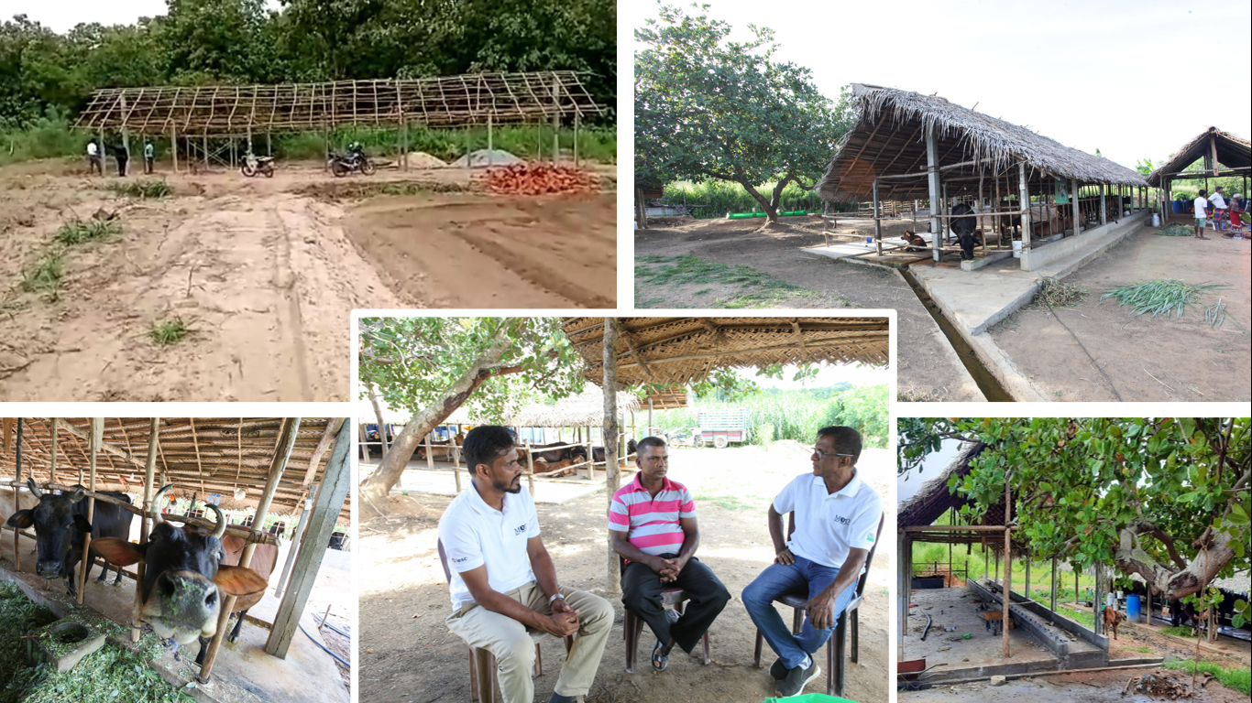
In July 2019, Mr. Sugath attended the Dairy Entrepreneur Development Program training offered by the United States Department of Agriculture (USDA) funded Market-Oriented Dairy (MOD) Project. The MOD methodology intrigued Mr. Sugath as he saw value in the entrepreneurial approach to dairy. With the guidance of MOD’s field officer Mr. Namal Karunasena, he developed an action plan to reach a target of 100 liters of milk per day within a period of 24 months. “What was unique about Mr. Sugath’s approach was that he was not looking for handouts to build the costly best-in-class cattle shed. To be successful at dairying he understood that a gradual process of adopting best practices and being mindful of resource utilization as advised by MOD is likely to lead him to a sustainable path,” commented Mr. Namal. Throughout the process, Mr. Sugath’s focus was on how to adopt the changes in the most cost-effective manner.
Mr. Sugath reflecting on his journey with MOD’s field team who provided the technical support to develop his farm and required cultivation to produce 100 liters per day.
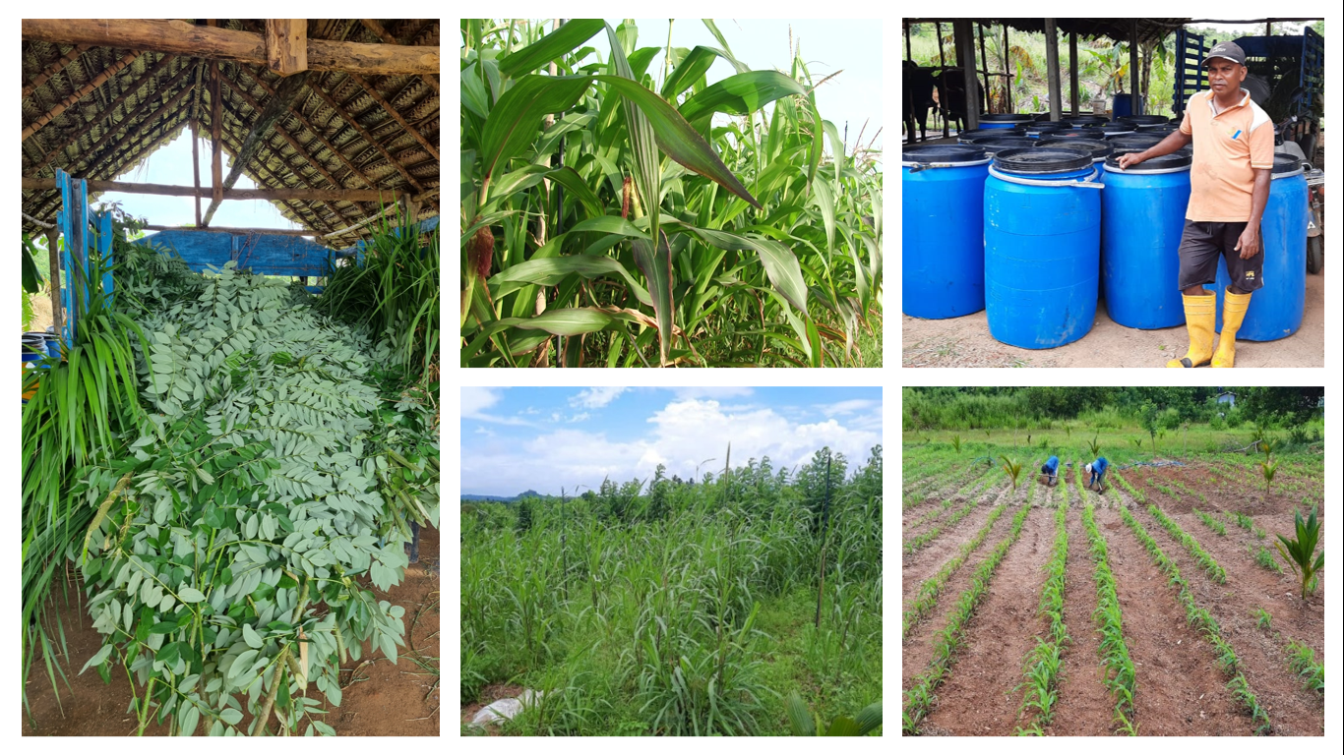
To provide adequate better quality fresh grass, Mr. Sugath cultivated C03 grass on three and a half acres of land and mechanically pumped manure from his farm as fertilizer. With the availability of better-quality grasses, he started providing a balanced ration to his cows, using the Total Mixed Ration (TMR) method promoted by MOD. To provide shelter for his animals, he constructed a shed using locally available low-cost materials at the highest point on his land to ensure adequate ventilation. He also constructed an auto dispenser to provide clean water to his animals 24 hours a day. With the gradual increase in milk production and cows coming into heat at the right time, he saw the direct benefits of providing access to clean drinking water, good quality feed, and improving cow comfort. Motivated by these results, he continued his quest to reach the 100-liter target by applying best management practices in calf rearing to ensure the health of his replacement herd. As advised by MOD, he also planted an additional one acre of high-quality grasses, such as improved Napier varieties, to test which types of grasses would result in the best milk yields before converting his C03 cultivation to grass types with higher nutritional values. Due to the limited availability and high cost of inorganic fertilizer in the country, Mr. Sugath learned from MOD the techniques of producing vermicompost, an inexpensive organic compost using farm wastes, and is currently testing the vermicompost and vermitea in sections of his cultivation.
Growing better quality grasses paddocked to meet the daily needs, Mr. Sugath ensiles the excess grass to preserve it as silage for future use assuring feed availability throughout the year.
With these improvements and his adoption of the MOD promoted dairy management best practices, Mr. Sugath is now producing over 100L per day over a period of 180 days whilst maintaining a lactation period of eight months. Commenting on his achievements, Mr. Sugath said, “Following an action plan and focusing on maximizing available resources ensured that I achieved my target at an affordable cost. Now my focus is to manage my herd to sustain a consistent milk yield and income throughout the year.” At present, Mr. Sugath’s cost of production is around 23 cents (or LKR 85) per liter with a net profit ratio of 22 percent. Mr. Sugath is also planning on investing in solar power to operate his milking machine, chaff cutter and sprinkler system with the support of MOD, which will not only reduce his costs but will also mitigate the country’s current pressures on energy availability and contribute towards climate smart initiatives.
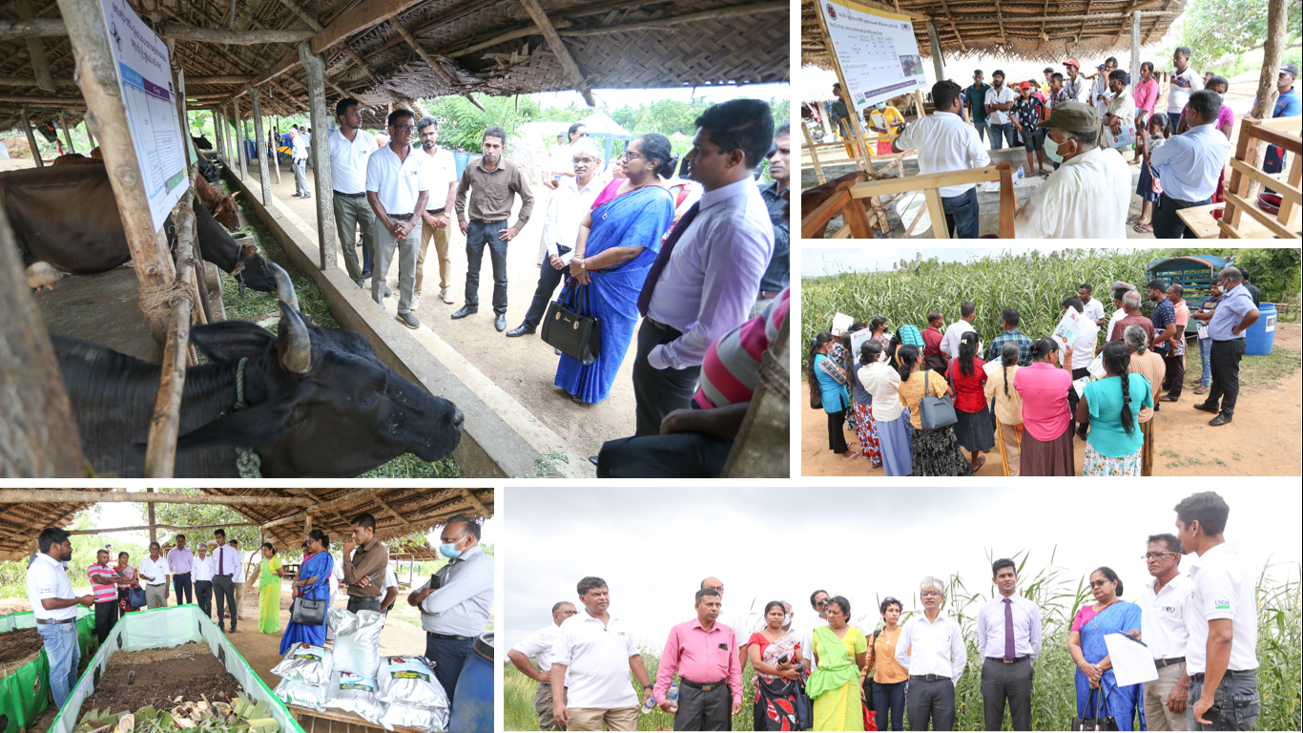
Following his success, Mr. Sugath agreed to share his experiences in developing a low-cost model to reach 100-liter per day. Nearly 300 dairy farmers from the Northwestern Province had the opportunity to witness the outcomes of Mr. Sugath’s efforts at a dairy farmer field day hosted by MOD and the Department of Animal Production and Health (DAPH). MOD’s Senior Technical Specialist Mr. Kapila Wickramasinghe overseeing technical interventions in the development of 100-liter farms stated, “MOD’s intent is to support DAPH to develop such low-cost yet productive models across the province. The country’s economic crisis has certainly highlighted the importance of replicating such models across the island to meet the national requirement for fresh milk.”
Senior officials of DAPH and dairy farmers tour the dairy farm during the Dairy Farm Field Day held to commemorate the World Milk Day.
To date MOD has trained 6,108 dairy farmers, of which over 30 percent are progressive farmers approaching dairy as a business targeting daily milk yields of over 60 to 100 liters. A recent survey showed that 56 percent of farmers supported by MOD have adopted all ten recommended dairy management best practices, while 60 percent provide more nutritious feed to their animals throughout the year through cultivation of their own fodder and supplementing feed shortages by purchasing grass or silage to bridge the gap. Most importantly, 76 percent of the farmers surveyed have experienced increased milk yields after MOD interventions.
Market-Oriented Dairy (MOD) Project, based in Sri Lanka, is funded by the United States Department of Agriculture (USDA) ‘Food for Progress’ initiative and implemented by IESC. The project aims to double the milk production of participating dairy farmers and enable them to obtain a higher price premium for fresh milk through interventions primarily designed to enhance their technical knowledge and create an entrepreneurial, business-oriented mindset. The project also supports enterprises along the dairy value chain to meet the demands of the country’s dairy sector to catalyze a sustainable growth. The project’s sub-partners are Sarvodaya, University of Florida, and Global Dairy Platform.

