Limited Scope Representation for Clients
A New Tool for Affordable Legal Services

What is limited scope representation (LSR)?
Limited scope representation is a new way that Michigan lawyers can help you with part of your case while you do the rest of the work. Limited scope representation is also called “unbundled” or “a la carte” representation. It helps lawyers and clients work together to divide up the different tasks in a case and decide who will be responsible for each. New rules let lawyers prepare legal documents for a client without going to court, sometimes called “ghostwriting.” Lawyers can also represent clients in just some parts of their court cases. This is different from before, when the rules said a lawyer had to represent their client in all parts of the court case, and the client had to pay for all parts of his case. These new rules apply only to most civil cases— not to any criminal cases.
How does LSR benefit me?
LSR can help you get legal help in just some parts of your case.
- You will only pay the lawyer for the parts of the case that they handle, which gives you more control over the cost. The amount you pay can vary depending on many things including the types of services provided, how many services are provided, and the lawyer’s experience level.
- You will have to do parts of your case yourself, and you can get help with parts of your case that are more difficult.
- Since you are representing yourself, you will be making most of the decisions and will have more control over your case.
What are examples of limited scope legal services?
Lawyers providing limited scope representation might offer some or all of these kinds of services:
- Researching your legal issue and giving you legal advice;
- Preparing legal documents for you;
- Reviewing legal paperwork you prepared;
- Serving court papers on the other party;
- Giving you legal advice;
- Drafting a demand letter or response letter;
- Negotiating or reviewing a settlement agreement;
- Coaching you on how to appear in court on your own; and
- Representing you in court at a specific hearing (usually the most complicated or important one) while you represent yourself in court for all other hearings.
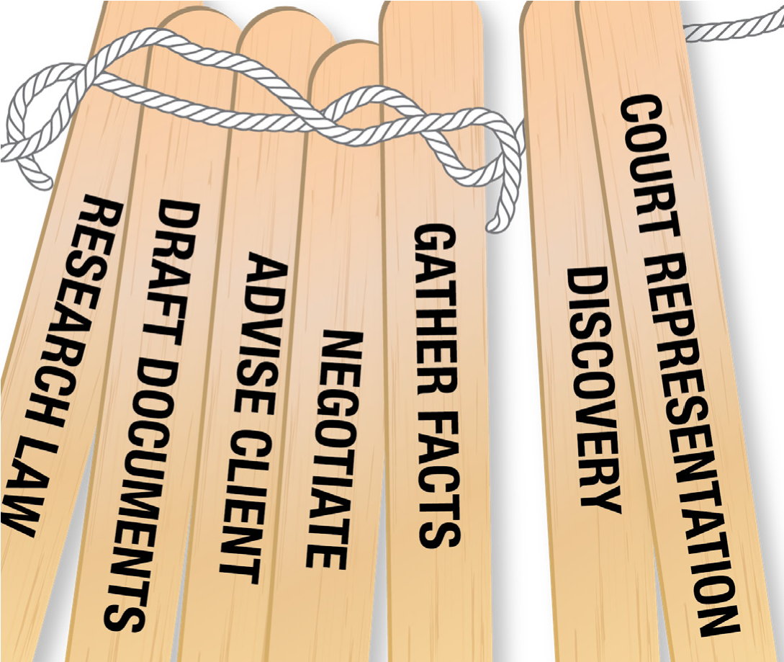
What are examples of limited scope legal services?
Lawyers providing limited scope representation might offer some or all of these kinds of services:
- Researching your legal issue and giving you legal advice;
- Preparing legal documents for you;
- Reviewing legal paperwork you prepared;
- Serving court papers on the other party;
- Giving you legal advice;
- Drafting a demand letter or response letter;
- Negotiating or reviewing a settlement agreement;
- Coaching you on how to appear in court on your own; and
- Representing you in court at a specific hearing (usually the most complicated or important one) while you represent yourself in court for all other hearings.
What will the lawyer do?
You and the lawyer will work together to decide who will be responsible for the different parts of your case. Make sure you ask your lawyer what things you will need to do, and make sure you are comfortable doing them on your own. Your lawyer should put this agreement in writing, have you sign the agreement, give you a copy of the agreement, and update it whenever any changes are made.
Will LSR work for me?
The new rules tell the lawyer to make sure your part of the work is “reasonable under the circumstances.” This means the lawyer must believe you are able to represent yourself. The rules also require the lawyer to get your “informed consent” to make sure you know what you have to do and what the lawyer agrees to do. It is best if this agreement is made in writing. michbar.org/pmrc/limited-scope
What will the lawyer do?
You and the lawyer will work together to decide who will be responsible for the different parts of your case. Make sure you ask your lawyer what things you will need to do, and make sure you are comfortable doing them on your own. Your lawyer should put this agreement in writing, have you sign the agreement, give you a copy of the agreement, and update it whenever any changes are made. Will LSR work for me?
The new rules tell the lawyer to make sure your part of the work is “reasonable under the circumstances.” This means the lawyer must believe you are able to represent yourself. The rules also require the lawyer to get your “informed consent” to make sure you know what you have to do and what the lawyer agrees to do. It is best if this agreement is made in writing.
Questions about representing yourself?
To find out more about representing yourself visit Michigan Legal Help at MichiganLegalHelp.org. This is a website for people who are handling their legal problems without a lawyer. It can help you learn about your legal problems and get ready for court. There are many do-it-yourself tools to help you create court forms. It does not give legal advice, and it is not a substitute for having a lawyer. If you need more help, use the Guide to Legal Help to get referrals to lawyers, community services, or a self-help center nearby.
Ask me about my LSR services:
I am a licensed Michigan lawyer, active and in good standing. I provide limited scope representation services and am happy to talk with you about them. See my State Bar of Michigan contact information below.

