Emerging Technologies Fact Sheet

Co-Chair: Miu Ling Lam, Associate Professor, City University of Hong Kong
Hong Kong SAR

Co-Chair: Kouta Minamizawa, Professor, Keio University, Japan

Program Schedule: Wednesday, 13 December – Friday, 15 December
Fast Facts

- This year's theme for Emerging Technologies is "IN(TER)VENTION." The program is a critical platform for fostering research communities and impacting the public by creating functional and experiential prototypes, a critical step in invention and technological intervention.
- The program received 41 submissions, the collective work of 128 authors from 10 countries/regions (Australia, China, Hong Kong, Japan, Netherlands, New Zealand, Russia, South Korea, United Arab Emirates, and USA).
- All submissions were critically reviewed by 12 Emerging Technologies committee members and 75 external reviewers who are experts in academia and industry. The committee finally accepted 23 projects, yielding an acceptance rate of 56%.
- The primary mode of presentation is through awe-inspiring demonstrations, with the "Best Demo Award" recognizing the most outstanding presentation.

Quote from Miu Ling Lam, Associate Professor, City University of Hong Kong,
Hong Kong SAR, SIGGRAPH Asia 2023 Emerging Technologies Co-Chair:

“Arthur Clarke once said Any sufficiently advanced technology is indistinguishable from magic. The Emerging Technologies is where magic comes true.”
Quote from Kouta Minamizawa, Professor, Keio University, Japan, SIGGRAPH Asia 2023 Emerging Technologies Co-Chair:

“Welcome to the forefront of innovation at SIGGRAPH Asia 2023 Emerging Technologies.
From 3D displays and haptics to assistive technologies and avatars --- Join us and experience the technologies shaping our future! “

SIGGRAPH Asia 2023 Emerging Technologies Highlights
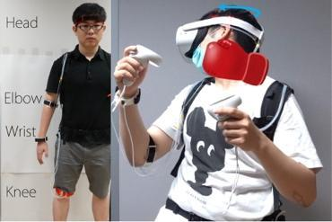 | - HangerBody: a Haptic Device Using Haptic Illusion for Multiple Parts of Body  Contributors: Takuto Nakamura (The University of Tokyo)  Hideaki Kuzuoka (The University of Tokyo)  Description: The hanger reflex is a phenomenon in which a strong sense of rotational force is perceived when one wares a wire hanger on his/her head. We propose the HangerBody system, which applies the hanger reflex to multiple parts of body simultaneously to expand the range of applications.
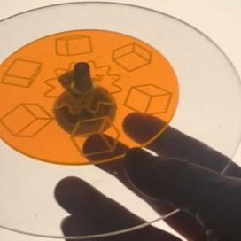 | - The Zoetop: a Kinestetic Aware Zoetrope  Contributors: Alvaro Cassinelli (City University of Hong Kong)  Daniel Saakes (University of Twente)  Description: We demonstrate an innovative variation of the Zoetrope relaying on internal sensing of speed and axis of rotation and thus not requiring motors or external stroboscopic lights.
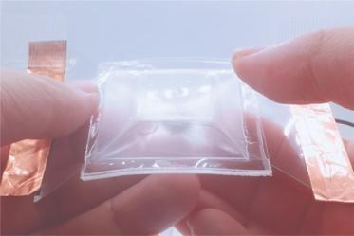 | - AirPolygon: Transparent, Film-based and Flexible 3D Display with Air-control  Contributors: Yuki Akachi (Keio University)  Junichi Yamaoka (Keio University)  Description: AirPolygon is a soft, bendable, and transparent pneumatic control film. AirPolygon distinguishes itself with its ease of fabrication, high transparency for direct LCD attachment, and lightweight, deflatable design for portability.
 | - Waylet: Self-Contained Haptic Device for Park-Scale Interactions  Contributors: Tomosuke Maeda (Toyota Central R&D Labs.)  Junnosuke Yamamoto (Keio University)  Takayoshi Yoshimura (Toyota Central R&D Labs.)  Hiroyuki Sakai (Toyota Central R&D Labs.)  Kouta Minamizawa (Keio University)  Description: Waylet is a self-contained haptic device that can provide translational and rotational pseudo-forces by asymmetric vibration for park-scale interactions. We demonstrate an intuitive haptic navigation system in a park-scale mixed-reality environment and haptic rendering to show the feasibility of our concept.

For Emerging Technologies Program highlights, please visit: https://asia.siggraph.org/2023/attend/emerging-technologies/
For the overall SIGGRAPH Asia 2023 program schedule, please visit https://asia.siggraph.org/2023/full-program/

