Bird-Butterfly: Modeling Predation and Natural Selection

Materials Needed: | - Bird-Butterfly Code Sheets (3-4 per student)  - Computers loaded with ViMAP bird-butterfly  - Computer Projector
Sequencing and Guiding Questions

Programming the Actions of Butterflies | - Provide each student or pair of student with a computer loaded with ViMAP Bird-Butterfly  - Ask students to explore the new commands. During this exploration, you may need to discuss conditionals (If/then/otherwise statements)  - Ask students to create thriving population of butterflies in the model. Discuss extinct, endangered and thriving in animal populations. Have students record their codes on the provided code sheets. Students will use these ‘code logs’ to debug and create stable models.  - After independent work, as a class discuss the programming choices students’ made. What did they put in “If nectar here”, Why? What do ‘go forward’ and ‘random turn’ do? Why are the ‘otherwise’ spaces left empty? Ask other similar questions.  - Draw students’ attention to the graphs and evidence of natural selection (see below for explanations)
EXPERT CODE: Note: Runs of ViMAP are random. The same settings produce different outcomes each time you hit ‘go’ Even the expert code can result in the death of all butterflies. We encourage users to ‘play’ with the code.
SETUP: BUTTERFLIES SETUP: OBSERVER
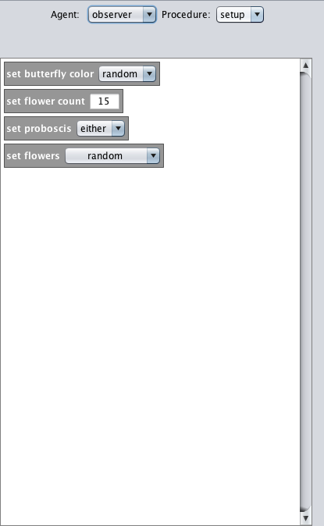
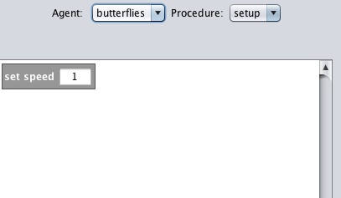

Color can be red, blue or random.
Butterflies lose energy based on how fast they go. A speed higher than one will cause butterflies to waste energy and die.
Max 15 butterflies
Proboscis short, long or either
Flower location Clustered, random, long/short or long/short/either

GO: BUTTERFLIES (there is no code in Go: Observer)
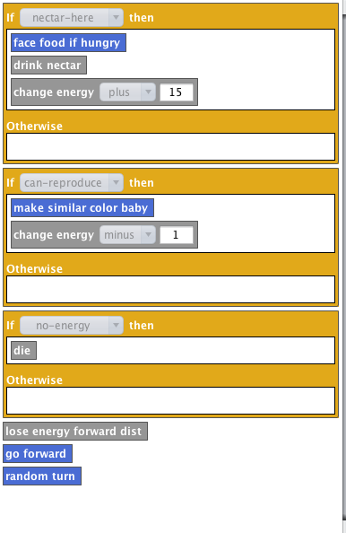
The ViMAP model is very sensitive to energy. Provide the butterflies with enough energy from food to survive. Minimum 15 energy per drink nectar.
Similar Baby versus Same Color Baby: For Natural Selection to occur, select similar color baby. Color will change over generations to camouflage with the flowers to avoid predation. Babies appear as small butterflies that grow over time. Reproduction costs energy.
If no energy, then the butterfly will die, turn black and disappear.
Lose energy Forward Distance: Butterflies lose energy based on speed.
Go Forward & Random Turn: Makes the butterflies wander around the screen.
NOTE: These actions are the ‘otherwise’ actions. Thus, why there is nothing in the otherwise portion of the blocks. If butterflies are not eating, they are wandering around for food.

To run the model:

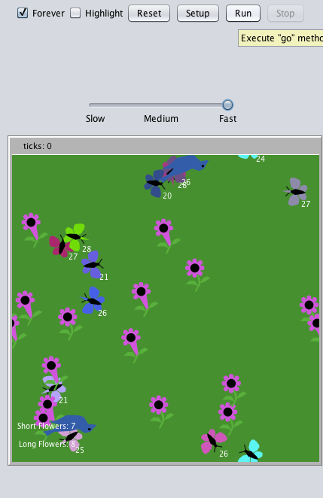
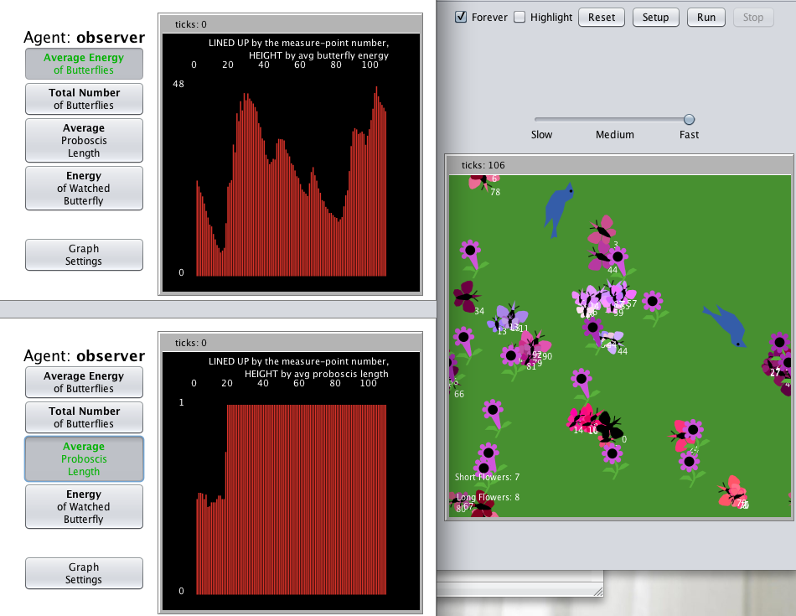
1. Select ‘Forever’ to run model continuously
2. Scroll slider to ‘Fast’ to produce more natural movement
3. Hit ‘Setup’
4. Hit ‘Go’
ENACTMENT WINDOW
1. ‘Ticks’ can represent time in ViMAP. One run = 1 tick
2. Butterflies are labeled with energy values.
3. Flower counts provided

4. Long Flowers are distinct from short flowers.
5. Butterflies begin as random colors (if random selected)

Average Energy graph shows the change in the total energy of the population.

Total Number of Butterflies shows how the population is changing over time.
NATURAL SELECTION:

Notice how the color of the population of butterflies has selected for a color close to the flower color (role of camouflage in survival)

Over time, the Average proboscis length becomes long (Long=1, Short =0). Long proboscises are more advantageous than short.

