Wild Tracks: Approximation

Materials Needed: | - Approximation Worksheet  - ViMAP One-Turtle
Set Up | - Transfer (or have students transfer) their step size data to the approximation worksheet.  - Choose values for Monesha’s step sizes (sample: 10, 12, 11, 10). Hand write these values on the worksheet and then make copies for students.
Sequencing and Guiding Questions

Approximation | - Pass the Approximation worksheet out to students.  - Follow the sequencing suggested in the worksheet.  - Have students mathematically justify their approximate values. They can do this by:  - Showing that their approximate value falls within the range of their actual values.  - Comparing their approximate total distance (add all approximate steps sizes) with their actual total distance (add all actual step sizes).  Big Ideas:  - Approximations are a stand in for averages. Like averages, approximations summarize discrete values. For instance, instead of measuring every step you ever took, you can define an approximate value for your step size and use that value as a representative value. If my approximate step size is 10, I can use that value to predict how far I might walk after 50 steps. This ‘guess’ is mathematically defined and fairly accurate.  - Accurate approximations are mathematically defined. We use the idea of a range to bound possible approximate values. Comparing actual to approximate distances also mathematically defines approximate values.
Model Approximate values | - Have students model and graph their approximate step sizes in one-turtle ViMAP.  - You may notice that many students recycle their code from the previous ViMAP step size activity. This is perfectly okay. Challenge students to use “the least amount of commands possible”. With this prompt, you might notice that students choose to use a repeat command in their code.  - Connect repeat with the number of steps taken. If we want to immediately see how far someone walked in 15, 20 or even 100 steps, all we have to do is change the repeat value.  - Odometer graph shows total distance. Distance Covered since last measure graph shows approximate step size values.  - Some student may want to ‘see’ all of their turtle movements without wrapping. You can reset where your turtle starts by right clicking in the turtle world and transferring those coordinates to a “set xy” command. This command can be placed at the top of your “go” command or in your ‘setup’ commands.  - Sample code is found below.

Without Repeat:
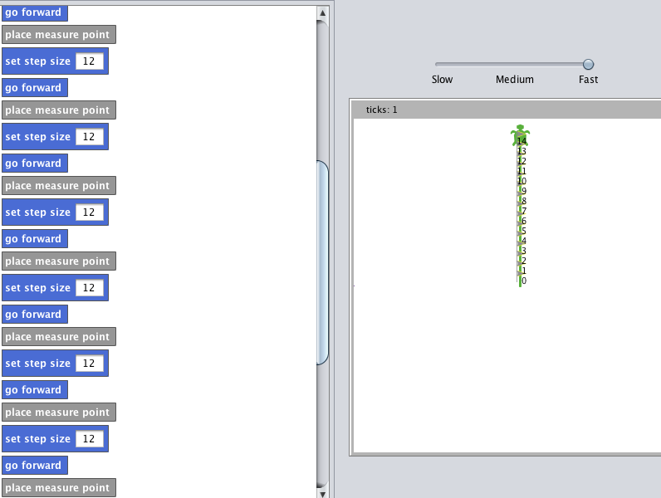
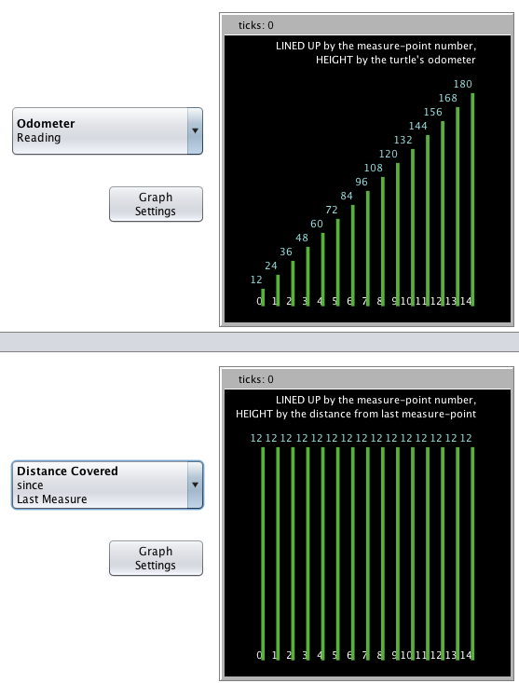

With Repeat:

