Can we predict the distance a person walked?

- What does “predict” mean?

________________________________________________________________________

________________________________________________________________________

________________________________________________________________________

________________________________________________________________________

- Damien took four steps, what total distance did he walk? Write your answer in the space next to the footsteps.

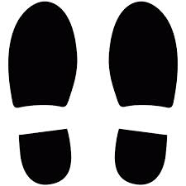


- Imagine that Damien took two more steps. Damien has now walked 6 steps total.

How were you able to figure out the total distance Damien walked after taking two more steps?
How far has Damien walked after taking two more steps?

- Imagine Damien has taken two more steps. Damien has now walked 8 steps total. How far has he walked after taking 8 steps?

- Can you write an addition equation showing haw far Damien has walked after 8 steps?

- Can you write a multiplication equation showing how far Damien has walked after taking 8 steps?

- What two pieces of information are we multiplying together? Can you write a formula for finding total distance traveled?

If we wanted to know the total distance traveled someone traveled, we came up with the formula:

Number of Steps X Step Size = Total Distance Traveled

- Can you predict how far Damien has walked after taking 10 steps? After 20 steps?

