Can We Use ViMAP to Predict Approximately How Far We Walked?

- What do you think “approximate” means?

________________________________________________________________________

________________________________________________________________________

________________________________________________________________________

________________________________________________________________________

Monesha’s footprints are below. She took four steps. Her step sizes were 11 inches, 10 inches, 11 inches & 12 inches long. How far did she walk? Write you answer in the space next to the footsteps.
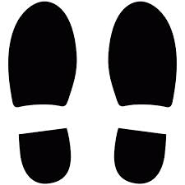


Imagine Monesha took two more steps. Can you predict her approximate total distance?
What is Monesha’s approximate distance after taking two more steps?

How did you predict Monesha’s approximate total distance?

Below is your Step Size Data:

Steps | Step Size (inches)
Step 1
Step 2
Step 3
Step 4
Step 5
Step 6
Step 7
TOTAL DISTANCE:

Using the Number Line Below, mark the range of your step sizes. Your step size range is the area between your smallest and biggest step sizes.

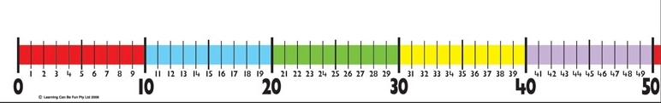

My Step Size Range is between _________________ and _______________ inches.

If my Step Size Range is between ________________and _______________ inches,

I think a good approximate step size is: ____________________inches.

Steps | Step Size (inches) | Approximate Step Size (inches)
Step 1
Step 2
Step 3
Step 4
Step 5
Step 6
Step 7
TOTAL DISTANCE: | ACTUAL = | APPROXIMATE =

- Do you think your approximate step size is a good representation of your actual step sizes? Explain why.

- Can you predict approximately how far you might have walked if you took 10 steps?

Building Models of Total Distance in ViMAP

We have already built exact models in ViMAP of our step sizes and total distance. Now let’s use what we have learned about approximate step sizes and distances to build a model that can help us predict our approximate total distances if we walked ANY number of steps.

Try building a model in ViMAP that measures how far you walked using your approximate step size.

My Step Size Program
Setup | Go

- Using your model, can you predict how far you might have traveled if you took 15 steps?

Total Distance for 15 steps = __________________________

- Which graph did you use to predict your approximate total distance traveled if you took 15 steps?

- Which bar on the graph tells you how far you traveled?

- Using your model, can you predict how far you might have traveled if you took 25 steps?

Total Distance for 25 steps = __________________________

- Did your turtle run into the wall when you ran your program? How did you change your model to keep the turtle from running into the wall?

