Wild Tracks: Leaving Footprints and Defining Measures

Materials Needed: | - Banner Paper  - Washable Jumbo Stamp Pads  - Clorox or Baby Wipes  - Old Towel(s)  - Painter’s Tape  - Measuring Tools (rulers, meter sticks, measure tape)  - Step Size Data Sheets  - 12x18” construction paper  - Strips of Construction Paper  - Glue  - Scissors
Set Up: | - Cut banner paper to a length of 8-10ft  - Draw a line or lay a strip of painter’s tape down the middle of the banner paper to produce two lanes for walking  - In small groups, have students ink the bottom of their shoes with washable ink and, with a normal gait, have students walk the length of the banner paper.  - Situate old towels at the end of banner paper for students to step on after walking on the banner paper.  - Using Clorox or baby wipes, clean the bottom of student’s shoes and wipe dry with an old towel. Student ‘helpers’ can help clean the shoes of their classmates  Note: For this activity, we used washable ink pads from Michaels similar to these:  http://www.amazon.com/Center-Enterprises-Ready2Learn-Washable-primary/dp/B000FA1SEC/ref=sr_1_3?ie=UTF8&qid=1439399599&sr=8-3&keywords=washable+jumbo+stamp+pads  The ink wiped off very easily and washed out of the towels. Red and Green ink were the easiest to clean, blue was harder to clean off, but also the easiest to see. Yellow was hard to see.
Sequencing and Guiding Questions

Introduction | 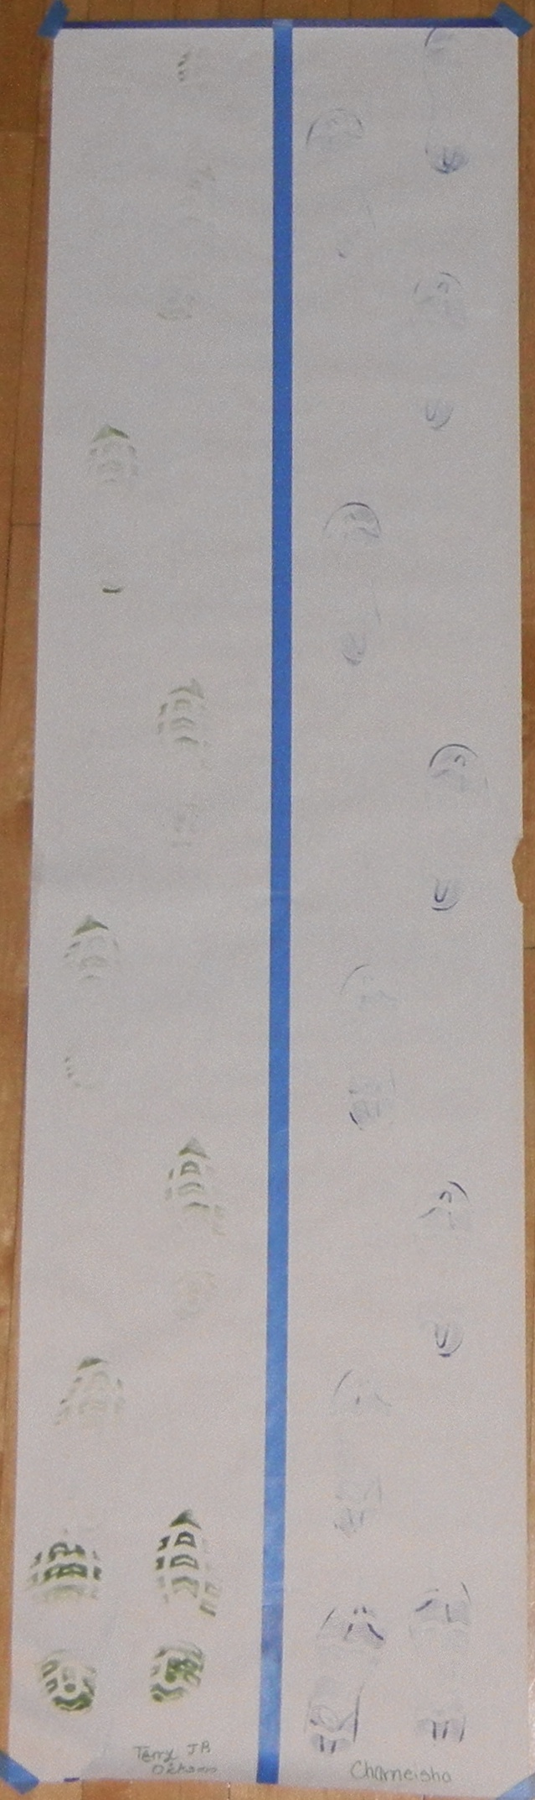  - Using Wild Tracks or a similar book, introduce the idea of footprints and how you can use them to understand the behavior of animals. What direction was the animal walking? Was it walking or running?  - Ask the class if they have ever seen or left footprints.  - Set up walking activity, and bring students out to the hallway or a corner of the room to leave footprints.
Leaving Footprints | - Follow the instructions above to leave footprints. At the end of this activity you should have pairs of student footprints on lengths of banner paper similar to the example below.
Defining a step size | - After students have left footprints. Ask the class how they could measure a ‘step size’. What is a step size? Where would we begin measuring and where would we end measuring?  - From experience, students will typically need scaffolding to identify what constitutes a step size – is it one foot or is it the gait? For this activity, a step size is the a gait.  - Once students have established that a step size is a gait, ask the class how they could measure a step size. Students will typically offer three options, as shown below. 1) Heel to Heel, 2) Heel to Toe and 3) Toe to Toe  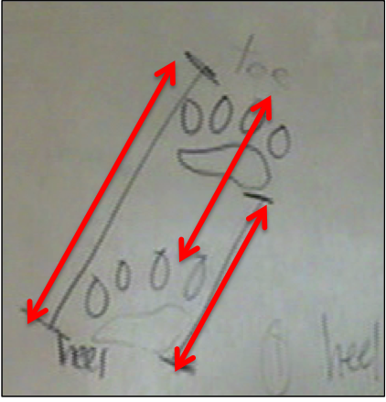  - Allow the students to select one measurement convention. There is no right or wrong answer.
Measuring Step Sizes | - Once students have selected a measurement convention for measuring a step size, have the students measure their individual step sizes using their footprints.  - Record step sizes on data sheet. Students will typically have between 5-7 step sizes recorded. Example is shown below.  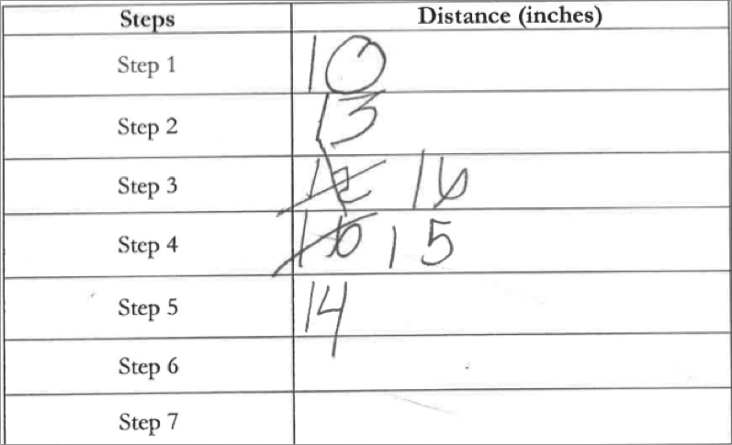
Graphing Step Sizes | - Have students graph their step sizes using the 12x18” construction paper and the strips of construction paper. An example is provided below.  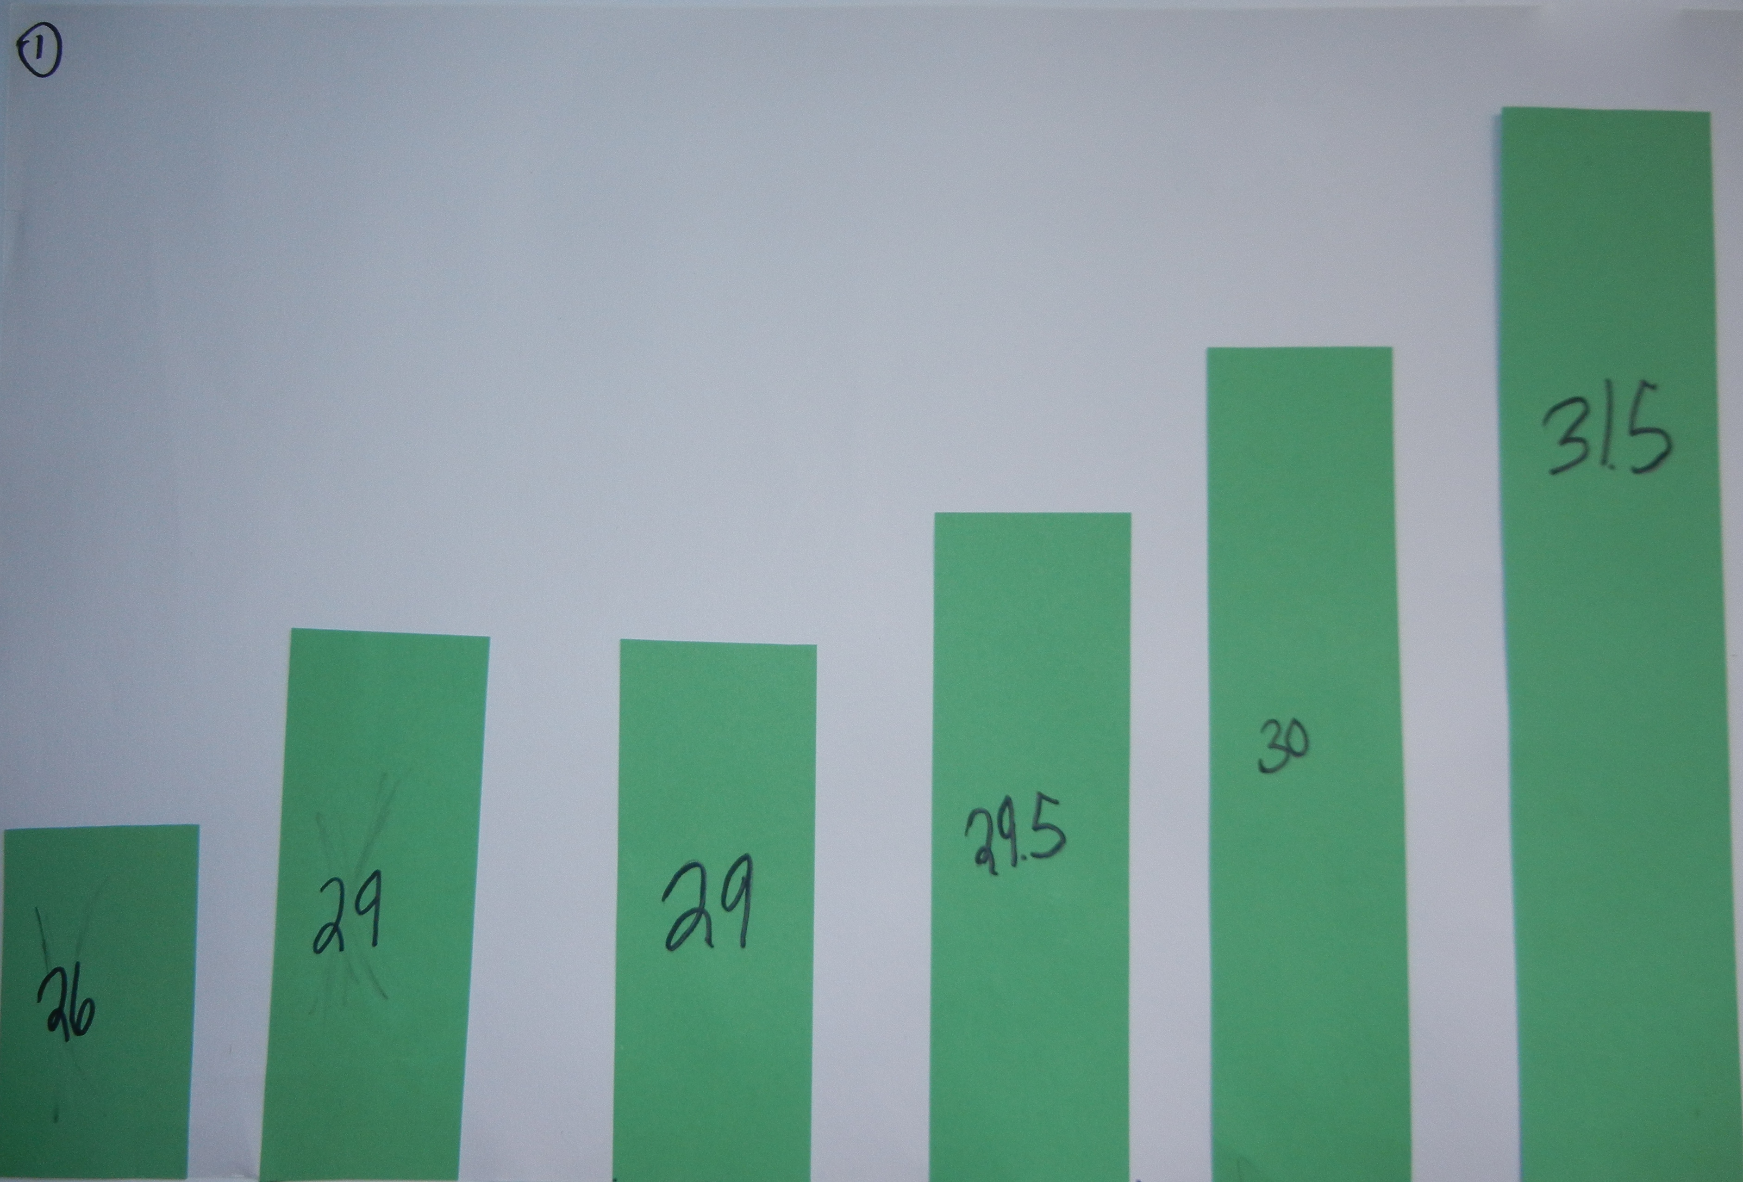  - Students may need help creating graphs. Ideas of scale and sequencing are good ideas to discuss.
Model Step Sizes in ViMAP | - Using one-turtle ViMAP, have students model their step sizes in ViMAP.  - Have students attend to the graphs in ViMAP. What does the odometer graph show you? (total distance travelled) What does the distance covered since last measure tell you? (Your individual step sizes).  - Ask the class to compare their graphs with the ones created in ViMAP. Are they similar?  - An example program is provided below using the sample data shown above.  