Geometry: Regular Polygons

Materials Needed: | - Classroom computers loaded with ViMAP one-turtle  - Projector  - Whiteboard & Whiteboard Markers
Sequencing and Guiding Questions

‘Sleuthing Challenge’: Finish the Shape | - On the overhead projector, project the unfinished ViMAP model shown below (or a variation of it, for instance use repeat 4 instead of repeat 5)  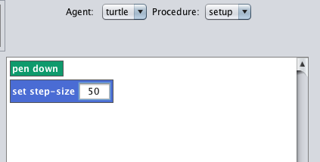  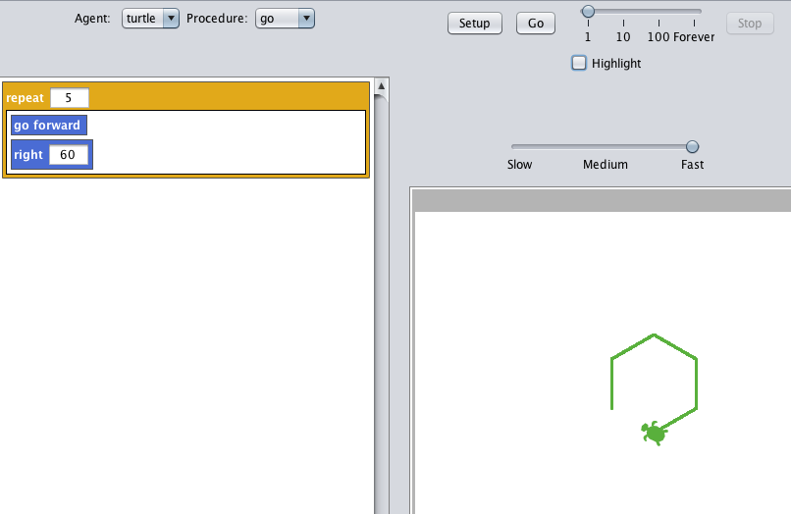  - Challenge the class to finish the shape. When students offer to up the repeat, ask them why changing the repeat will close the shape.  - Connect number of repeat to number of sides of the polygon.
Regular Polygons from 3-10 sides | - Challenge the class to make their own regular polygons. Using the chart below (posted on the whiteboard), ask the class to fill in the information. Students will typically use trial and error to find the angle for triangles, pentagons, etc.  - As students correctly identify the repeats and turn angle, ask them to report this information to the class by writing it on the chart below.  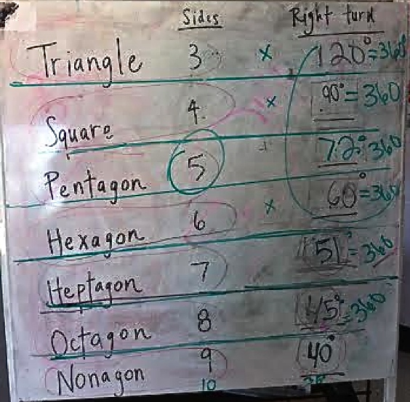  - Classmates can check the work of other students if there are disagreements. For instance, angles of 43-47 look ‘correct’ for an octagon.  Triangle: Repeat 3, Right 120  Square: Repeat 4, Right 90  Pentagon: Repeat 5, Right 72  Hexagon: Repeat 6, Right 60  Heptagon: Repeat 7, Right 51  Octagon: Repeat 8, Right 45  Nonagon: Repeat 9, Right 40  Decagon: Repeat 10, Right 36
Equation for interior angle of regular polygons | - Once repeats, turn angles and number of sides are completely filled in, point out patterns in the relationship between number of sides and turn angle. As number of sides goes up, the turn angle decreases. (Inversely related)  - Ask the class to use their calculators and report what 120x3= and what 90x4 =  - Point out that they both equal 360. Ask students what the formula is. What two things are we multiplying together to get 360?  - Write the formula on the board: Number of sides (Repeat) x Angle = 360  - Explanation for angle is below:  45°  135°  45°  45°  Octagon: Right 45
Regular Polygons of infinite sides (circles) | - Once you have the formula for generating regular polygons, you can ask the class to create and ‘any-side-agon’. If they want a 20-agon, the angle would be 360/56= 18  - Ask what students notice happens to the shapes as the number of sides increases? (They become more circular). HINT: Increase step size to ‘see’ the sides better.  - Connect that circles are infinitely sided polygons.  - If any of the class had difficultly generating a circle in the previous lesson. The formula can help you. Try the two programs below and discuss how and why they are different. What does increasing the step size do? Why?  Pen Down  Set Step Size 1  Repeat 180  Right 2  Pen Down  Set Step Size 1  Repeat 360  Right 1

