Bird-Butterfly: Foraging for Nectar and Generating Energy Graphs
(Complete all activities twice – across 2 days - as students will attend to different aspects of the environment based on their previous experiences)

Materials Needed: | - 20-40 plastic vases. 50% ‘short’ and 50% ‘tall’.  - 20-40 Silk Flowers (either varied or all the same type)  - Mailing Labels  - Plastic Baggies, enough for all students in the class.  - Drinking Straws  - Plastic Cups  - 200-300 Glass ‘Energy’ Beads  - 12x18 Construction Paper  - Construction Paper cut into 1.5” strips  - Glue  - Pen/Pencils/Markers  - Scissors  - Energy Data Sheets
Set Up: | - Number flower vases using mailing labels  - Place silk flowers in vases and drop some glass beads into the bottom of the vase  - Place vases around the classroom. Try to create ‘habitats’ of flowers. For instance, cluster most of the short flowers in one section of the classroom. You may also choose to create a ‘mixed’ habitat of tall and short flowers.  - Record location of each flower (using the number on the vase) on the map of the classroom. This map will be used for the following activity.  - Fill plastic cups with glass beads and place one plastic cup next to each flower. Students will take ‘nectar’ from the flowers by removing beads from the plastic cup.  - Cut drinking straws into two lengths, half that can reach the bottom of both vases and half that can only reach the bottom of the short vases.  - Place 15 beads each in plastic baggies, one for each student.
Sequencing and Guiding Questions

Introduction | - Provide half of the class with a short straw and half of the class with a long straw  - Provide each student a plastic baggie with 15 ‘energy’ beads  - Briefly describe what a proboscis is on a butterfly. What do butterflies drink? With what? Connect proboscis to straws.  - Explain to the class that they have each been given 15 ‘energy beads’ and they will be playing the part of butterflies foraging for nectar. You might have to ask what energy is: how do we get our energy? What does energy do for us? Do all animals need energy?
Rules for Embodied Activity | Walk the class through the following rules. It is helpful to enact these rules yourself in front of the class and to show the class how they can calculate how their energy is changing using the data sheet.  - Each ‘butterfly’ has 15 energy beads. Flowers have been placed around the classroom. Some are tall and some are short. Some of have short straws and some of you have long straws.  - Your goal is to drink nectar from the flowers in the classroom. As you walk to a flower, each step costs 1 energy bead.  - If you are able to drink from the flower (straw touches the bottom of the vase), you may take 5 energy beads from the cup beside the flower.  - If you are not able to drink from the flower (straw does not touch bottom of the vase), you cannot take any beads from the cup. You may continue foraging.  - Record the number of steps taken, the number of the flower you visited and whether you could drink from the flower on your energy data sheet.  - Calculate your remaining energy and transfer that number to the next row.  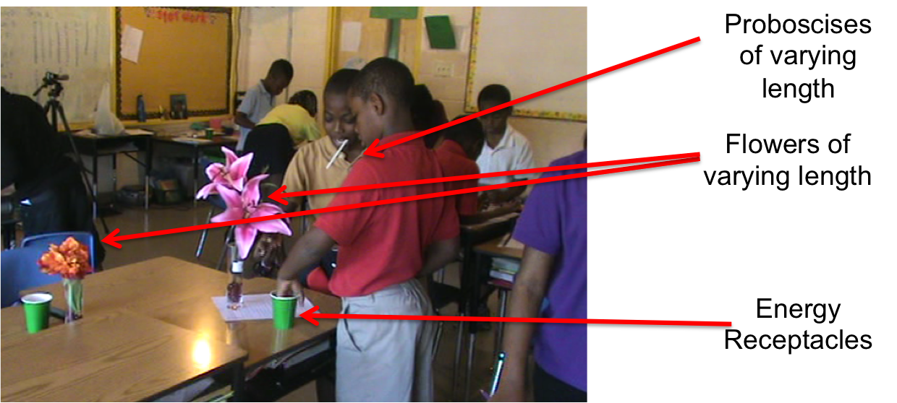
Embodied Modeling Activity | Allow the class to run through the embodied modeling activity (15-20 minutes)  If a student loses all of their energy beads, they have ‘died’ and have to sit out the rest of the activity.
Creating Graphs of Change in Energy | After the class has run through the embodied modeling activity, distribute 12x18inch construction paper, glue, scissors, markers and pens and strips of construction paper (20 minutes)  - Tell the class that they need to create a picture or graph of how their energy changed over time using their data sheets  - Do not tell the class how to make the graph. Their data sheets contain information such as flower number, number of steps taken, energy gained and total energy. Which information students choose to represent is part of the learning process. Consider the two graphs below:  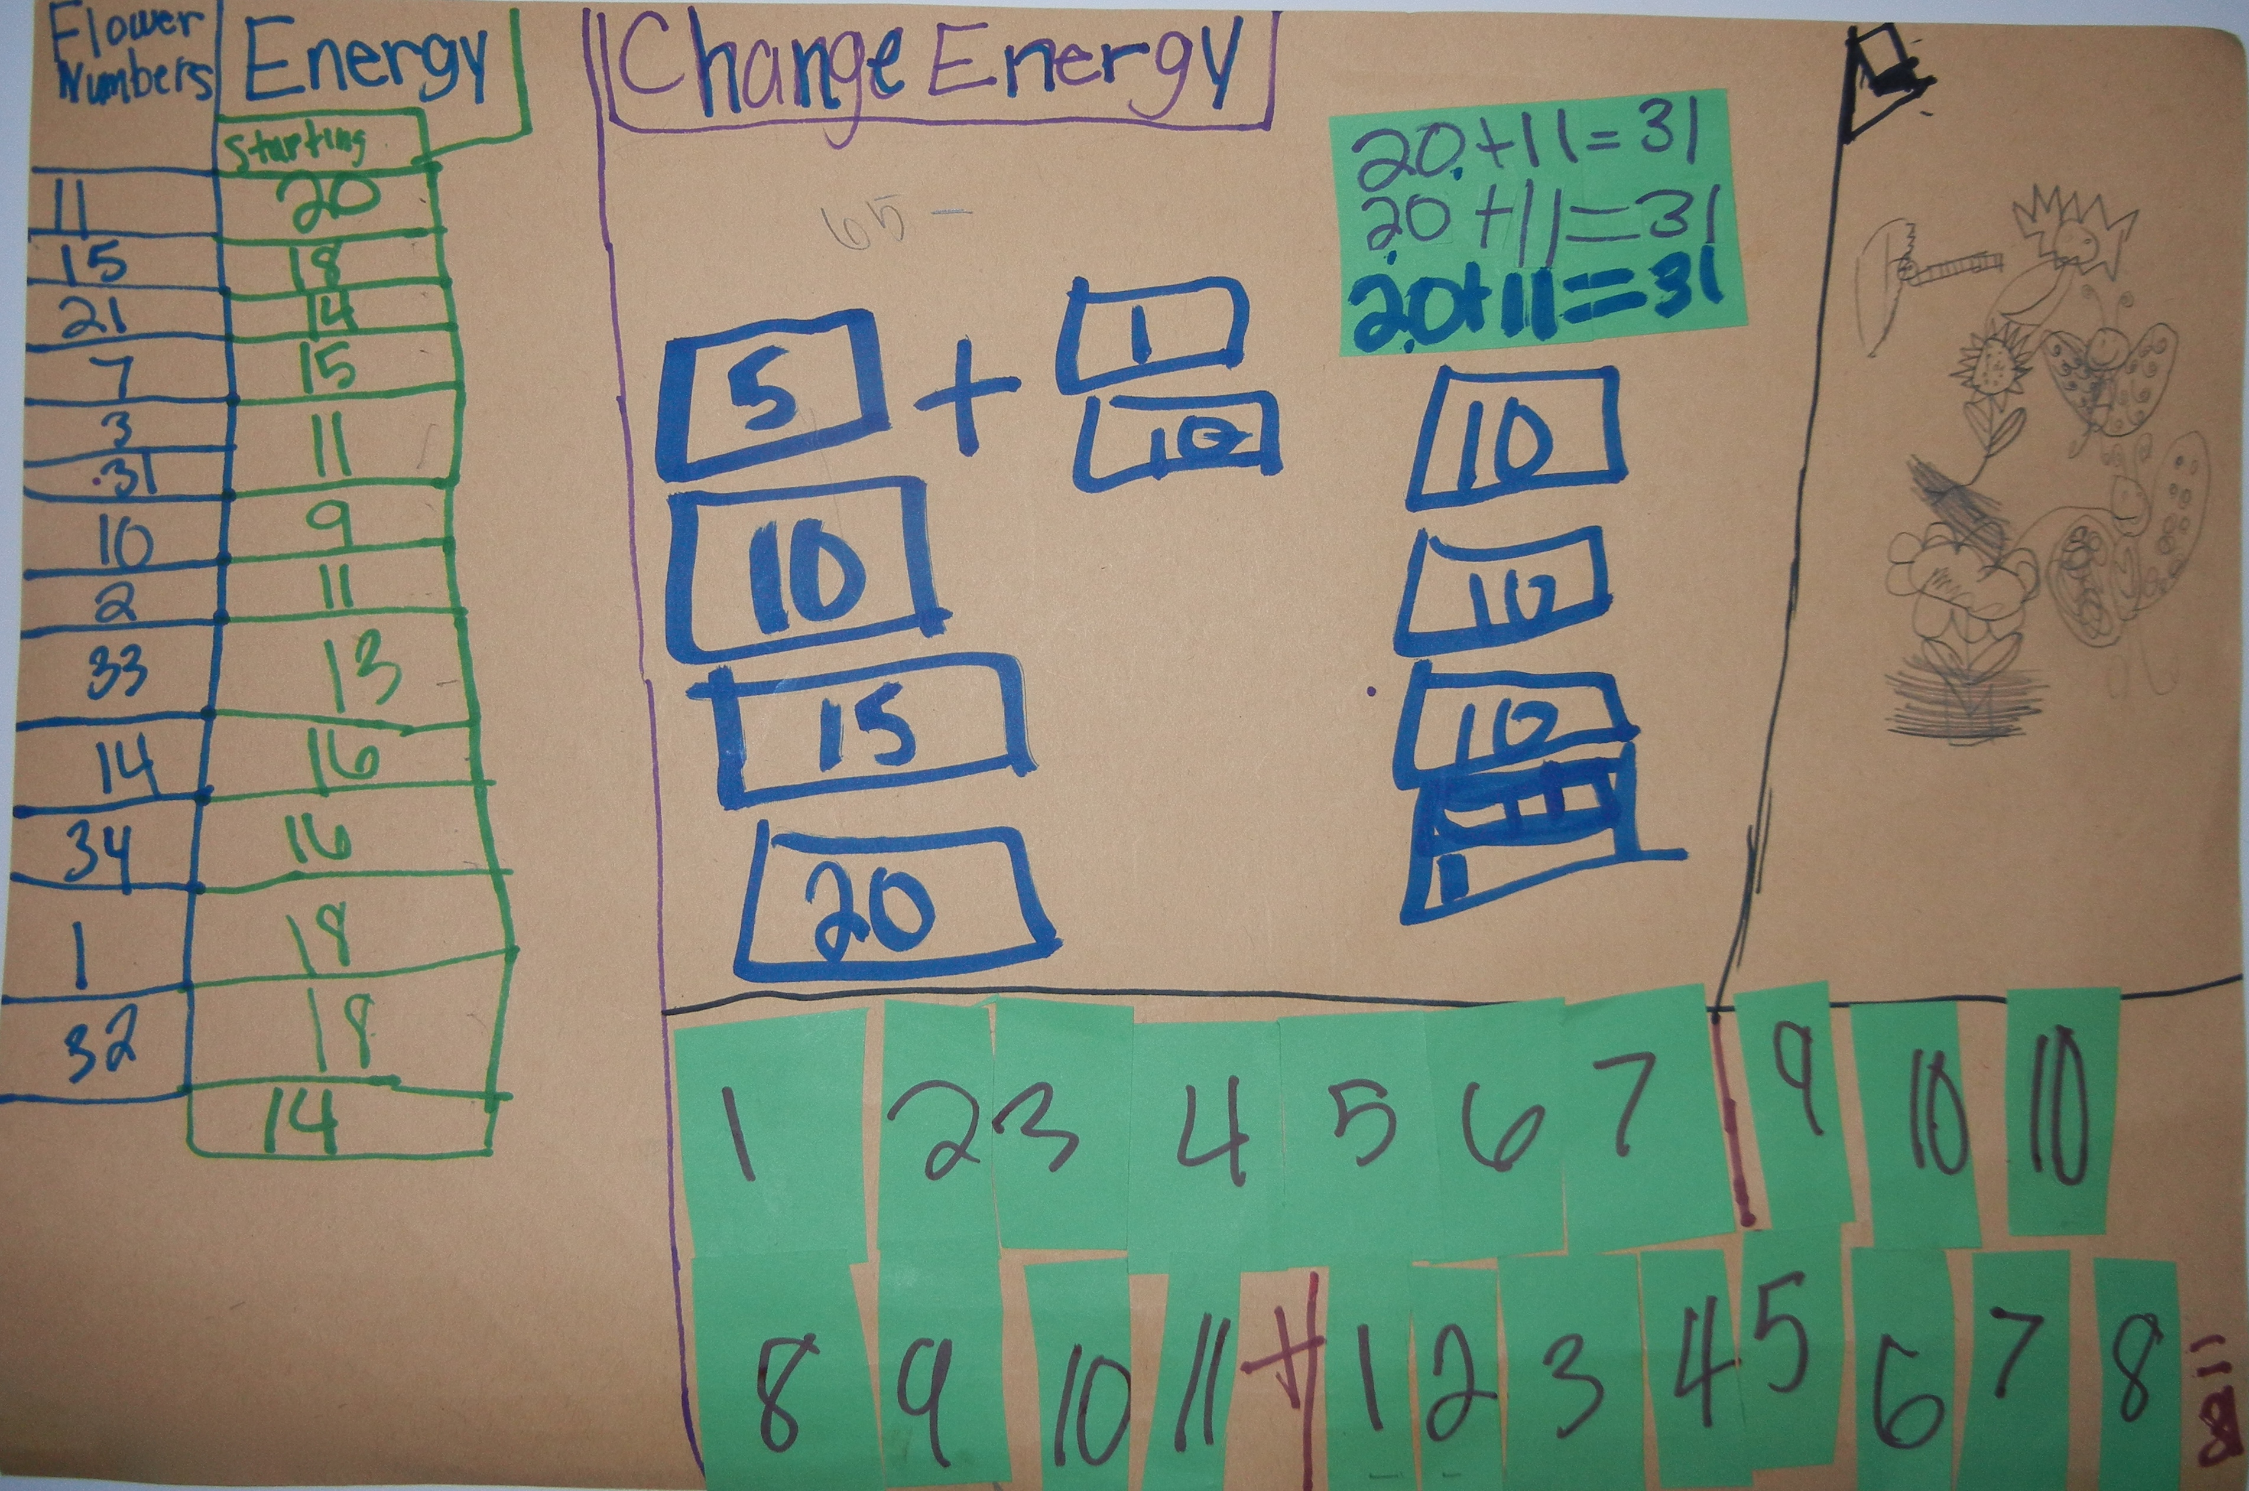  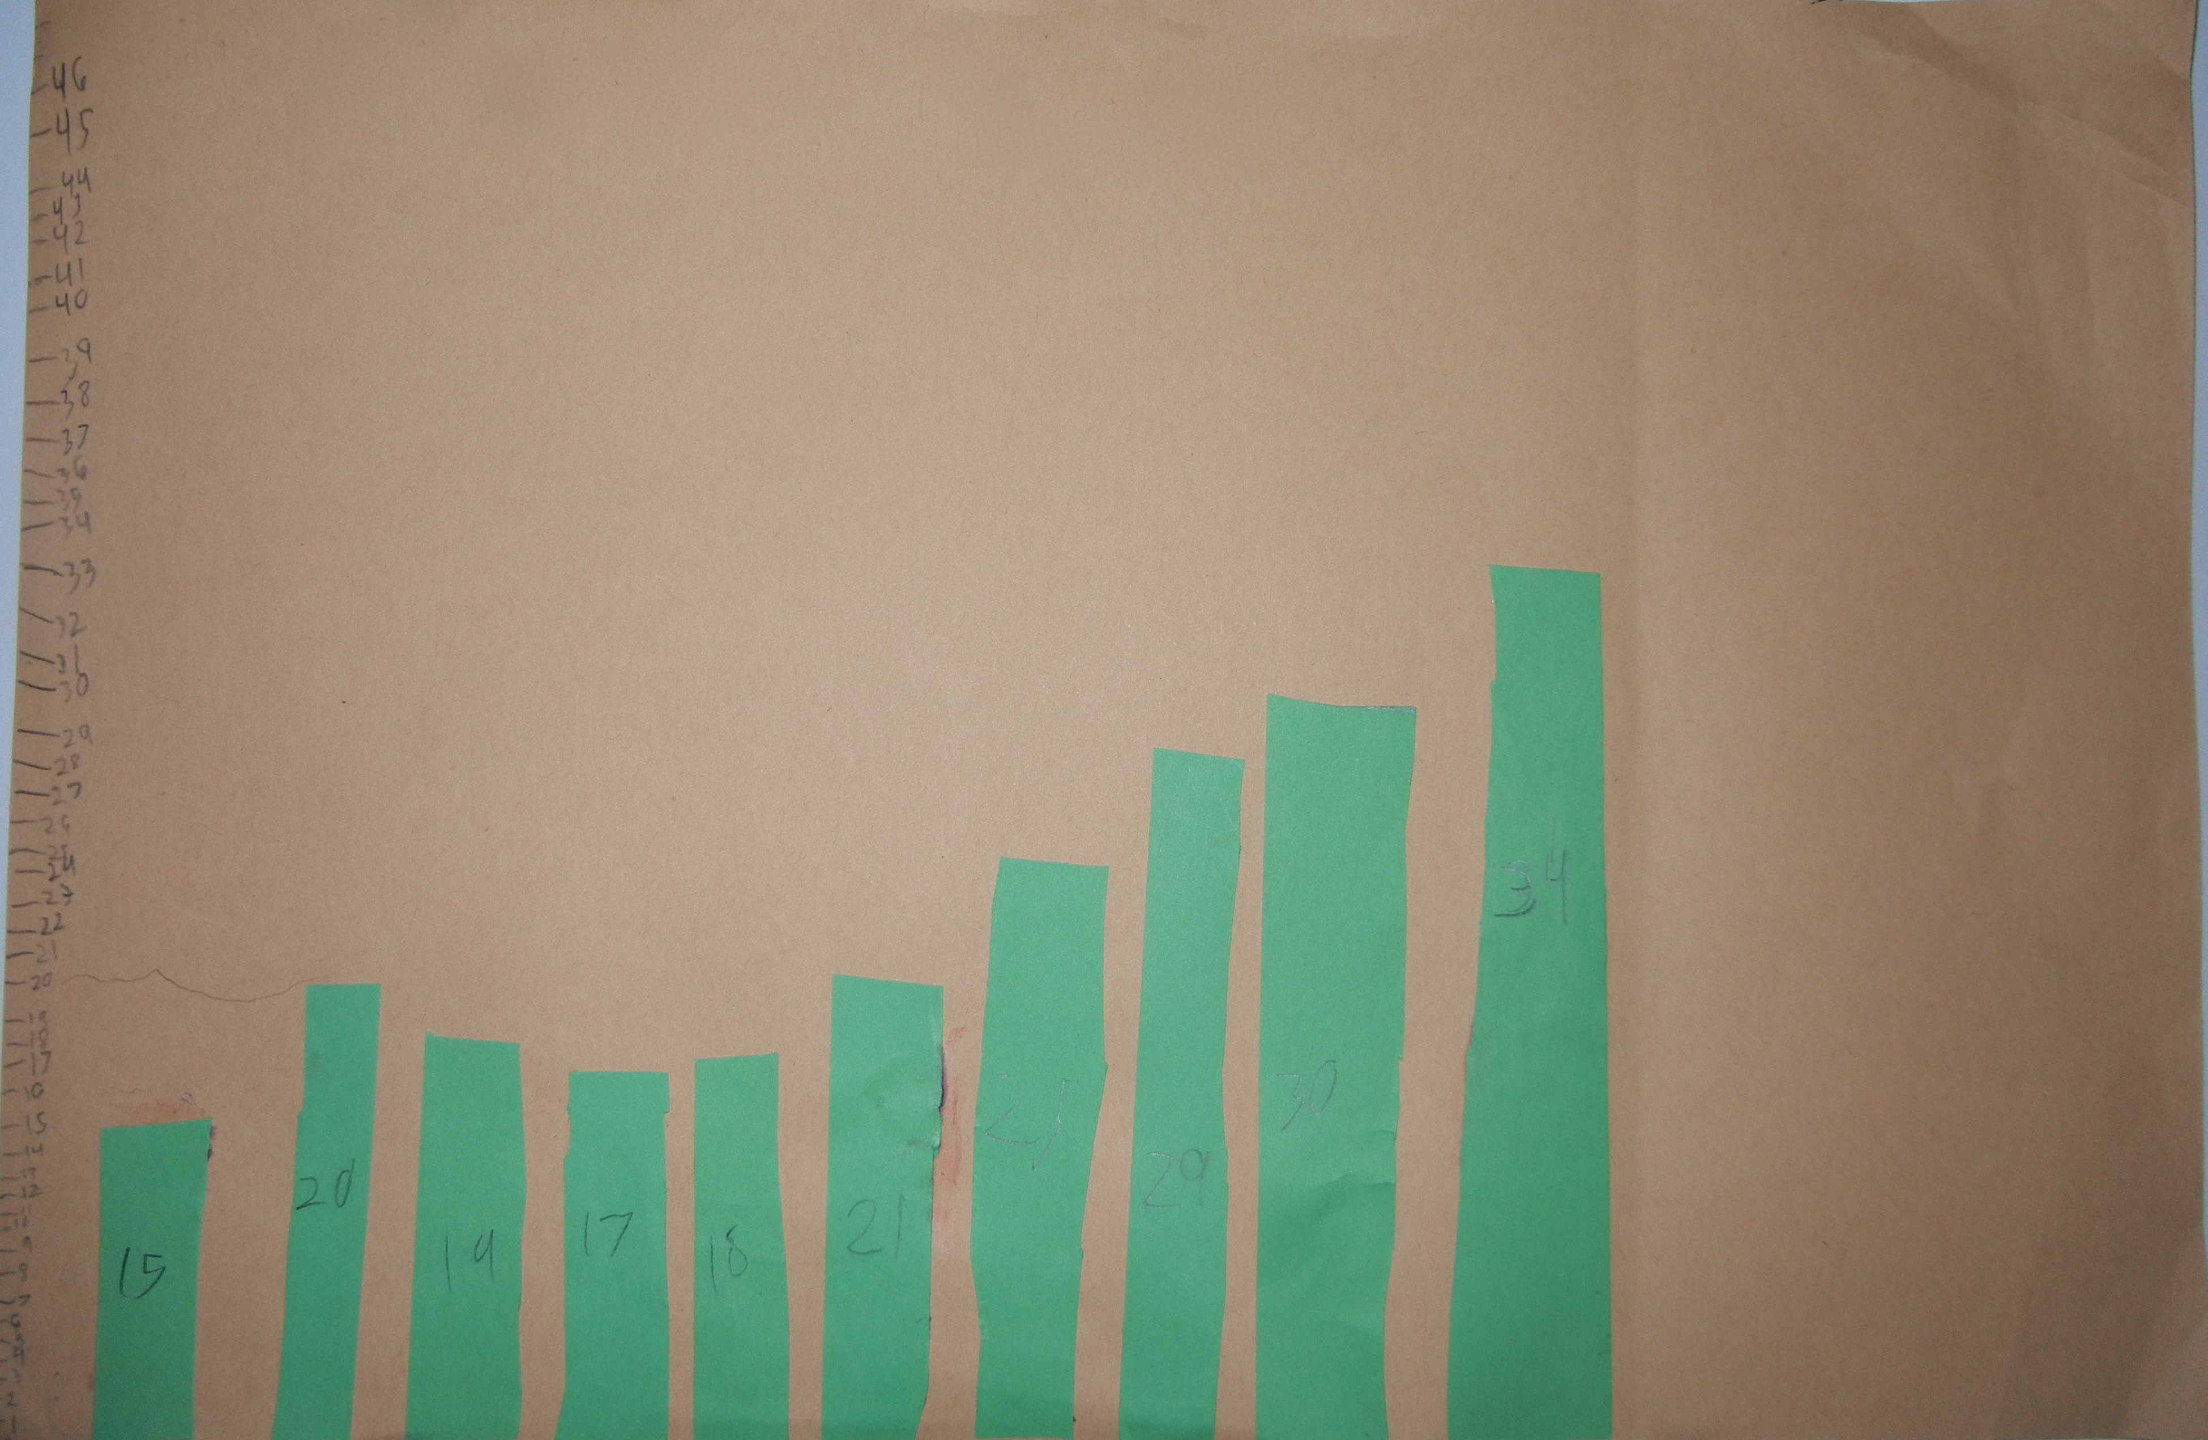  In the top graph, the student has tried to represent all of the data on their data sheet. While this ‘graph’ is meaningful to the student, it doesn’t communicate how their energy changed to a casual observer. The bottom graph is more canonical – this student chose to represent only total energy, arranged the bars in terms of order of forage, and included a scale. The bottom communicates more than the top graph.  - Select student graphs for sharing. Ask the student to explain why they chose to represent the data they did. Allow the students in the class to ask the student questions. Students often notice things like: “Why are bars of the same value not the same height?” “Why did you choose to show flower number?”  - In your discussion, privilege communicativity. Communicative graphs accurately represent the data they are trying to show. Scales, titles, sequencing of data and choosing what data to graph are attributes of communicative graphs.
Bird-Butterfly worksheet | Complete the Butterfly Activity Sheet I (20 minutes)
Model Change in Energy in ViMAP | Students model their change in energy in one-turtle ViMAP using the Butterfly Activity Sheet II (20 minutes)
Suggested Extensions | - Limit resources. Allow the embodied modeling activity to run long enough such that the flowers run out energy. That flower is not ‘dead’ and cannot be drunk from.  - Replenish flowers at certain time intervals. Empty flowers can be refilled after 5 minutes  - Students are often ‘greedy’ during the modeling activity and forage more than they need. This leads to flowers running out of energy as students amass more and more energy beads. Animals do not deplete their resources; compare the students’ actions to an animal’s actions.

