Unit Guide: Seeing and Measuring Constant Acceleration

Video Summary: http://vimeo.com/135590729

Learning aims
Students will…
- Use materials and video to investigate and measure a real-world example of constant acceleration.
- Examine and represent the relationships among distance, speed, time, and acceleration.
- Develop a mathematical understanding of constant acceleration due to gravity.
- Understand constant acceleration as a continuous change in the distance traveled during each equal increment of time.
- Build computational models that explain and describe an observed example of constant acceleration, using graphs and other representations.

Part 1: Is speed changing?

Guiding questions: Is the speed changing of the marble changing as it moves down the ramp? How do you know? How could you provide evidence to someone else to convince them of your idea?

Materials:
- Inclined planes. We recommend clear corner protectors, typically found in the paint aisle of a hardware store, and 4 feet long, approximately $2.00 each.
- Stopwatches
- Post-it flags, may be used to mark the corner protectors or partition them into equal segments
- Masking tape to hold the inclined planes in place
- Meter sticks, string, or other tools for measuring distance
- Marbles or other objects that will roll down inclined plane without bouncing off.
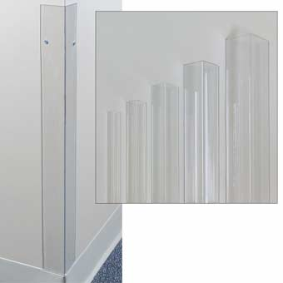
- Bags or cups to catch the marble at the end of the ramp.
- Devices that capture video

Figure 1. Clear plastic corner protectors, used as inclined planes
Image credit: http://cdn.nathosp.com/images/large/DX434_C.jpg

Activity 1: How can we convince someone else that the marble is changing speed as it travels down the ramp?

Encourage students to use the materials to establish a description of the motion and to find evidence that they can share with someone else to support their ideas.

As needed, elicit non-academic experiences in which students may have experienced acceleration due to gravity. For example, students may apply what they know about slides on a playground or speeding up as you run down a hill. These examples are intuitive resources for thinking about constant acceleration.

Ask students to find and share evidence that the marble is changing speed in a forum in which other students can ask them questions about their claims. Push students to tie their ideas to evidence. As evidence becomes more sophisticated, students will become increasingly convinced that the marble is speeding up as it travels down the ramp.

Examples of evidence:
- Comparisons of speed at the top of ramp and the bottom based on the time to travel equal partitions of the inclined plane, or visual indicators of speed
- Videos of the motion

Activity 2. How can we know and model how much the speed is changing?
- Does changing the slope of the inclined plane change the speed?

Materials:
- Inclined planes. We recommend clear corner protectors, typically found in the paint aisle of a hardware store, and 4 feet long, approximately $2.00 each.
- Stopwatches
- Post-it flags, may be used to mark the corner protectors or partition them into equal segments
- Masking tape to hold the inclined planes in place
- Meter sticks, string, or other tools for measuring distance
- Marbles or other objects that will roll down inclined plane without bouncing off.
- Bags or cups to catch the marble at the end of the ramp.
- Devices that capture slow motion video, see below.
- Millimeter Rulers, or printable paper rulers, included in this Unit Guide

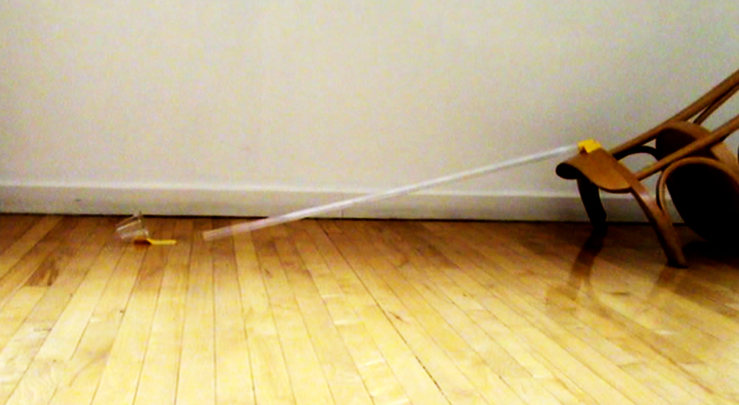

Figure 2: Camera angle is perpendicular to the direction of motion

Student groups will make a measurable video of the motion of the marble as it moves down the ramp. We used the native video feature on iPad minis, however, it doesn’t matter what technology you use, as long as the motion on video that has enough resolution to take measurements of the position of the marble at equal intervals of time, or equal intervals of frames.

Teacher note: Successful videos will have the camera placed perpendicular to the motion, so that the field of view looks something like that in Figure 2. Successful videos do not obstruct the view of the marble, and allow for the beginning and end of the ramp to be seen easily. If time allows, you may wish to have students make videos with little direction, try taking a first round of measurement, then refine their plans and remake their video that better allow for measurement of the distances traveled in each successive interval of time.

We have found that a frame counter or a video timer that displays time to the tenth or hundredth of a second is important for making speed measurements.

Mac OS: We recommend using Quicktime 7 using the frame counter feature (see Figure 3). Download here: http://support.apple.com/kb/DL923?locale=en_US

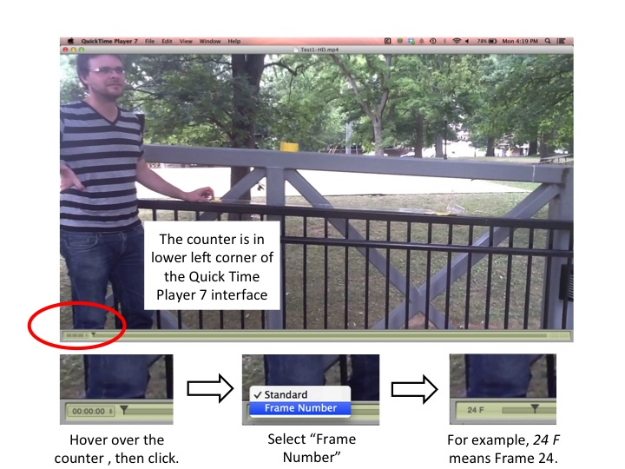

Figure 3. Change the counter to display the Frame Number

Instructions for collecting measurement data from the videos:
- Students take measurements on the actual video data. For these measurements, students should be able to play the video frame-by-frame (supported in Quicktime 7, but not in Quicktime 10; or Vimeo (use SHIFT + left or right arrow key). Note that the distances will be scaled, based on the dimensions of the video as it is played! We have found that this does not bother students––they are comfortable accepting the video as a model of the actual phenomenon.
- Students record the frame number at which the marble is first released, and the frame at which the marble reaches the end of the ramp.
- Students choose an interval at which to take measurements. “For example, I will take measurements every 10 frames.”
- By subtracting, students find the distance that the ball traveled in each equal-time interval, which is called the step-size.

Measure point | Frame Number | Distance from the beginning of the ramp  Measure in millimeters (mm). | Step-size  How far did the ball travel in this step?
0 | 200 | 0 mm
0 | 200 | 0 mm | Step 0  distance₁ – distance₀ = 2 mm
1 | 210 | 2 mm | Step 0  distance₁ – distance₀ = 2 mm
1 | 210 | 2 mm | Step 1  distance₂ – distance₁ = 8 mm
2 | 220 | 10 mm | Step 1  distance₂ – distance₁ = 8 mm
2 | 220 | 10 mm | Step 2  distance₃ – distance₂ = 15 mm
3 | 230 | 25 mm | Step 2  distance₃ – distance₂ = 15 mm
3 | 230 | 25 mm | Step 3  distance₄ – distance₃ = 22 mm
4 | 240 | 47 mm | Step 3  distance₄ – distance₃ = 22 mm
4 | 240 | 47 mm | Step 4  distance₅ – distance₄ = 28 mm
5 | 250 | 75 mm | Step 4  distance₅ – distance₄ = 28 mm
5 | 250 | 75 mm | Step 5  distance₆ – distance₅ = 35 mm
6 | 260 | 110 mm  (end of ramp) | Step 5  distance₆ – distance₅ = 35 mm
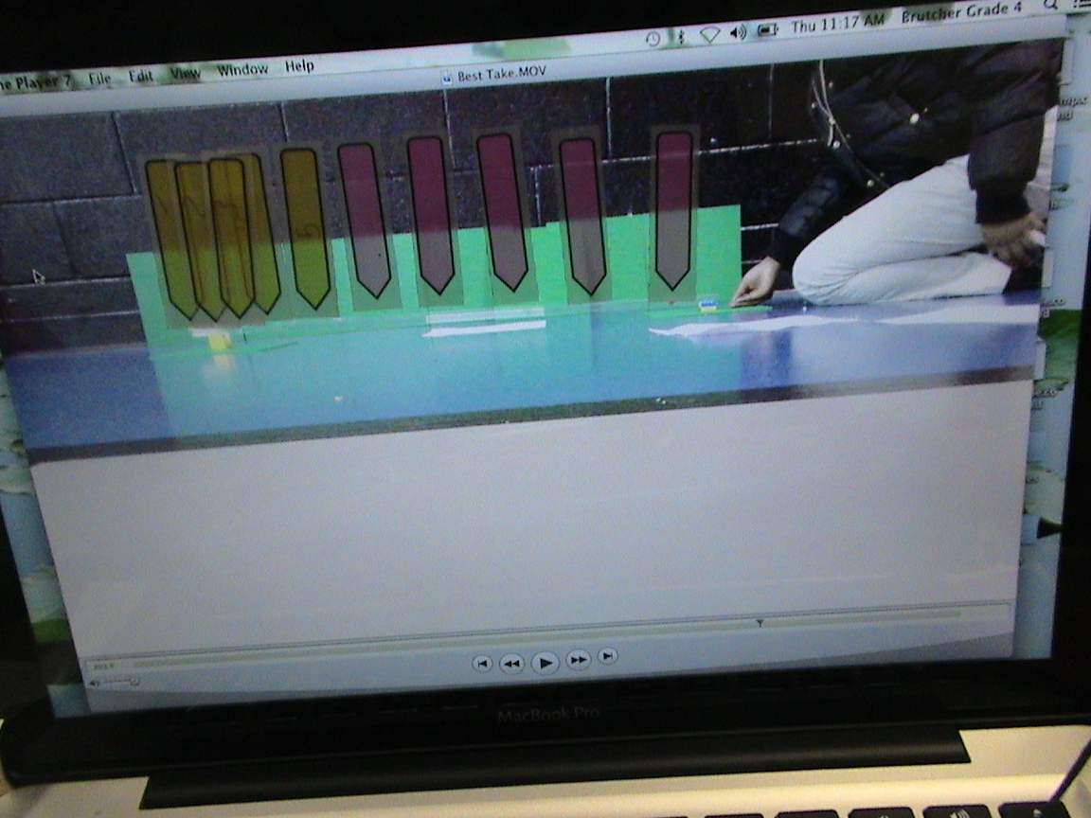

Figure 4. Sample student work, made by pausing the video every 10 frames.
Students may also wish to mark the frame numbers on the tabs.

Sample Student Data: How much is step size changing?

- In the last column of the table in the handout students determine how much step-size is changing, or the value of acceleration.
- All measurement includes error. While the “change in step-size” number should be constant, it likely will not be perfectly constant. They should determine what a typical, or representative change in step-size might be, and model again using that number.
- Samples of student ViMAP models and graphs are shown in Figures 4, 5, and 6.

Step-size | Change in Step-size
Step 0  distance₁ – distance₀ = 2mm | Step 1 - Step 0 = 6 mm
Step 1  distance₂ – distance₁ = 8mm | Step 2 - Step 1 = 7 mm
Step 2  distance₃ – distance₂ = 15mm | Step 3 - Step 2 = 7 mm
Step 3  distance₄ – distance₃ = 22mm | Step 4 - Step 3 = 6 mm
Step 4  distance₅ – distance₄ = 28mm | Step 5 - Step 4 = 7 mm
Step 5
distance₆ – distance₅ = 35mm

Is the change in step-size, as you measured it, constant?

Do you think it is constant in real life?

What is a typical change in step-size? For example, you may wish to use the mean or the mode of all your change in step-size values.

(I chose 7!)
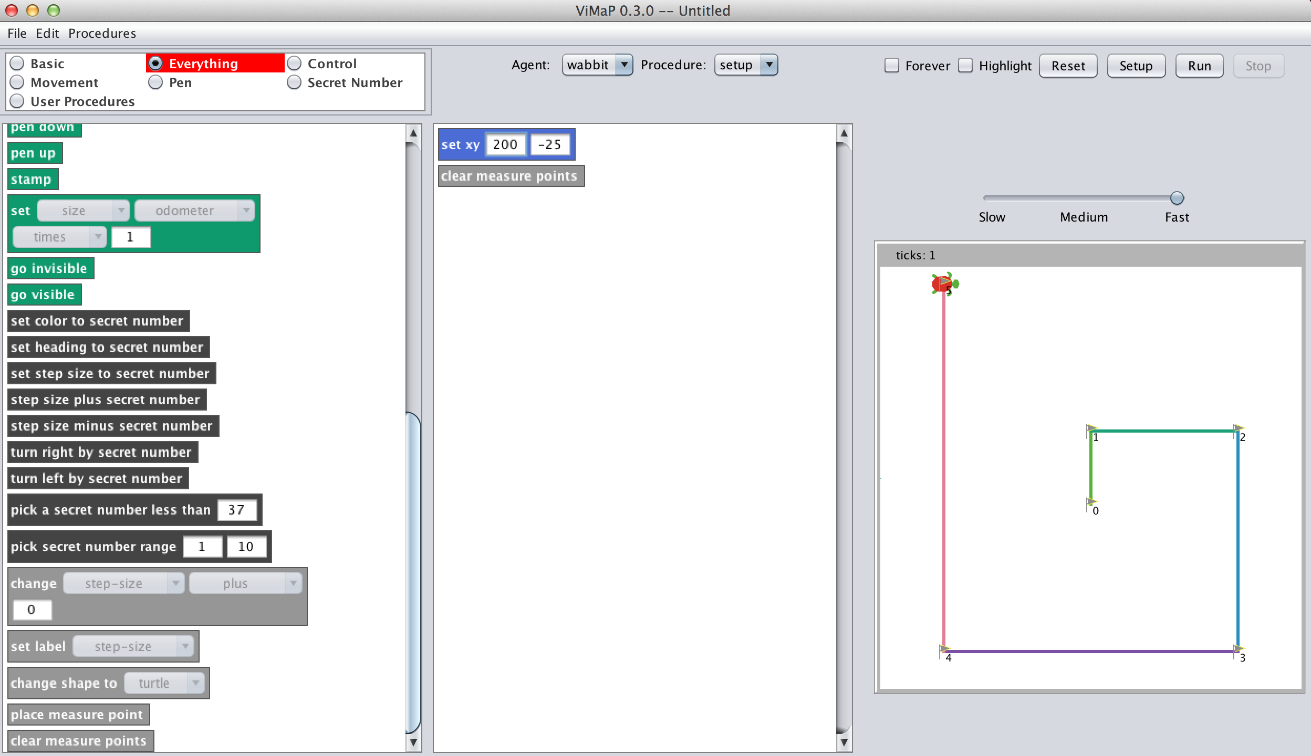
Figure 4. Sample Setup Procedure

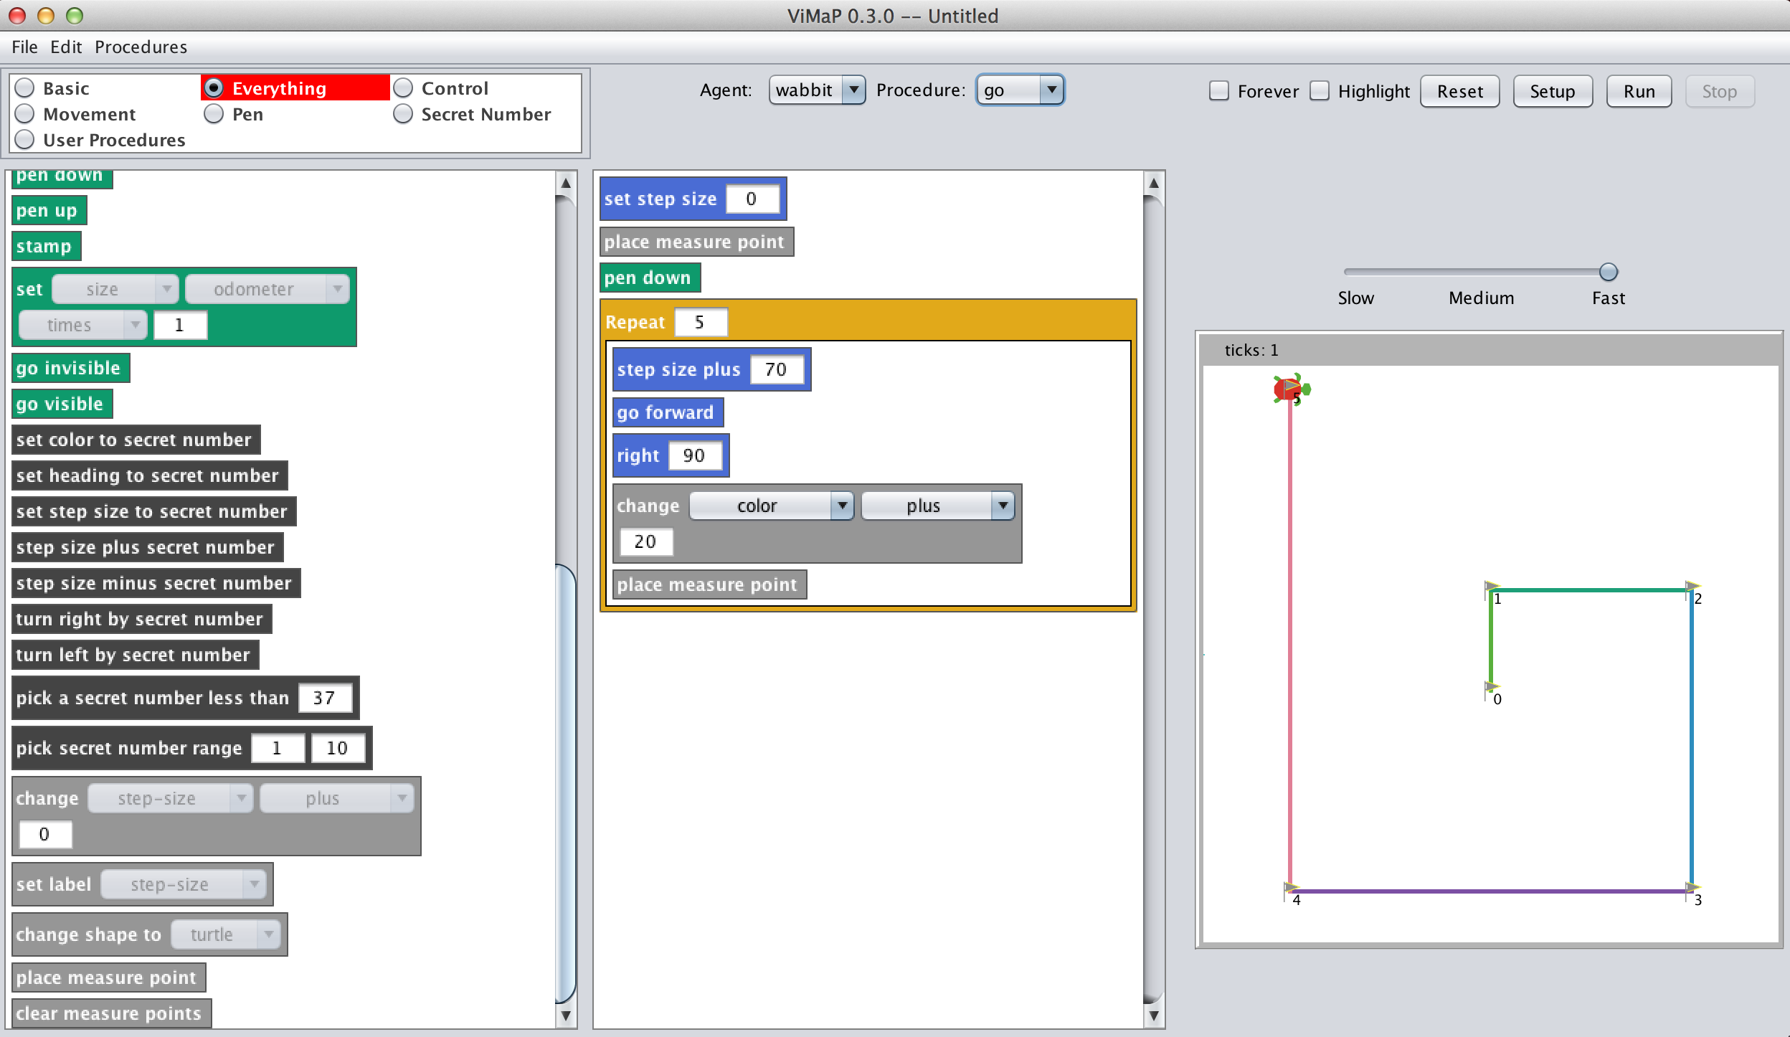
Figure 5. Sample Go Procedure
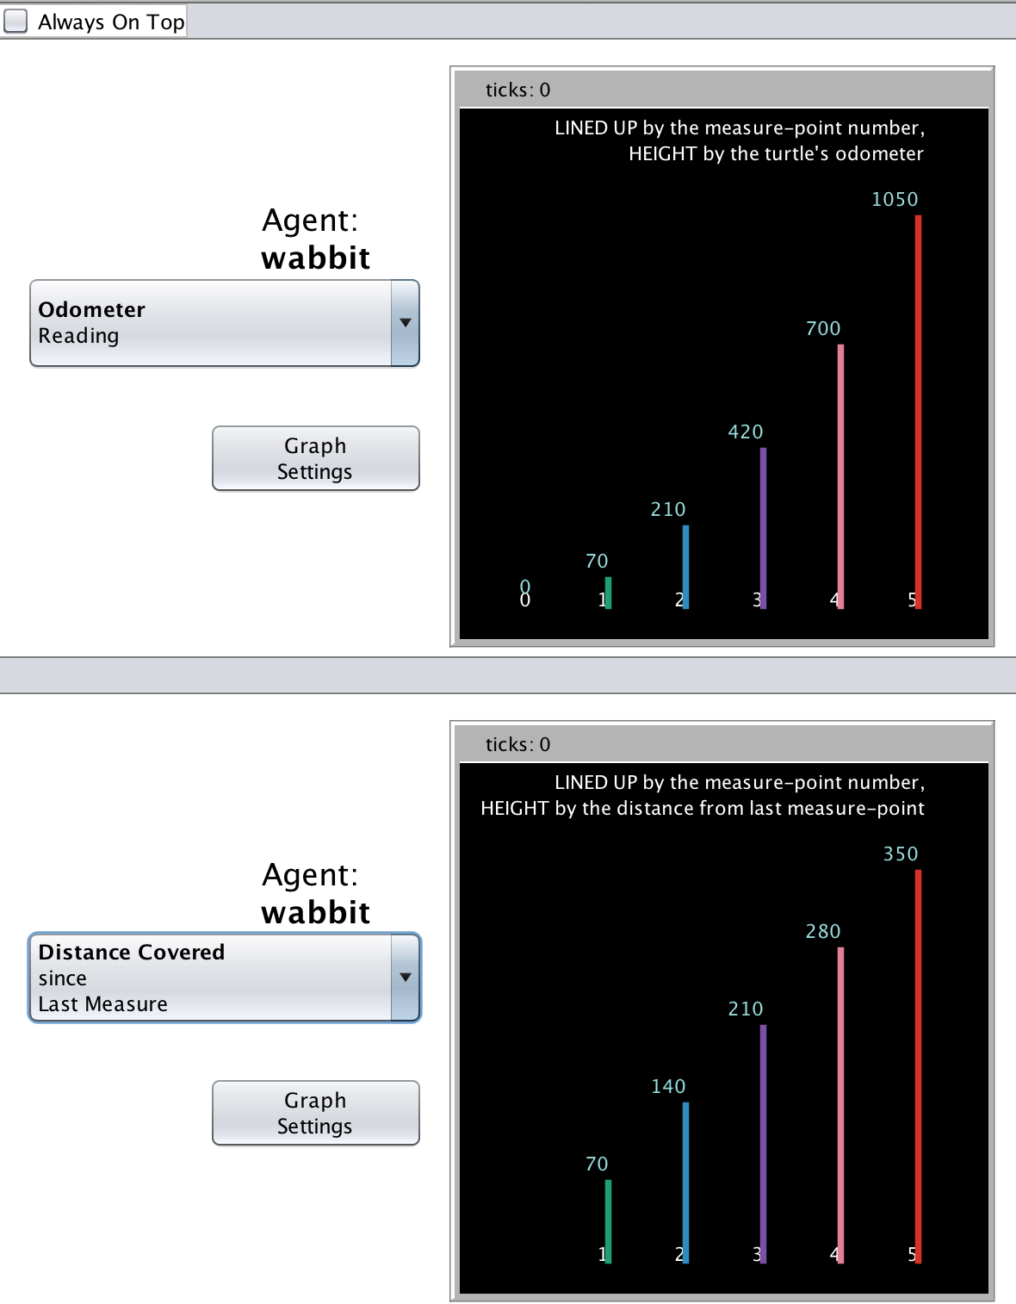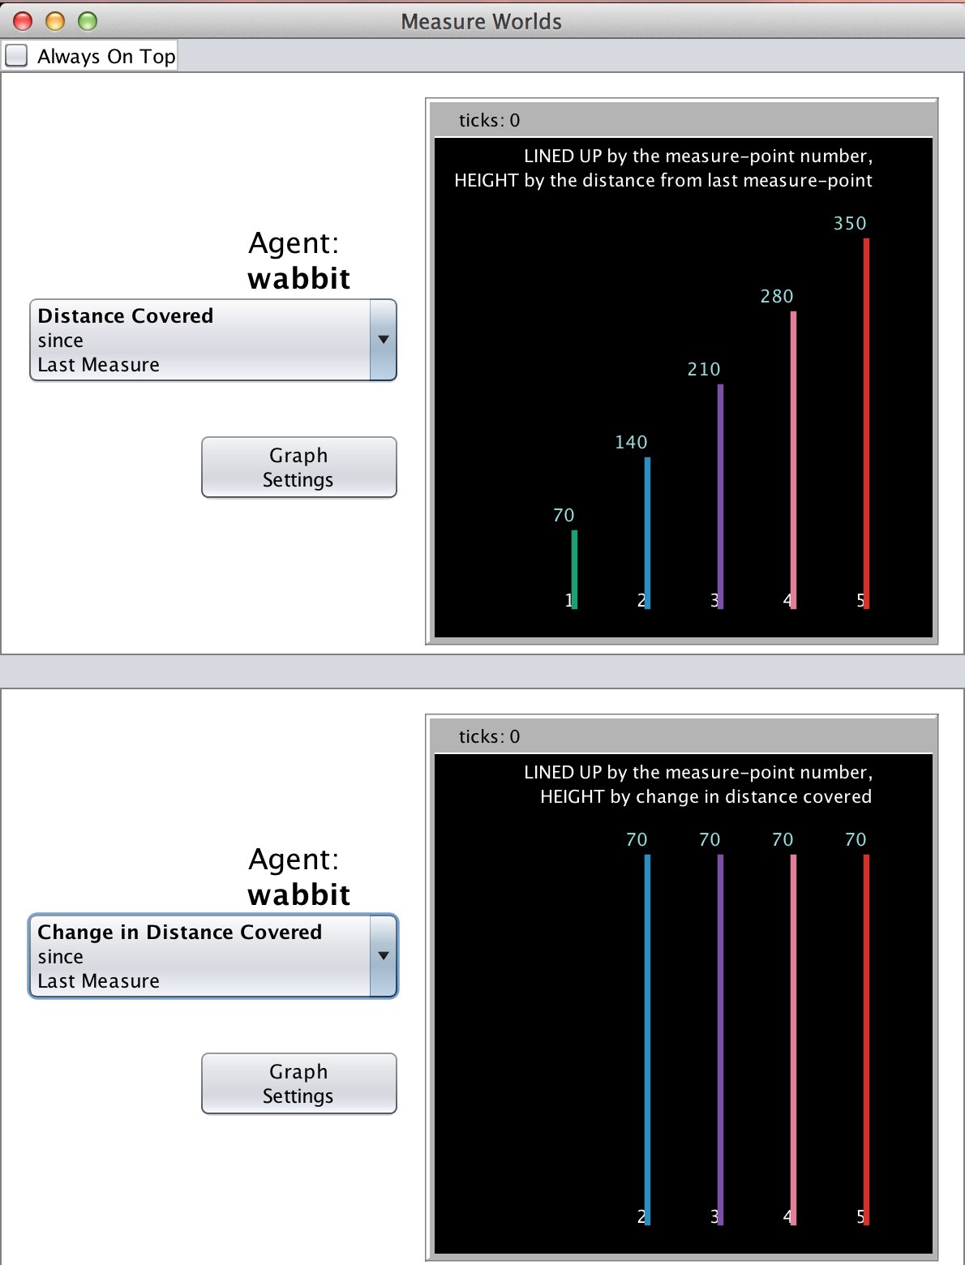

Figure 6. Sample Graphs (Here, all measurements are scaled up by 10.)

