Wild Tracks: Speed

Materials Needed: | - Speed Worksheet  - ViMAP Two-Turtle
Set Up | - On the classroom computer, enter the step size values provided in the worksheet in two-turtle ViMAP  - Remember to set pen-down in setup.  Walker 1: Walker 2:  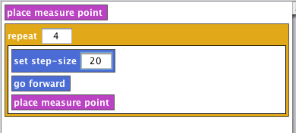  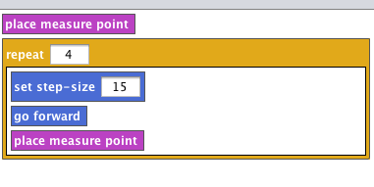
Sequencing and Guiding Questions

Step Size as Speed | - Relate step sizes to speed and steps to time. From experience, an intuitive way to do this is to have members of the class race.  - Have two students model the movements above. One student takes 4 steps of 15 and another takes 4 steps of 20.  - The student who has a large step size will ‘win’ the race because they have travelled more distance in the same intervals of time. This idea is demonstrated below.  15  15  15  15  20  20  20  20  - The student who has a step size of 20 is ‘faster’. Also notice in the sample above that the student with a step size of 20 travelled the same distance (60) in only 3 steps where as it took the student with a step size of 15.  - Both students travel the same period of time since they each took four steps. You can have the students clap to keep time, clapping once for every step. NOTE: Time is a tricky concept, many students may not fully grasp that time is a construct and can be anything we want. The big idea here is that ‘steps’ are a measure of time.
Speed x Time = Distance | - Use the worksheet to scaffold the transition from our general formula for distance travelled (Step Size x Number of Steps = Distance) to the more recognizable formula of Speed x Time = Distance.  - Complete the worksheet and have students solve the problem in the worksheet. They may do this by hand or using ViMAP.
Model Real World Speed/Time/Distance Problems | - Provide students with problems of your own, asking them to solve them using ViMAP and by hand.  - As student work through problems, focus on the turtle enactment and the graphs. The turtle enactment makes it clear that greater speed = more distance covered/bigger ‘gaps’ and slower speed = less distance covered/smaller ‘gaps’. This concept is shown below.  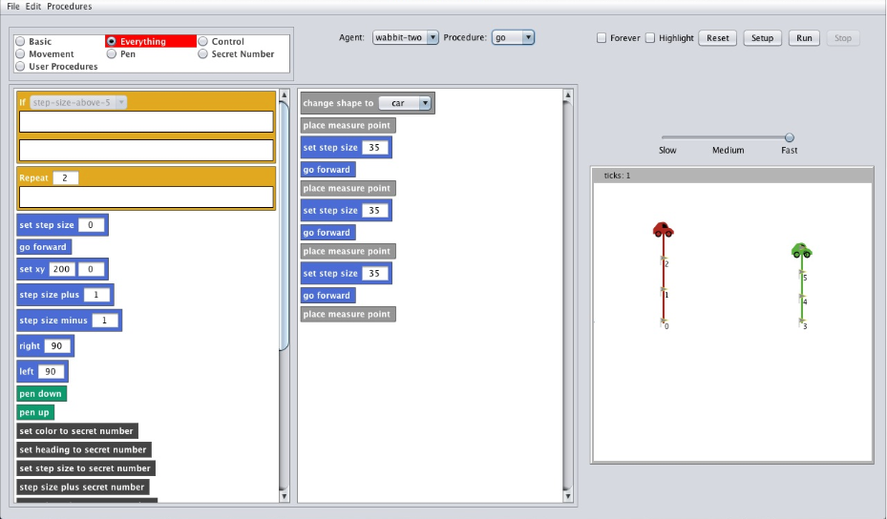  - The below is an example of how to represent speed/time/distance problems to your class. Visual representations which show that

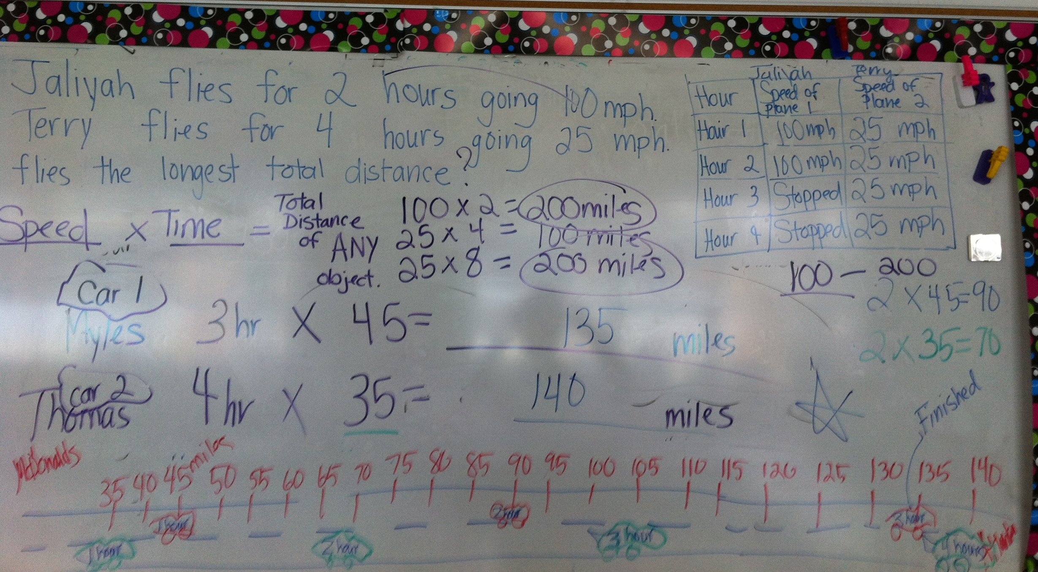

15

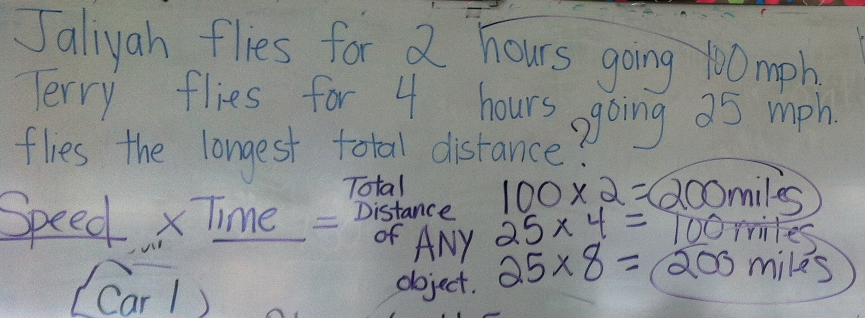

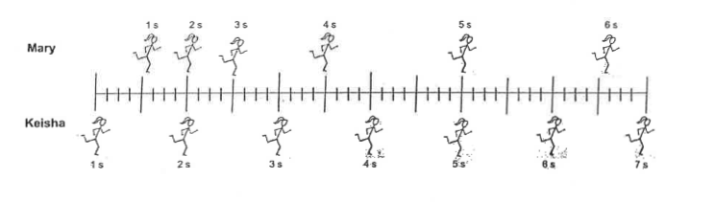
The question below is taken from the Force Concept Inventory, an assessment for college physics students. Notice how our focus on speed as ‘gaps’ or distances over periods of time helps students as young we 3rd grade correctly reason about motion. Between 3 and 4 sec, Mary and Keisha travelled the same distance (8 units of distance). Thus, their speed was the same between 3 and 4sec. A sample student response is shown below.

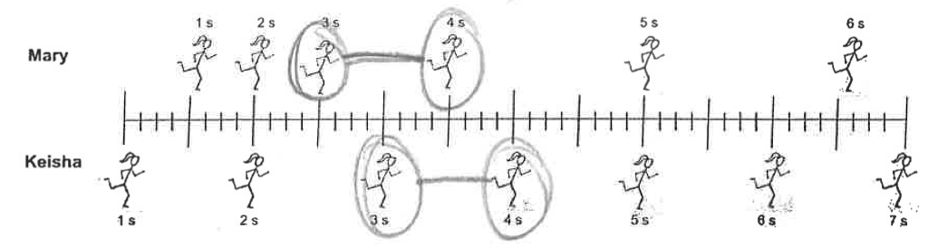
Student response (age 8):

