Contacting Legislators
www.akleg.gov
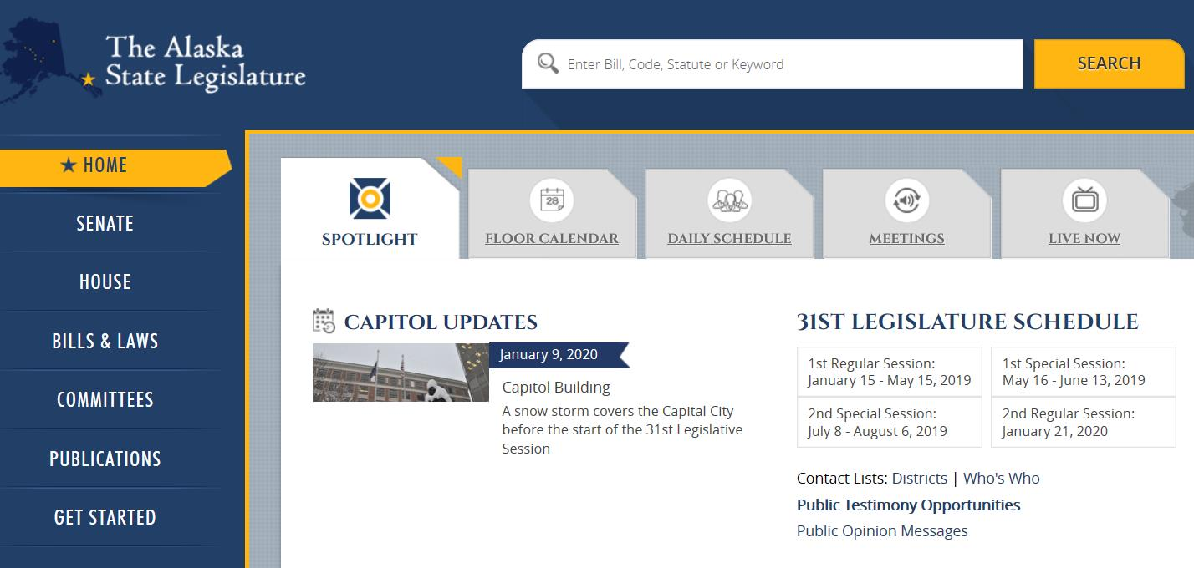
Email addresses for members of each body. A copy and paste list follows.

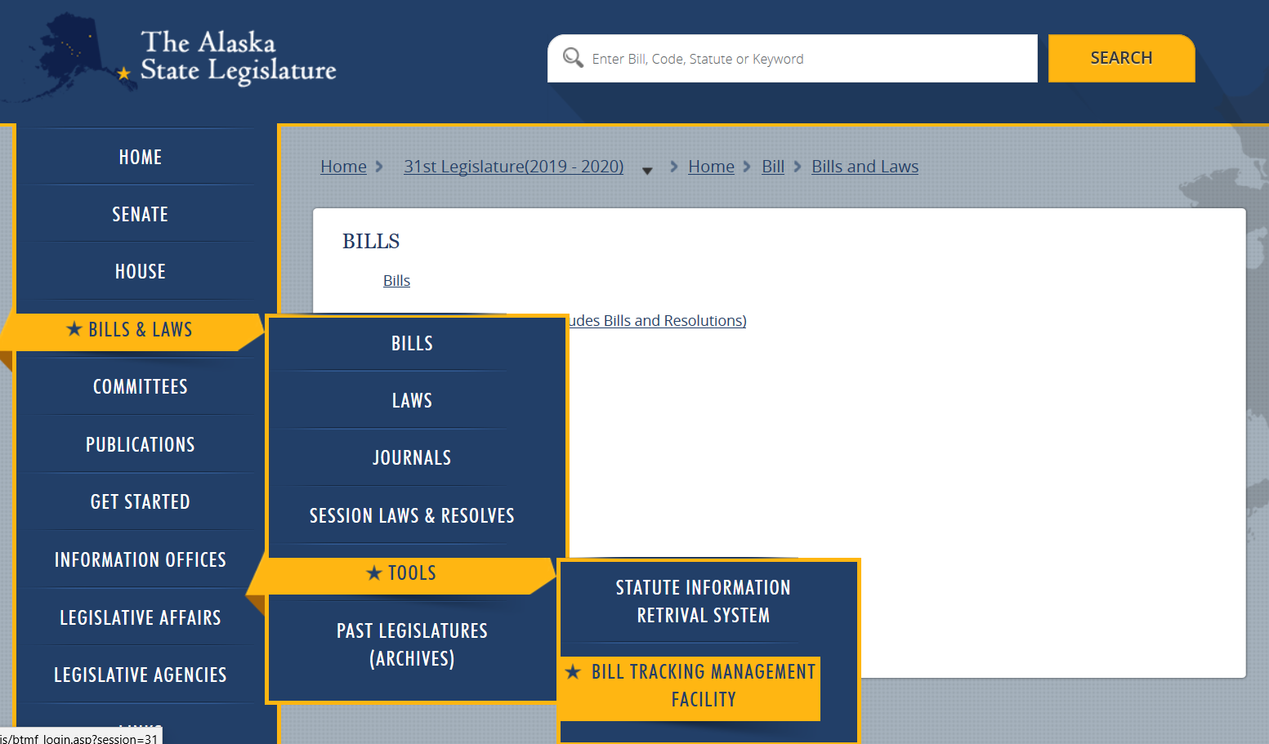
You can sign up for email notifications on specific bills that you would like to track – stay informed of committee meetings and public testimony opportunities!

Watch Committee Meetings Online – recorded or in real time!
Gavel Alaska on the 360 North website: www.360north.org >> then go to the Gavel Alaska tab

Public Testimony – Remote Access (have bill number ready when you call)

Juneau telephonic public testimony: (844) 586-9085
Mat-Su Legislative Information Office (located at Mat-Su Central School): (907) 376-3704 *Sometimes hosts town halls; will connect constituents to Juneau meetings for remote testimony

31st Legislature – Copy/Paste email list (updated with second session changes)

Senator.Cathy.Giessel@akleg.gov Senator.Mia.Costello@akleg.gov Senator.Tom.Begich@akleg.gov Senator.Click.Bishop@akleg.gov Senator.John.Coghill@akleg.gov Senator.Elvi.Gray-Jackson@akleg.gov Senator.Lyman.Hoffman@akleg.gov Senator.Shelley.Hughes@akleg.gov Senator.Scott.Kawasaki@akleg.gov Senator.Jesse.Kiehl@akleg.gov Senator.Peter.Micciche@akleg.gov Senator.Donny.Olson@akleg.gov Senator.Josh.Revak@akleg.gov Senator.Lora.Reinbold@akleg.gov Senator.Mike.Shower@akleg.gov Senator.Bert.Stedman@akleg.gov Senator.Gary.Stevens@akleg.gov Senator.Natasha.vonImhof@akleg.gov Senator.Bill.Wielechowski@akleg.gov Senator.David.Wilson@akleg.gov Representative.Ben.Carpenter@akleg.gov Representative.Matt.Claman@akleg.gov Representative.Harriet.Drummond@akleg.gov Representative.David.Eastman@akleg.gov Representative.Bryce.Edgmon@akleg.gov Representative.Zack.Fields@akleg.gov Representative.Neal.Foster@akleg.gov Representative.Sara.Hannan@akleg.gov Representative.Grier.Hopkins@akleg.gov Representative.Sharon.Jackson@akleg.gov Representative.DeLena.Johnson@akleg.gov Representative.Jennifer.Johnston@akleg.gov Representative.Andy.Josephson@akleg.gov

Representative.Gary.Knopp@akleg.gov Representative.Chuck.Kopp@akleg.gov Representative.Jonathan.Kreiss-Tomkins@akleg.gov Representative.Bart.LeBon@akleg.gov Representative.Gabrielle.LeDoux@akleg.gov Representative.Mel.Gillis@akleg.gov Representative.John.Lincoln@akleg.gov Representative.Kelly.Merrick@akleg.gov Representative.Mark.Neuman@akleg.gov Representative.Dan.Ortiz@akleg.gov Representative.Lance.Pruitt@akleg.gov Representative.Sara.Rasmussen@akleg.gov Representative.George.Rauscher@akleg.gov Representative.Laddie.Shaw@akleg.gov Representative.Ivy.Spohnholz@akleg.gov Representative.Andi.Story@akleg.gov Representative.Louise.Stutes@akleg.gov Representative.Colleen.Sullivan-Leonard@akleg.gov Representative.Dave.Talerico@akleg.gov Representative.Geran.Tarr@akleg.gov Representative.Steve.Thompson@akleg.gov Representative.Cathy.Tilton@akleg.gov Representative.Chris.Tuck@akleg.gov Representative.Sarah.Vance@akleg.gov Representative.Tammie.Wilson@akleg.gov Representative.Adam.Wool@akleg.gov Representative.Tiffany.Zulkosky@akleg.gov

Mat-Su Delegates

Senator.Mike.Shower@akleg.gov, Senator.David.Wilson@akleg.gov, Senator.Shelley.Hughes@akleg.gov, Representative.David.Eastman@akleg.gov, Representative.DeLena.Johnson@akleg.gov, Representative.Mark.Neuman@akleg.gov, Representative.Colleen.Sullivan-Leonard@akleg.gov, Representative.Cathy.Tilton@akleg.gov

