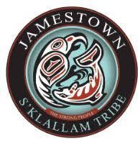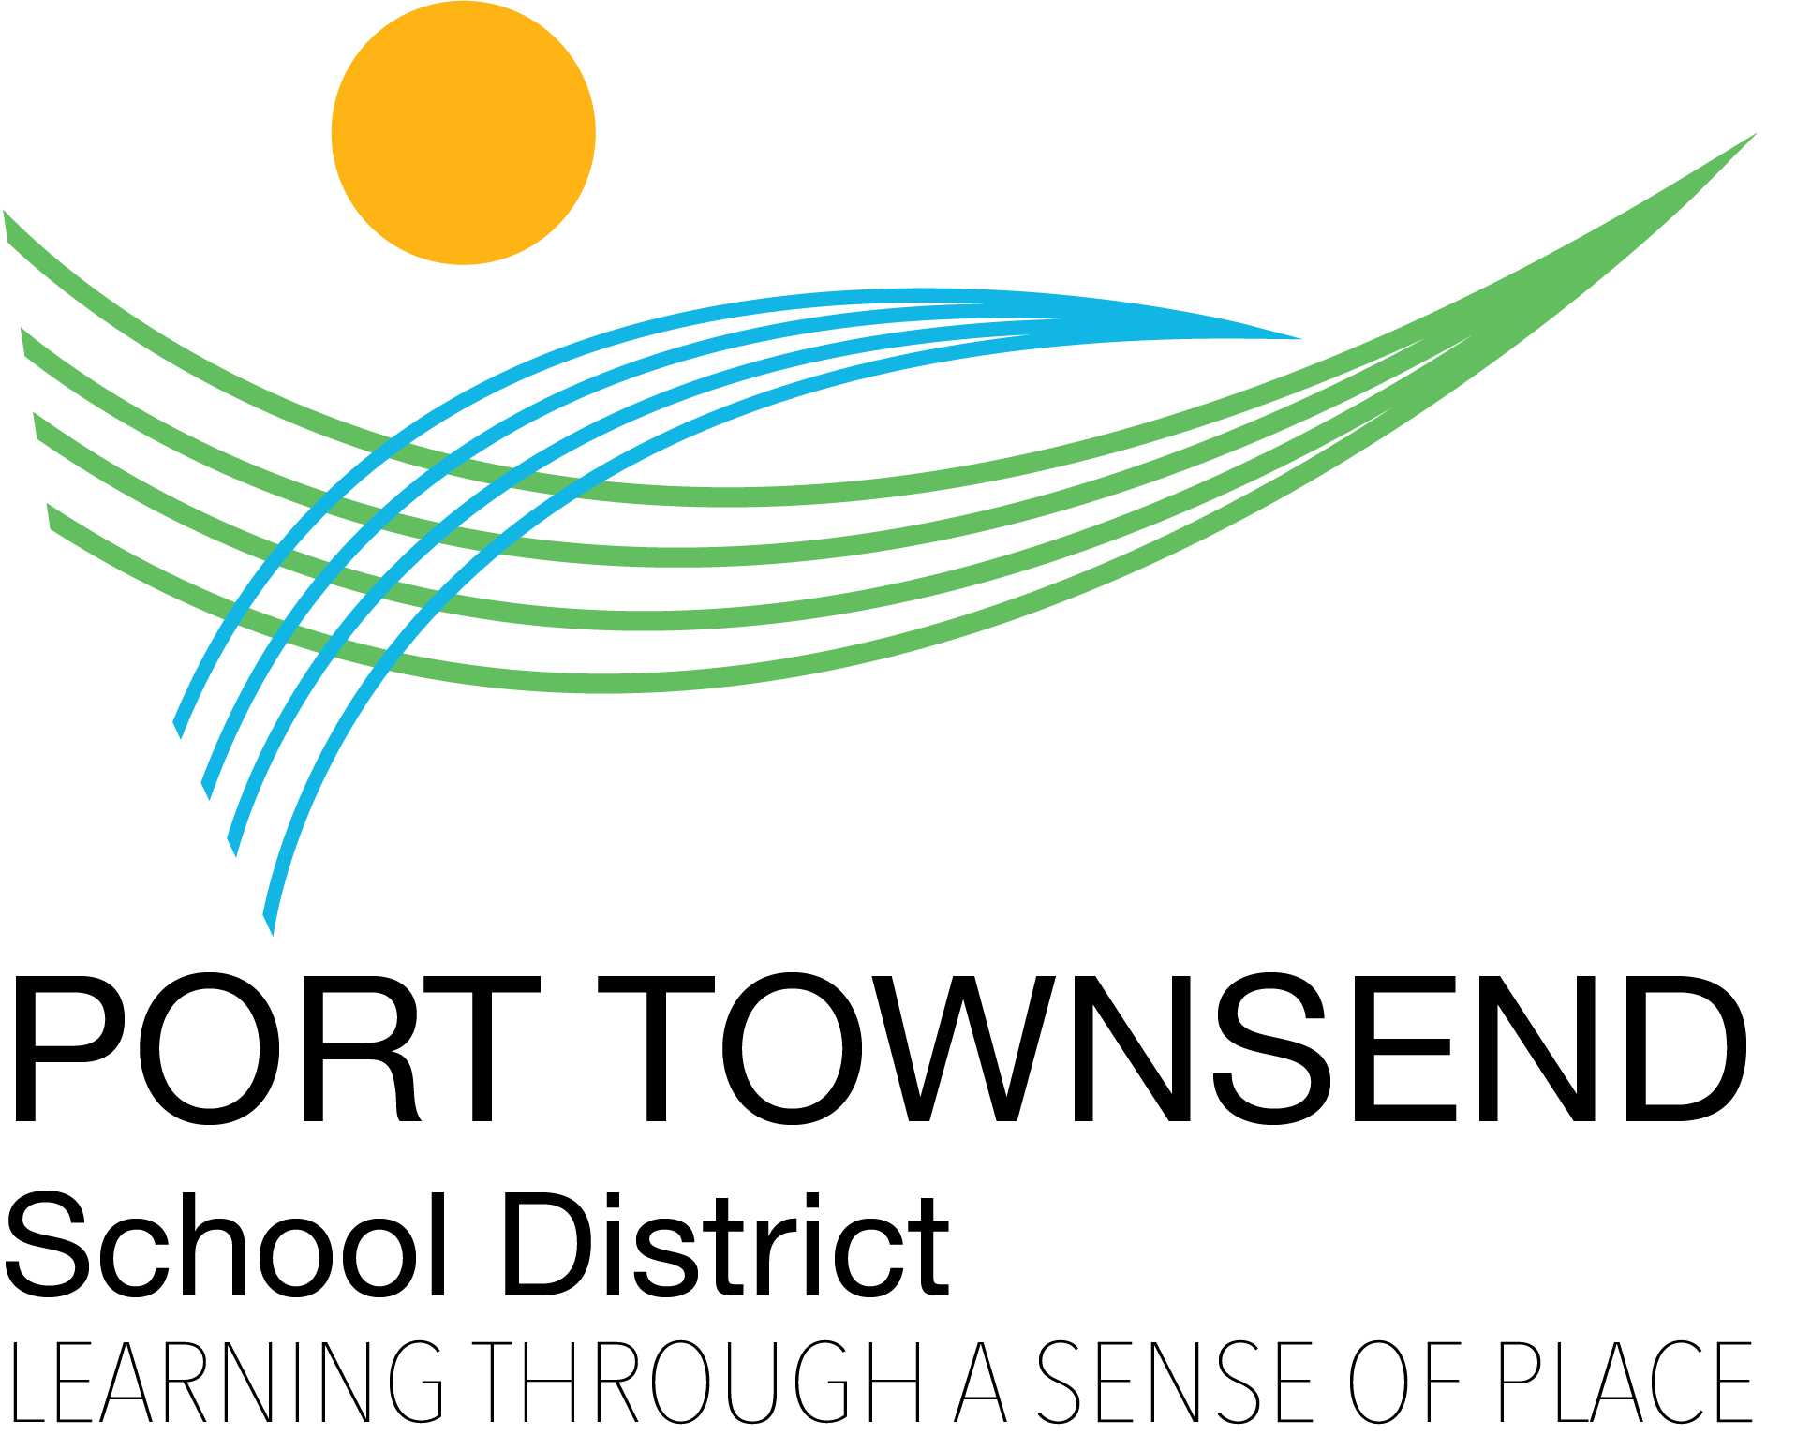

MEMORANDUM OF UNDERSTANDING

BETWEEN
THE JAMESTOWN S’KLALLAM TRIBE

AND
THE PORT TOWNSEND SCHOOL DISTRICT #50

FOR
DELIVERING TITLE VI AND OTHER SERVICES

TO
AMERICAN INDIAN/ALASKA NATIVE STUDENTS LIVING WITHIN THE PORT TOWNSEND SCHOOL DISTRICT
AND
SUPPORTING CULTURALLY RELEVANT CURRICULA

ENACTED ON March 15, 2022

TABLE OF CONTENTS

Introduction…………………………………………………………………………
….………………3

Purpose………………………………………………………………………………
…………….…….3

Definitions……………………………………………………………………………
………….………3

Authority of Government to Government Relations 4
Cooperative Agreements with Tribal Governments 5
Geographical Boundaries for Services 6
Terms of Agreement within the MOU 7
Effect and Modification………………………………………………………………………….
.12
Signature Page…………………………………………………………………………………
……..13
Appendix A: Tribal and District Contact Information 14

INTRODUCTION
This Memorandum of Understanding (“MOU”) is entered into between the Jamestown S’Klallam Tribe (hereinafter "Tribe") and the Port Townsend School District #50 (hereinafter "District"), acting in their representative capacities. This MOU is based on the fundamental principles of the government-to-government relationship acknowledged in the 1989 Centennial Accord.

PURPOSE
The purpose of the MOU between the two parties is to formalize a government to government partnership to serve a common population. This formal MOU was also created to implement strategies and protocols, discussed with the Tribe, within the Every Student Succeeds Act (“ESSA”) as a precursor to the District’s submission of its Title I grant application. By coordinating efforts and braiding resources, the Tribe and District will work to close the opportunity gap for all American Indian/Alaska Native (AI/AN) students living within the Port Townsend School District.

DEFINITIONS
- Active Efforts Casework means active and continuous collaboration with the student (where age, development and maturity make it appropriate), student’s parent or guardian, and the student’s tribe.
- Child Protective Services means the enforcement body of the Department of Child and Family Services to assist families in the protection of children in cases of abuse and neglect.
- Data Sharing Agreement means the legal agreement that allows the District to share student information with us that is pertinent to the Title VI funding, educational needs, and Individualized Education Plans.

- Department of Child and Family Services (“DCYF”) means the Washington State agency responsible for child welfare services, including child protective services.
- Indian Child means any unmarried person who is under age eighteen and is either (a) a member of an Indian tribe or (b) is eligible for membership in an Indian tribe and is the biological child of a member of an Indian tribe or (c) an unenrolled member of a tribe. The tribe is the government that determines who is an Indian child.
- Jamestown S’Klallam Tribe (“Tribe”) means the federally recognized tribe residing in Blyn, Washington.
- Jamestown S’Klallam Tribal Council means the governing body of the Jamestown Tribe.
- Port Townsend School District (“District”) means the governing educational entity responsible for the administration of public education in the town of Port Townsend, Washington.
- Since Time Immemorial Curriculum (STI) means the curriculum passed by the Washington State Legislature in 2015 (Senate Bill 5433), requiring the inclusion of tribal sovereignty curriculum to be taught in all schools.
- Skyward means the secure system in which student data is held (i.e. student name, address, parent contact information, and grades).
- Smarter Balanced Assessments (SBA) Data means data from the SBA, which assesses students in grades 3 to 8 and 10 in areas of: reading, writing, listening and speaking, research, math concepts and procedures, math problem solving and modeling and data analysis, and math communicating and reasoning.
- Student Growth Percentile (SGP) Data means the data which describes a student’s growth compared to other students with similar prior test scores (their academic peers).
- Title VI Program means the federal program under the United States Department of Education’s Office of Indian Education that gives funding to local school districts to assist in the provision of educational services to Indian children.
- Washington Kindergarten Inventory of Developing Skills (WAKids) Data means the data from the transition process that helps to ensure a successful start to the K-12 experience and connect the key adults in a child’s life. It involves three components: family connection, whole-child assessment, and early learning collaboration.
- 506 Form means the form in which tribal enrollment information is gathered for official record. The information is required by the United States Department of Education in order for the local school districts to receive grant funding for Title VI programs.

AUTHORITY OF GOVERNMENT TO GOVERNMENT RELATIONS

Presidential Executive Order #13175
Established by the President of the United States of America in order to establish regular and meaningful consultation and collaboration with tribal officials in the development of Federal policies that have tribal implications, to strengthen the United States

government-to-government relationships with Indian tribes, and to reduce the imposition of unfunded mandates upon Indian tribes.
Link to Presidential Executive Order #13175; November 6, 2000

Washington State Centennial Accord
The Accord was executed between the federally recognized Indian tribes of Washington signatory to this Accord and the State of Washington, through its governor, in order to better achieve mutual goals through an improved relationship between their sovereign governments. This Accord provides a framework for that government-to-government relationship and implementation procedures to assure execution of that relationship.
Link to Centennial Accord Text; August 4, 1989

Chapter 43.376 Revised Code of Washington (RCW): Government to Government Relationship with Federally Recognized Indian Tribes
The Revised Code of Washington is State Law that solidifies the Government to Government relationship with federally recognized Indian tribes in Washington State.
Link to RCW 43.376

  - Washington State Office of the Superintendent of Public Instruction Consultation Protocol The Office of the Superintendent of Public Instruction (OSPI) is the primary agency charged with overseeing Kindergarten through 12th grade (K-12) public education in Washington State.
OSPI recognizes that each federally recognized Indian Tribe is a government with responsibilities to provide services to tribal members of the tribal community and that each government has unique interests and concerns that should be addressed in any government to government consultation. In order to facilitate strong government to government consultation, the parties have established this Consultation Protocol.

COOPERATIVE AGREEMENTS WITH TRIBAL GOVERNMENTS

UNITED STATES CONSTITUTION SEC. 8(3).
To regulate Commerce…with the Indian Tribes…
https://constitutioncenter.org/media/files/constitution.pdf

OFFICE OF MANAGEMENT & BUDGET (OMB) CIRCULAR A-87 SEC. 225.5—PURPOSE.
This part establishes principles and standards for determining costs for Federal awards carried out through grants, cost reimbursement contracts, and other agreements…with federally-recognized Indian tribal governments (governmental units).
https://www.gpo.gov/fdsys/granule/CFR-2012-title2-vol1/CFR-2012-title2-vol1-part225

ESSA SEC. 6112. GRANTS TO LOCAL EDUCATIONAL AGENCIES AND TRIBES, p. 300.
The Secretary may make grants, from allocations made under section 6113, and in accordance with this section and section 6113, to…

  - Indian tribes, as provided under subsection (c)(1);
  - Indian organizations, as provided under subsection (c)(1);
  - consortia of 2 or more local educational agencies, Indian tribes, Indian organizations, or Indian community-based organizations, if each local educational agency participating in such a consortium, if applicable…
5) Indian community-based organizations, as provided under subsection (d)(1).
https://legcounsel.house.gov/Comps/Elementary%20And%20Secondary%20Education%20Act%20Of%201965.pdf

ESSA SEC. 6112 (b)(2) COOPERATIVE AGREEMENTS, p. 300.
A local educational agency may enter into a cooperative agreement with an Indian tribe under this subpart if such Indian tribe—
- represents not less than 25 percent of the eligible Indian children who are served by such local educational agency; and
- requests that the local educational agency enter into a cooperative agreement under this subpart.
https://legcounsel.house.gov/Comps/Elementary%20And%20Secondary%20Education%20Act%20Of%201965.pdf

- REVISED CODE OF WASHINGTON 43.376.020, Government-to-government relationships. In establishing a government-to-government relationship with Indian tribes, state agencies must: (1) Make reasonable efforts to collaborate with Indian tribes in the development of policies, agreements, and program implementation that directly affect Indian tribes and develop a consultation process that is used by the agency for issues involving specific Indian tribes…
http://apps.leg.wa.gov/rcw/default.aspx?cite=43.376

REVISED CODE OF WASHINGTON 28A.604, Educational Data Sharing Agreements – School Districts and Tribes.
The Washington state school directors' association, in consultation and collaboration with tribes, shall develop a model policy and procedure to establish data sharing agreements between school districts and local tribes.
http://lawfilesext.leg.wa.gov/biennium/2019-20/Pdf/Bills/Session%20Laws/Senate/6263.SL.pdf?q=20210224110058

GEOGRAPHICAL BOUNDARIES FOR SERVICES
For the purpose of this MOU, the Tribe has a geographical service area that includes any AI/AN student who attends a school within the District. The District has a service area that includes the areas of Port Townsend, and some of Discovery Bay.

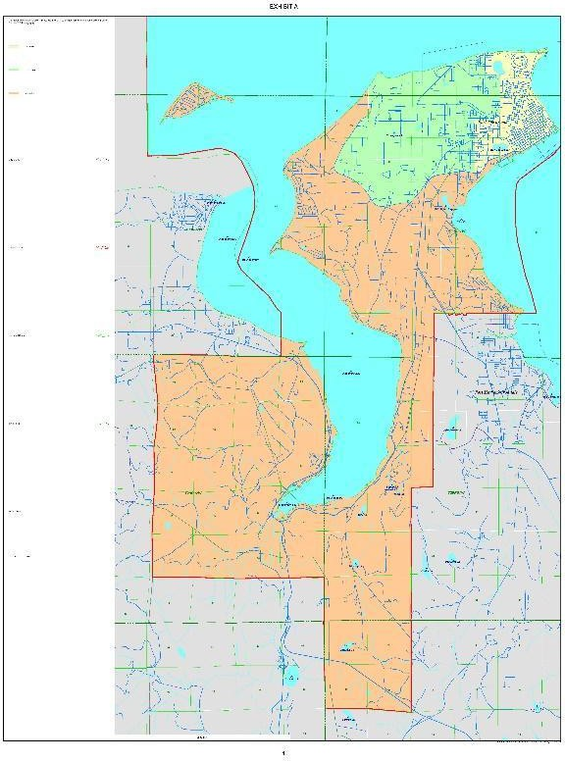

TERMS OF AGREEMENT WITHIN THE MOU

Consultation Philosophy and Protocol
By nurturing a strong government-to-government relationship between the District and the Tribe, any policy or funding change that would affect AI/AN students must require a Tribal Consultation to seek mutual agreement on the implementation of policy and funding changes. Our coordinated efforts will provide opportunities for AI/AN students to be prepared for life after high school by graduating with academic, social, and behavioral knowledge, skills, and abilities. The government-to-government relationship is an especially critical component in the success of AI/AN students living within the District.
The following five priorities were agreed upon between the Tribe and District as areas of focus during a collaborative process in 2020-22. These priorities guide the coordinated efforts of the District and the Tribe, and align with ESSA:
  - Improve outcomes for all AI/AN students in the District.
  - Establish and maintain strong collaboration between the Tribe and the District.
  - Full implementation of the Since Time Immemorial curriculum in the District in support of the District’s place-based learning program.
  - Provide culturally relevant services and education to AI/AN students in the District paying specific attention to transitional times for students.
  - Provide culturally relevant parent and family engagement opportunities.

Collaboration and Child Protective Service (CPS) Referrals

In the event a CPS referral is warranted for a Jamestown student, the District agrees to call or email the Tribe’s ICW Manager to inform the Tribe. The District employee still must make the CPS referral. A MOU agreement is currently in place between the Tribe and the Washington State Department of Social and Health Services Children’s Administration to notify the Tribe of any referral that involves a Jamestown student. The Tribe will work with CPS to provide services to the student and student's family. The Jamestown S’Klallam ICW contacts are:

Indian Child Welfare Case Manager 360-681-4639

Social & Community Services Supervisor 360-582-5785

If a teacher or other staff person feels that a Jamestown student is in a situation that could soon lead to a referral, the District may call the Tribe’s ICW Case Manager to help intervene with prevention services. However, if the situation compromises the safety of the student, the Tribe or District must make the referral to CPS immediately. The referral must come from the party that witnesses the behaviors.
The District will put a process in place to ensure that District staff are aware of students that fall under this section.

Coordinating Staff and Resources to Augment Current Services for AI/AN Students and Families

The District and the Tribe agree to partner in the following activities:

  - The Tribe and the District will separately enter into a Data Sharing – Memorandum of Agreement which will allow for data sharing for program audit or evaluation of the progress of all AI/AN students in the District regardless of participation in the Title VI program. This agreement is in accordance with Senate Bill 6263 – Educational Data Sharing Agreements – School Districts and Tribes which added a new section to Chapter 28A.604 RCW. The legislation became effective June 11, 2020.

  - The Tribe will provide documentation for any tribal staff that will be working within the school’s students. The Tribe conducts FBI background checks on all tribal employees. The Tribe and District agree that any staff person who works with a child must be safe.

  - The District and the Tribe will coordinate efforts to augment current resources available for programs and services for AI/AN students living within the District.

  - With proper releases, Title VI and other tribal staff shall make home or school visits for students who struggle with attendance or other school-related issues.

  - The District will ask the parent of the AI/AN student if they desire to have tribal staff available for any meeting regarding their student’s educational needs.

  - At parental discretion, the District will include tribal staff in invitations to individual education plan (IEP), vocational rehabilitation, developmental disabilities, parent-teacher conferences, parent-teacher meetings, truancy meetings, or other meetings in which a parent or student would desire a tribal education advocate.

  - The District and the Tribe will facilitate meetings and services in District and/or Tribal facilities to maximize participation and use of the resources. For example, Tribal counselors are invited to see clients on school property, and District staff might hold select IEP, developmental disability services, vocational rehabilitation meetings on the Tribal campus.
  - The District and the Tribe will concurrently case-manage students with high-risk factors to ensure wraparound services that may include programs that meet research, best practices, regulatory guidelines, and are culturally appropriate when needed.

  - Tribal staff will be available to work closely with students, families and District staff to enhance each student's access to early childhood services, entrance into kindergarten, elementary school, middle school, high school, and exit into graduation. District personnel will support and comply with provisions and assurances required for participation in federally and state funded programs used to fund educational programs in the District. Tribal staff will enhance the efforts of significant transition periods.

  - The District will invite the Tribe to have representation on the Community Engagement Board.

Coordinated Efforts to Enhance Future Programs and Services

The District and the Tribe agree to partner in the following activities:

  - The District and the Tribe will jointly apply for programs and services beneficial for AI/AN students living within the boundaries of the District when both the District and the Tribe agree that a potential application meets the respective organizational standards for grant applications.

  - The District and the Tribe will support each other’s individual applications for programs and services beneficial for AI/AN students living within the boundaries of the District when both the District and the Tribe agree that a potential application meets the respective organizational standards for grant applications.

  - The District and the Tribe agree to collaborate to identify and access external future funding to enhance Klallam language, history and culture.

  - The District will accept Klallam language credits from accredited programs.

  - The District and Tribe agree to collaborate to identify methods for students to earn high school credits for Klallam language programs offered directly by the Tribe and certified by the Klallam Language Board.

  - The District and Tribe agree to collaborate to identify interagency collaboration efforts such as Handle with Care that will support AI/AN students and families.

Cultural Expression in High School Graduation Ceremonies.

The District will inform graduating seniors of their right to wear cultural regalia at their high-school graduation ceremony. Indian regalia items may include but not limited to:
  - Button blanket;
  - Button vest;
  - Wool shawl;
  - Front skirt;
  - Feathers worn in hair;
  - Cedar head band;
  - Cedar woven graduation cap;
  - Cedar woven hat (not a graduation cap); and
  - Moccasins.

Developmental Disability Services, Vocational Rehabilitation Services, and Transitional Services
  - The District, as required by law, will provide access to needed resources in accordance with the IEP;

  - The District, as required by law, will provide students with access to all assessment services, and resources.

Title VI Programs and Services
The District and the Tribe agree to partner in the following activities:
  - The District will identify a lead staff person as the Title VI Coordinator to be the primary contact for the Tribe.

  - The Tribe and the District will work jointly to complete a Title VI grant application in 2022, to begin in the 2022-23 school year, and on an annual basis.

  - The District will apply as the local education agency (LEA) grant recipient for the Title VI funds and must follow federal regulations for remaining in compliance with federal regulations. This currently includes the use of 506 forms to track tribal enrollment data.

  - The District will work with the Tribe to explore options that might exist within the Office of Indian Education to use processes or protocols (in lieu of the enrollment numbers) to determine and certify student eligibility for Title VI services.
  - If the Title VI application is funded, the District will contract with the Tribe to provide services funded by the annual Title VI Program.

  - The Tribe will provide the District with data and information for students, parents, teachers, and administrations as required by the Office of Indian Education and by the contract with the District.

  - The Tribe will send out invitations for the Annual Parent Meetings and quarterly meetings. The District staff in charge of facilitating the Annual Parent Meetings and quarterly meetings will provide a sign in sheet and agenda. Meetings may be held virtually or in person by mutual agreement of the Tribe and the District.

  - The District will include 506 forms in all registration packets, along with a Release of Information (ROI) for the Tribe.

  - The District will involve the Tribe in the preparation and completion of the Title VI application, the Title VI Annual Count Week, and the Title VI Annual Performance Report.

  - Upon funding of the Title VI grant the District will invite the Tribal staff noted in the below section to monthly meetings which provide a review of formative assessment and risk indicator data for AI/AN students living within the District boundaries.

  - The District and the Tribe will conduct an annual evaluation of the Title VI services.

Data Sharing with Release of Information for Title VI Services
To support Title VI services, the Tribe will partner with the District to secure a Release of Information (ROI) from families of AI/AN students living within the District boundaries. The ROI will provide the following staff to have access to individual data, Skyward account, meeting invitations, and permission to assist the family in obtaining tribal enrollment information, at the discretion of the parents/guardians:

  - Jamestown Behavioral Health Specialist(s);
  - Higher Education Coordinator;
  - Title VI Program Advocate;
  - Indian Child Welfare (ICW) Case Manager;
  - Children, Youth, and Teen Program Supervisor;
  - Teen Program Assistant;
  - Career Development Coordinator;
  - Social and Community Services Supervisor.

Support for Implementation of Since Time Immemorial Curriculum and Culturally Relevant Instructional Materials

  - The District will invite the Tribe to have representation on the Instructional Materials Committee which recommends and reviews curriculum.

  - The District will ensure that the Since Time Immemorial (STI) curriculum is implemented in all of its buildings, and that one teacher at each grade level, at a minimum, is OSPI trained in the use of the STI curriculum.

  - The District will collaborate with the Tribe to incorporate information and materials specifically related to the history, culture, language and government of the Tribe into the Since Time Immemorial Curriculum as part of the commitment to place-based learning and teaching about tribal sovereignty.
  - ​

Dynamic Professional Development Opportunities for District and Tribal staff

The District and the Tribe agree to partner in the following activities:

  - The District will provide, at the Tribe’s request, instructional sessions in the use of OSPI Data Analytic tools and District databases for example, Skyward, and assessments, for example, SBAC.

  - The District will reach out to the Tribe to provide Culturally Responsive Teaching training to the District’s principals, teachers, and counselors. This training will be placed on the District Professional Development calendar each year.

  - The District will provide tribal staff access to the professional development sessions offered in the District on in-service days and early release Wednesdays. The District will provide an annual calendar of the Professional Development Wednesday training topics to the Tribe’s Higher Education Coordinator.

  - The District will provide information to the Tribe about professional development opportunities in enhancing the academic, social, and behavioral outcomes for all students, but notably AI/AN students living within the boundaries of the District.

Regular Reporting and Collaboration

  - Monthly meetings of District Title VI staff and Tribal staff to assess AI/AN student progress and discuss joint case management and Title VI services.

  - The District will designate a staff member responsible for preparing an annual report in collaboration with Tribal Staff to the School Board on the progress of MOU objectives and partnership between the District and the Tribe.

  - Upon bi-annual renewal of the MOU the parties will hold a joint meeting of the District Board of Directors and Tribal Council to confer on the academic progress of Indian students and review the progress of the MOU.

EFFECT AND MODIFICATION
This is a working document to guide the Tribe and District in supporting AI/AN student’s in educational and other appropriate and applicable services and resources. Its description of services and processes may be changed as programs are added, changed or deleted, eligibility requirements are added, changed or deleted, or as circumstances otherwise warrant.
This MOU may be modified at any time by mutual written agreement of the Tribe and District.
District and Tribe support and comply with provisions and assurances required for participation in federally-funded Title programs used to fund the educational and education support programs described herein.
This MOU does not constitute, nor create, nor is it intended to constitute or create, any legally binding or enforceable obligation on the part of either party or relationship between the parties.
The term of this MOU is for a period of two years from the effective date of this agreement and may be extended upon written mutual agreement. It shall be reviewed at least every two years to ensure that it is fulfilling its purpose and to make any necessary revisions.

IN WITNESS HEREOF, the parties have caused this Agreement to be executed on the 15th day of Marc, 2022, and by means of the signatures below, the Tribe and District hereby agree to abide

by this MOU, effective upon the signature of both parties.

FOR THE TRIBE: FOR THE DISTRICT:

W. Ron Allen, Tribal Chairman/CEO Dr. Linda Rosenbury, District Superintendent
Or

Loni Greninger, Tribal Vice Chair

APPENDIX A: TRIBAL AND DISTRICT CONTACT INFORMATION

Jamestown S’Klallam Tribe | Port Townsend School District
Ron Allen, Tribal Council Chairman/CEO rallen@jamestowntribe.org  *Please direct all emails to Social & Community Services  Loni Greninger, Tribal Council Vice Chair lgreninger@jamestowntribe.org  Theresa Lehman, Tribal Council Treasurer tlehman@jamestowntribe.org  Rochelle Blankenship, Tribal Council Secretary rblankenship@jamestowntribe.org  Kurt Grinnell, Tribal Councilperson K_grinnell@msn.com | Nathanael O'Hara, Board Chair nohara@ptschools.org  Doug Ross, Vice-Chair dross@ptschools.org  Jennifer James-Wilson, Director jjwilson@ptschools.org  Connie Welch, Director cwelch@ptschools.org  Jeff Taylor, Director jtaylor@ptschools.org
Director, Social & Community Services 360-681-4868  *Provides oversight of all SCS services | Superintendent 360-379-4501
Deputy Director, Social & Community Services 360-681-4660  *Provides oversight of Higher Education, Title VI | Director of Special Services  *For submission of Title VI tracking sheets  360-379-4267
Higher Ed. Coordinator, Social & Community Services 360-681-4626  *Provides oversight of Title VI Advocate, Title VI data | Principal, Salish Coast Elementary School 360-376-3366
ICW Case Manager, Social & Community Services 360-681-4639  *Provides ICW services | Principal, Blue Heron Middle School 360-379-4541
Title VI Program Advocate, Social & Community Services 360-460-7860  *Provides Title VI services | Principal, Port Townsend High School 360-379-4522
Professional. Dev. Coord., Social & Community Services 360-681-4635  *Provides coordination of DVR services | Principal, OCEAN and Place-Based Learning Director 360-385-6661
Case Navigator, Social & Community Services 360-618-4606
*Provides the “front door” to services

