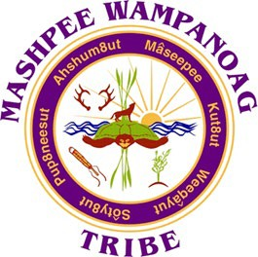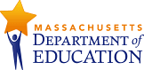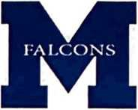

Memorandum of Understanding Between the

Mashpee Wampanoag Tribe Education Agency (TEA) And
Mashpee Public School District (LEA);
Massachusetts Department of Elementary & Secondary Education (SEA)

This Memorandum of Understanding (MOU) is made between the Mashpee Wampanoag Tribe Education Agency, the Mashpee Public School District, and the Massachusetts Department of Elementary and Secondary Education (DESE).

Mission

To significantly improve the capacity of the TEA to address the academic and cultural needs of Native (AI/AN) students attending the LEA, through collaboration, consultation, and data-sharing. The TEA increases its ability to assume shared responsibility with the SEA and LEA in data analysis and decision-making, the provision of supplemental academic instruction, and engagement in technical assistance and professional development opportunities; this, in the furtherance of ensuring equitable access to high- quality core curriculum and instruction, advanced studies, extra-curricular activities, and safe, mutually respectful learning environments.

Responsibilities

The Parties in this MOU will work together with the goal of increasing equity for Native students: quality academic instruction and access to opportunities not traditionally pursued by Native students in Public Schools; and to improve data-sharing in K-12, to include tracking academic progress under Title I, Part A; School Improvement Grants (ESEA
§1003(g); and the exchange of professional development opportunities to support the goals of Improving Teacher Quality State Grants (Title II, Part A) to help ensure the funding for these programs help to meet the unique cultural and educational needs of Native students.

The TEA agrees to:
- Seek technical assistance from the LEA to expand its ability to more effectively use qualitative and quantitative data to build a foundation of data-driven decision-making.

- Collaborate with the LEA to utilize shared data solely for the purposes of determining appropriate interventions and programming; geared toward improving academic proficiency and access to advanced opportunities for Native students.
- Offer the expertise of the Tribe’s Multi-Disciplinary Team and Elder’s Panel to provide interventions and other supports for improving attendance, academic performance, and well-being of Native students.

- Facilitate cultural competency workshops, seminars, and technical assistance sessions for SEA staff and LEA faculty, administrators, and school committee members, in their collective understanding of the Mashpee Wampanoag Tribe, Native perspectives, tribal history, historical trauma, colonization, cultural identity, learning styles, among other opportunities to bridge those cultural and instructional gaps.

- Actively Participate in Quarterly Partnership Meetings with the LEAs to share, collaborate and assess progress with the intent of the Agreement.
- Collaborate with the K-12 curricular areas of History, Social Studies, Science, College & Career Readiness (CCR) and Career & Technical Education (CTE), to identify resources and enhance knowledge of Native people, in historical and contemporary times.
- Expand on opportunities for students to enroll in Wôpanâak courses (Wampanoag Language), in conjunction with WLRP.

- Ensure that staff and contractors complete a fingerprint background check and Massachusetts CORI background check as required under state law, specifically, but not including to 603 CMR 51.00 et. seq, in advance of providing services to students; evidence thereof will be provided to the LEAs.

8. Participate in consultation sessions, with the SEA twice a year to ensure information and opportunities are shared; and to develop a process for disaggregating data for Native American students in all realms of K-12 activities including Advanced

Placement, Gifted & Talented, Independent Studies, extracurricular activities, and athletics.

10. Annually share State Tribal Education Partnership (STEP) Grant Performance Objective results at a regularly scheduled School Committee meeting.

The LEAS agree to:
- Share the identification of all Native students enrolled in the district with written parental permission and to actively solicit written parent permission to share school data of all Native students with the TEA.
- Support routine, scheduled consultation with teaching staff, counselors, and administrators regarding the academic progress of students; and access to technology labs, libraries, and space for working with Native students.
- Share academic performance data of Native students, with the TEA to be used for decision-making in the provision of supplemental services and supporting full access to more advanced academic opportunities not generally pursued by Native students; through written parent permission and in compliance with the Family Education Rights and Privacy Act (FERPA) and 603 CMR 23.00 et. seq..

- Provide technical assistance needed to administer education programs, to the TEA, such as data-driven decision-making, identification of resources, and expanded opportunities for students.

- Share the disaggregated/de-identified data for Native students receiving services under Title I, Part A and those students requiring additional academic assistance, in accordance with 34 C.F.R. § 99.31(b), with the goal of improving academic proficiency.

- Schedule cultural competency workshops, seminars, and technical assistance sessions professional development opportunities, for K-12 faculty, administrators, and school committee members in collaboration with the TEA.

- Schedule Quarterly Partnership Meetings with the TEA to collaborate and assess progress with the Agreement.

- Explore opportunities for expansion of Wôpanâak (Wampanoag Language) course offerings, in conjunction with the Wôpanâak Language Reclamation Project (WLRP);

The SEA agrees to:

- Hold consultation sessions twice a year to promote Native education, exchange information and create opportunities.

- Include the TEA in technical assistance sessions, not limited to but inclusive of CCR, CTE and other areas of relevance for strengthening educational services for Native students.

- Collaborate with the TEA to identify the technical assistance needs of DESE staff and administration, in their collective understanding of the Mashpee Wampanoag Tribe, Native perspectives, and tribal history, to underscore the needs of Native students in Public Schools, and to bridge cultural gaps.

Terms of Understanding
The term of this MOU is for a period of three (3) years from the effective date of this MOU and may be extended upon written mutual agreement. Finalization of the MOU is to be enacted no later than 120 days after the awarding of this STEP grant. No funds will be shared or exchanged during the course of this agreement.

Both parties commit to making their best efforts to reach consensus and finalize agreement, on a provision regarding data sharing that is consistent with FERPA, within 90 days after the start of the project,
The MOU shall be reviewed annually to ensure that it is fulfilling its purpose and to make any necessary revisions. Any of the named Agencies may terminate this MOU upon ninety days written notice without penalties or liabilities.

This MOU may be amended only by written approval of the TEA, SEA, and LEAs; this MOU is governed by the laws of the Commonwealth of Massachusetts.

NON-BINDING
This MOU is not intended to be a legally binding document, but rather a joint commitment to achieve the goals announced herein, in accordance with the various action items identified above. No party is compensating the other party and neither party is assuming any specific financial commitments to the other.


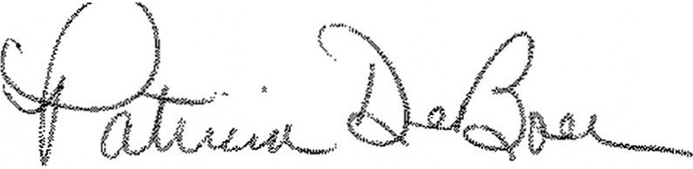
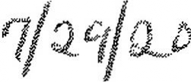
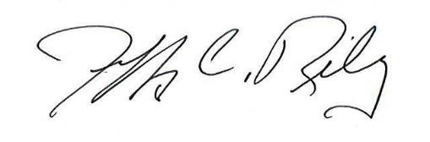
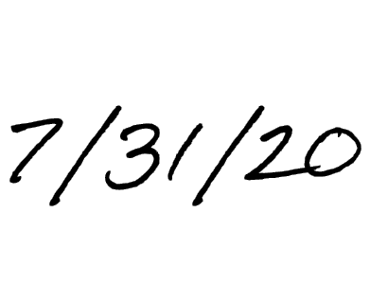
Patricia DeBoer, Superintendent Mashpee Public Schools

Jeffrey C. Riley, Commissioner Massachusetts Department of Elementary and Secondary
Education
�.�,· fl(��·---
Roxanne Mills Brown, Education Director
Mashpee Wampanoag Tribe
Date

7/31/2020
Date

Date

